**MINISTRY OF EDUCATION AND TRAINING**

**FPT UNIVERSITY**

Capstone Project Document

Website of Law Firm Management System

Report #3 – Software Requirement Specification

|  |  |
| --- | --- |
| Group 14 | |
| Group Members | Lê Duy Hoàng – Team Leader – SE60744  Đặng Nguyễn Khiêm – Team Member – SE60595  Trần Anh Tuấn – Team Member – SE60631  Phạm Văn Duy – Team Member – SE60634 |
| Supervisor | Nguyễn Văn Sang |
| Capstone Project code | LFMS |

- Ha Noi, 09/2014 –

Contents

3.1. User Requirement Specification 3

3.1.1. Functional Requirements 3

3.1.2. Non-Functional Requirements 4

3.2. System Requirement Specification (Specific Requirements) 4

3.2.1. External Interface Requirements 4

3.2.2. Functional Requirements 4

3.2.3. Non-Functional Requirements 195

3.3. Entity Relationship Diagram 196

## User Requirement Specification

### Functional Requirements

#### Case Management:

**Access right: All users**

* Manage all information of Case by customers, general information, operation event, lawyer viewpoint, people related, document related and Used Service. Assign one or many lawyer into Case, payments of each case.

#### Manage Calendar:

**Access right: All users**

* Manage all calendar work of staff.

#### Customer Management:

**Access right: Administrator**

* Add new, edit customer information and delete customer. Stored for use in later Cases.

#### Staff Management:

* **Access right: Aministrator**
* Add new, edit staff information and deactivate staff. Division of roles in the system used.

#### Service Management:

* **Access right: Administrator**
* Add new, edit service information and delete service. Use for Used Service.

#### Office Management:

* **Access right: Administrator**
* Add new, edit office information and deactivate office. Can only be used by “super admin” – the admin user role have StaffId is 1.

#### Statistics Management:

* **Access right: Administrator**
* View all Statistics of system about revenue, number of case received and compare revenue, number of case between offices, staffs.

### Non-Functional Requirements

The Law Firm Management System (LFMS) is an internal website, which allows management law office system.

* + - **Learnable**: The user interface must be easy to learn, even at the first time looking at the screen, user may immediately understand the function of each button or icon.
    - **Efficiency**: The user interface must minimize the number of steps that the system takes to complete its task.
    - **Memorable**: System contains some complex screens. Therefore, interface should be easier to use each time the user interacts with it.
    - **Visibility**: Important information (example: text in nodes) should be clearly visible.
    - **Consistency**: Like-items should always be displayed and act the same way through the entire application.

## System Requirement Specification (Specific Requirements)

### External Interface Requirements

#### User Interfaces

System is designed so friendly and easy to use with users. Home page list all the records of reception Cases. Besides have the calendar, prompted by notification bar at the top.

All functions in menu must be grouped in a meaningful way to make it easy for users to locate and access the features.

#### Communications Protocol

The system is web base so it’s should be applied Hypertext Transfer Protocol (HTTP) is main communication protocol.

### Functional Requirements

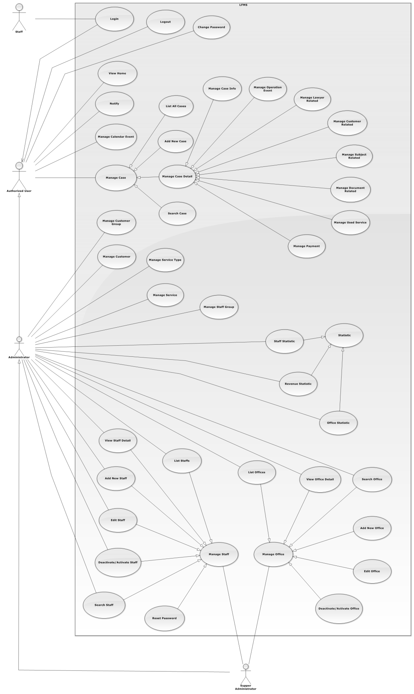

Figure 1: Overview Use-Case Diagram

#### UC0001 - Login

##### Use-Case Diagram

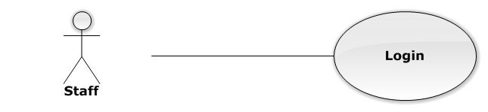

Figure 2: Login Use-Case Diagram

##### Use-Case Specification

|  |  |  |  |
| --- | --- | --- | --- |
| USE CASE SPECIFICATION | | | |
| Use-case No. | UC0001 | Use-case Version | 1.0 |
| Use-case Name | Login | | |
| Author | Trần Anh Tuấn | | |
| Date | 09/10/2014 | Priority | Normal |
| Actor:  Staff.  Summary:  This use case allows staff to log on into the system.  **Goal:**  Authenticate user.  Triggers:  User access website area that is intended staff.  Preconditions:  User has an account and has not logged in yet.  Post Conditions:  **Success**: User logged in. System redirects user to “Home” page.  **Failure**: System redirects to “Login” page.  Main Success Scenario:   |  |  |  | | --- | --- | --- | | *Step* | *User* | *System* | | 1 | User go to website page | Website will show [Login] page | | 2 | User input information into username field and password field |  | | 3 | Presses “Đăng nhập” button or click “Enter” key | Checks username and password.  Redirect to “Home” page.  [Exception 1]  [Exception 2] |   Alternative Scenario:  N/A  Exceptions:   |  |  |  | | --- | --- | --- | | *#* | *User* | *System* | | 1 | Presses “Login” button. If invalid username or password. | System redirect to “Login” page and display error message “Tên đăng nhập hoặc mật khẩu không đúng!” | | 2 | Presses “Login” button. If have error when connect database | System redirect to “Login” page and display error message “Lỗi kết nối đến máy chủ!” |   Relationships:  N/A  Business Rules:   * Password must be longer than 6 characters | | | |

#### UC0002 - Logout

##### Use-Case Diagram

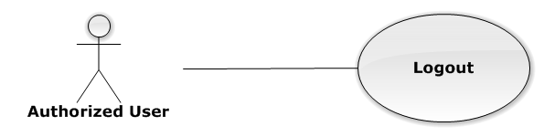

Figure 3: Logout Use-Case Diagram

##### Use-Case Specification

|  |  |  |  |
| --- | --- | --- | --- |
| USE CASE SPECIFICATION | | | |
| Use-case No. | UC0002 | Use-case Version | 1.0 |
| Use-case Name | Logout | | |
| Author | Trần Anh Tuấn | | |
| Date | 09/10/2014 | Priority | Normal |
| Actor:  Authorized User.  Summary:  This use case allows staff to logout the system.  **Goal:**  The users can log out successful from their roles.  Triggers:  Staff click on “Đăng xuất” on User Control Panel.  Preconditions:  Staff has logged in to the website.  Post Conditions:  Success: Back to login screen  Failure: An error message is displayed.  Main Success Scenario:   |  |  |  | | --- | --- | --- | | *Step* | *User* | *System* | | 1 | Staff click “Đăng xuất” button on User Control Panel | The user name of user will be disappeared on webstie, Redirect to “Login” page. |   Alternative Scenario:  N/A  Exceptions:  N/A  Relationships:  N/A  Business Rules:  N/A | | | |

#### UC0003 - Change Password

##### Use-Case Diagram

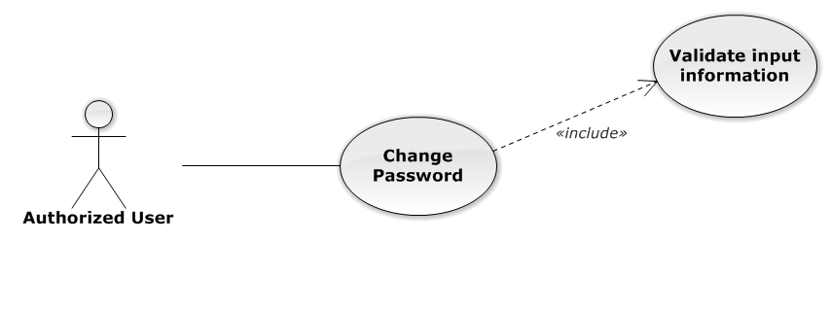

Figure 4: Change Password Use-Case Diagram

##### Use-Case Specification

|  |  |  |  |
| --- | --- | --- | --- |
| USE CASE SPECIFICATION | | | |
| Use-case No. | UC0003 | Use-case Version | 1.0 |
| Use-case Name | Change Password | | |
| Author | Trần Anh Tuấn | | |
| Date | 09/10/2014 | Priority | Normal |
| Actor:  Authorized User.  Summary:  This use case allows staff can change password of them.  **Goal:**  Change password.  Triggers:  User access website area and click on “Đổi mật khẩu”.  Preconditions:  User has logged in.  Post Conditions:  **Success**: The password is changed and display message “Cập nhật mật khẩu nhân viên thành công!”  **Failure**: Password is not changed. Display error message.  Main Success Scenario:   |  |  |  | | --- | --- | --- | | *Step* | *User* | *System* | | 1 | Staff has logged in, click on “Đổi mật khẩu” on User Control Panel. | Modal Popup “Thay đổi mật khẩu”is display with three fields:“Mật khẩu cũ, “Mật khẩu mới and “Lặp lại mật khẩu mới  Two button “Đóng” , “Đổi mật khẩu” | | 2 | User input information, Click “Đổi mật khẩu” button  [Alternative 1]  [Exception 1] | Check information validity and change password |   Alternative Scenario:   |  |  |  | | --- | --- | --- | | *#* | *User* | *System* | | 1 | Click on [X] button, “Đóng” button, or click out of modal | Modal popup is close |   Exceptions:   |  |  |  | | --- | --- | --- | | *#* | *User* | *System* | | 1 | Field “Mật khẩu cũ” are blank | Shows error message “Hãy nhập lại mật khẩu cũ” | | Field “Mật khẩu mới”, are blank | Shows error message “Hãy nhập mật khẩu mới” | | Field “Lặp lại mật khẩu mới ” are blank | Shows error message “Hãy nhập lại mật khẩu mới” | | Input to field “Mật khẩu cũ”, “Mật khẩu mới” and field “Lặp lại mật khẩu mới” regular expression. | Shows error message “Mật khẩu không được có kí tự đặc biệt” | | Input to field “Mật khẩu mới ” and field “Lặp lại mật khẩu mới ” not enough 6 character | Shows error message “Mật khẩu mới phải có ít nhất 6 kí tự” | | Input to field “Mật khẩu mới ” and field “Lặp lại mật khẩu mới ” are diffirent | Shows error message “Mật khẩu 2 không trùng khớp” | | Input to field “Mật khẩu cũ” not the same with database | Shows error message “Mật khẩu cũ không đúng!”. |   Relationships:  N/A  Business Rules:   * Password must be longer than 6 characters | | | |

#### UC0004 - View Home

##### Use-Case Diagram

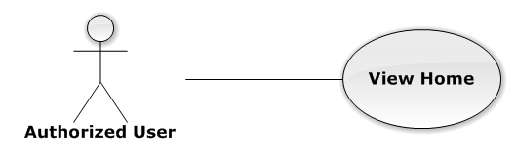

Figure 5: View Home Use-Case Diagram

##### Use-Case Specification

|  |  |  |  |
| --- | --- | --- | --- |
| USE-CASE SPECIFICATION | | | |
| Use-case No. | UC0004 | Use-case Version | 1.0 |
| Use-case Name | View Home | | |
| Author | Trần Anh Tuấn | | |
| Date | 09/10/2014 | Priority | Normal |
| Actor:  Authorized User  Summary:  User must be Login before and then redirect them to “Trang Chủ” page.  Goal:  To allowing user to view some information of all Cases, which is operating and assigned by Staff related.  Triggers:   * User click on logo LFMS * Click on “Trang Chủ” link.   Preconditions:   * Must be logged-in * The page is fully loaded   Post Conditions:  Success: System redirect user to “Trang Chủ” page and list cases  Failure: Do nothing.  Main Success Scenario:   |  |  |  | | --- | --- | --- | | *Step* | *User* | *System* | | 1 | Click on logo LFMS or “Trang Chủ” link | * Redirect to “Trang Chủ” page * List Cases by Office filter |   Alternative Scenario:  N/A  Exceptions:  N/A  Relationships:  N/A  Business Rules:  N/A | | | |

#### UC0005 - Notify

##### Use-Case Diagram

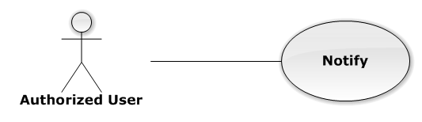

Figure 6: Notify Use-Case Diagram

##### Use-Case Specification

|  |  |  |  |
| --- | --- | --- | --- |
| USE-CASE SPECIFICATION | | | |
| Use-case No. | UC0005 | Use-case Version | 1.0 |
| Use-case Name | Notify | | |
| Author | Trần Anh Tuấn | | |
| Date | 09/10/2014 | Priority | Normal |
| Actor:  Authorized User  Summary:  User must be login before and then the system will be show notification in navigation bar.  Goal:  User can see all Today's events.  Triggers:  The notification is always to show.  Preconditions:   * Must be logged-in * The page is fully loaded   Post Conditions:  Success: Show to user  Failure: Do nothing.  Main Success Scenario:   |  |  |  | | --- | --- | --- | | *Step* | *User* | *System* | | 1 | Login into the system | User can see notification about all Today's events |   Alternative Scenario:  N/A  Exceptions:  N/A  Relationships:  N/A  Business Rules:  N/A | | | |

#### Manage Calendar Event

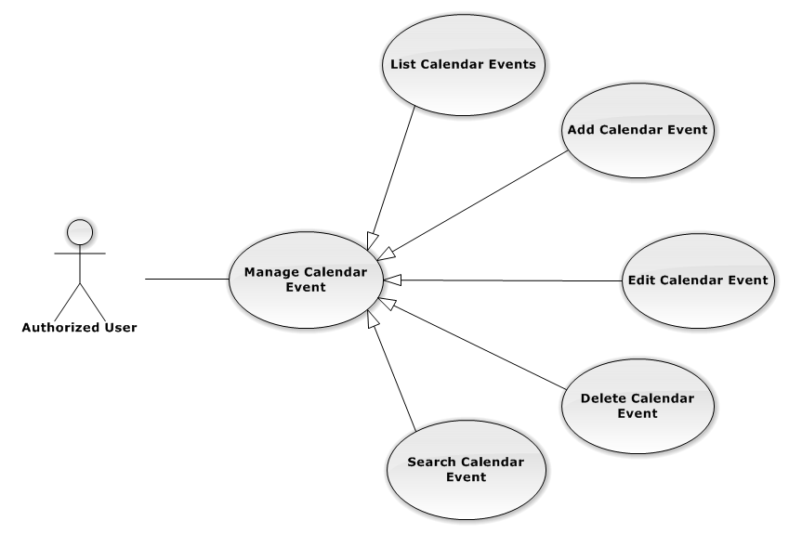

Figure 7: Manage Calendar Event Use-Case Diagram

##### UC0006 - List Calendar Events

###### Events Use-Case Diagram

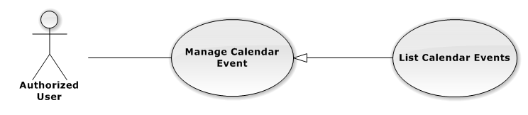

Figure 8: List Calendar Event Use-Case Diagram

###### Events Use-Case Specification

|  |  |  |  |
| --- | --- | --- | --- |
| USE CASE SPECIFICATION | | | |
| Use-case No. | UC0006 | Use-case Version | 1.0 |
| Use-case Name | List Calendar Events | | |
| Author | Trần Anh Tuấn | | |
| Date | 09/10/2014 | Priority | Normal |
| Actor:  Authorized User.  Summary:  List All Calendar Event.  Goal:  The purpose of List Calendar Event use case is allowing User to view all Events in full-calendar.  Triggers:  User choose “Lịch làm việc” tab in Homepage.  Preconditions:  User is authenticated.  Post Conditions:  Success: All Calendar Events are listed.  Failure: N/A  Main Success Scenario:   |  |  |  | | --- | --- | --- | | *Step* | *User* | *System* | | 1 | Click “Lịch làm việc” tab in home page. | All Calendar Events are loaded. |   Alternative Scenario:  N/A  Exceptions:  N/A  Relationships:  Manage Calendar Event  Business Rules:  N/A | | | |

##### UC0007 - Add New Calendar Event

###### Use-Case Diagram

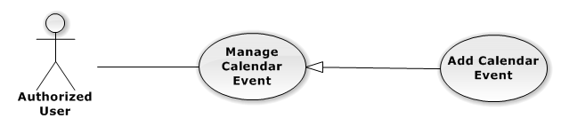

Figure 9: Add New Calendar Event

###### Use-Case Specification

|  |  |  |  |
| --- | --- | --- | --- |
| USE CASE SPECIFICATION | | | |
| Use-case No. | UC0007 | Use-case Version | 1.0 |
| Use-case Name | Add New Calendar Event | | |
| Author | Trần Anh Tuấn | | |
| Date | 09/10/2014 | Priority | Normal |
| Actor:  Authorized User.  Summary:  Add new Calendar Event.  Goal:  The purpose of Add Calendar Event use case is allowing User to add new Calendar Event.  Triggers:  User choose “Lịch làm việc” tab in home page.  Preconditions:  User is authenticated.  Post Conditions:  Success: New Calendar Event is created.  Failure: N/A  Main Success Scenario:   |  |  |  | | --- | --- | --- | | *Step* | *User* | *System* | | 1 | Click anywhere in calendar. | Show Add new calendar event pop-up. | | 2 | Enters the Calendar Event Name |  | | 3 | Presses “Thêm Sự kiện” button.  [Alternative: 1] | Add new Calendar Event to database. |   Alternative Scenario:   |  |  |  | | --- | --- | --- | | *#* | *User* | *System* | | 1 | Presses “Đóng”, “X” button or click outside pop-up. | The Add New Calendar event pop-up is close. |   Exceptions:  N/A  Relationships:  Manage Calendar Event  Business Rules:  N/A | | | |

##### UC0008 - Edit Calendar Event

###### Use-Case Diagram

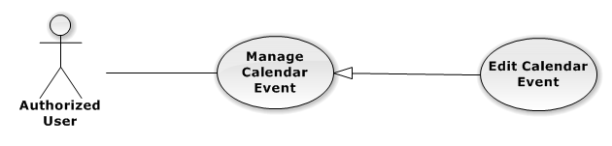

Figure 10: Edit Calendar Event Use-Case Diagram

###### Use-Case Specification

|  |  |  |  |
| --- | --- | --- | --- |
| USE CASE SPECIFICATION | | | |
| Use-case No. | UC0008 | Use-case Version | 1.0 |
| Use-case Name | Edit Calendar Event | | |
| Author | Trần Anh Tuấn | | |
| Date | 09/10/2014 | Priority | Normal |
| Actor:  Authorized User.  Summary:  Update Calendar Event.  Goal:  The purpose of Update Calendar Event use case is allowing User to edit Calendar Event.  Triggers:  User choose “Lịch làm việc” tab in Homepage.  Preconditions:  User is authenticated.  Post Conditions:  Success: The Calendar Event is Updated.  Failure: N/A  Main Success Scenario:   |  |  |  | | --- | --- | --- | | *Step* | *User* | *System* | | 1 | Click at an exist event. | Show edit calendar event pop-up. | | 2 | Enters the new Calendar Event Name |  | | 3 | Presses “Lưu chỉnh sửa” button.  [Alternative: 1] | Update Calendar event to database. | | 1 | Drag and drop an exist event. | Update Calendar event to database. | | 1 | Reside an exist event. | Update Calendar event to database. |   Alternative Scenario:   |  |  |  | | --- | --- | --- | | *#* | *User* | *System* | | 1 | Presses “Đóng”, “X” button or click outside pop-up. | The Update Clendar event pop-up is close. |   Exceptions:  N/A  Relationships:  Manage Calendar Event  Business Rules:  N/A | | | |

##### UC0009 - Delete Calendar Event

###### Use-Case Diagram

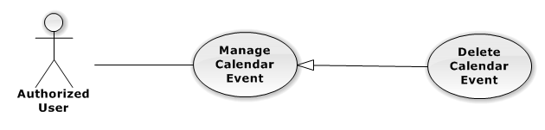

Figure 11: Delete Calendar Event Use-Case Diagram

###### Use-Case Specification

|  |  |  |  |
| --- | --- | --- | --- |
| USE CASE SPECIFICATION | | | |
| Use-case No. | UC0009 | Use-case Version | 1.0 |
| Use-case Name | Delete Calendar Event | | |
| Author | Trần Anh Tuấn | | |
| Date | 09/10/2014 | Priority | Normal |
| Actor:  Authorized User.  Summary:  Delete Calendar Event.  Goal:  The purpose of Delete Calendar Event use case is allowing User to delete Calendar Event.  Triggers:  User choose “Lịch làm việc” tab in Homepage.  Preconditions:  User is authenticated.  Post Conditions:  Success: The Calendar Event is deleted.  Failure: N/A  Main Success Scenario:   |  |  |  | | --- | --- | --- | | *Step* | *User* | *System* | | 1 | Click at an exist event. | Show confirm pop-up | | 2 | Presses “Xóa sự kiện” button.  [Alternative: 1] | Delete Calendar Event from database. |   Alternative Scenario:   |  |  |  | | --- | --- | --- | | *#* | *User* | *System* | | 1 | Presses “Đóng”, “X” button or click outside pop-up. | The confirm pop-up is close. |   Exceptions:  N/A  Relationships:  Manage Calendar Event  Business Rules:  N/A | | | |

##### UC0010 - Search Calendar Event

###### Use-Case Diagram

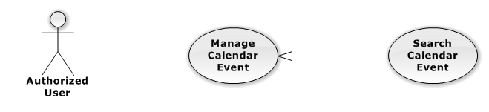

Figure 12: Search Calendar Event Use-Case Diagram

###### Use-Case Specification

|  |  |  |  |
| --- | --- | --- | --- |
| USE CASE SPECIFICATION | | | |
| Use-case No. | UC0010 | Use-case Version | 1.0 |
| Use-case Name | Search Calendar Event | | |
| Author | Trần Anh Tuấn | | |
| Date | 09/10/2014 | Priority | Normal |
| Actor:  Authorized User.  Summary:  Show all Calendar Event of a Staff.  Goal:  The purpose of Search Calendar Event use case is allowing User to view Calendar event of other staff.  Triggers:  Click at “Lịch làm việc luật sư khác” button.  Preconditions:  User is authenticated.  Post Conditions:  Success: The Calendar Event is showed.  Failure: Do nothing.  Main Success Scenario:   |  |  |  | | --- | --- | --- | | *Step* | *User* | *System* | | 1 | Click at “Lịch làm việc luật sư khác” button. | Show helper frame. | | 2 | Choose a staff in combo-box | Show al Calendar Event of these Staff. |   Alternative Scenario:  N/A  Exceptions:  N/A  Relationships:  Manage calendar event  Business Rules:  N/A | | | |

#### Manage Case

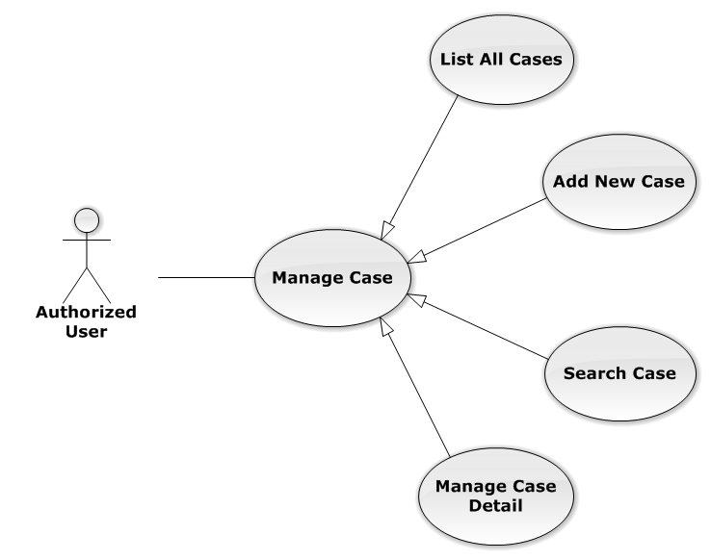

Figure 13: Manage Case Use-Case Diagram

##### UC0011 - List All Cases

###### Use-Case Diagram

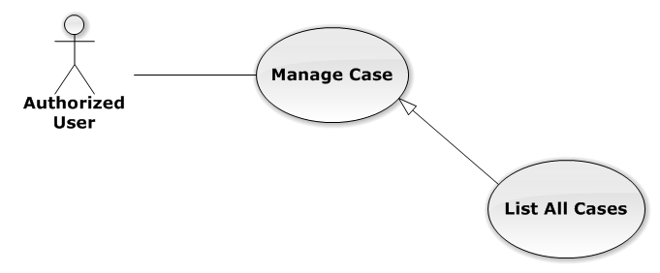

Figure 14: List All Cases Use-Case Diagram

###### Use-Case Specification

|  |  |  |  |
| --- | --- | --- | --- |
| USE-CASE SPECIFICATION | | | |
| Use-case No. | UC0011 | Use-case Version | 1.0 |
| Use-case Name | List All Cases | | |
| Author | Trần Anh Tuấn | | |
| Date | 09/10/2014 | Priority | Normal |
| Actor:  Authorized User  Summary:  Redirect to “Danh sách hồ sơ” page and list all cases.  Goal:  To allowing customer to view any detail information of all Cases  Triggers:   * User click on User Control Panel and then click on “Danh sách hồ sơ” link * Click on “Danh sách hồ sơ” link in Case Detail of each Case   Preconditions:   * Must be logged-in * The page is fully loaded   Post Conditions:  Success: System redirects user to “Danh sách hồ sơ” page.  Failure: Do nothing.  Main Success Scenario:   |  |  |  | | --- | --- | --- | | *Step* | *User* | *System* | | 1 | Click on “Danh sách hồ sơ” link | * Redirect to “Danh sách hồ sơ” page * Show all Cases by searching condition |   Alternative Scenario:  N/A  Exceptions:  N/A  Relationships:  Manage Case  Business Rules:  N/A | | | |

##### UC0012 - Add New Case

###### Use-Case Diagram

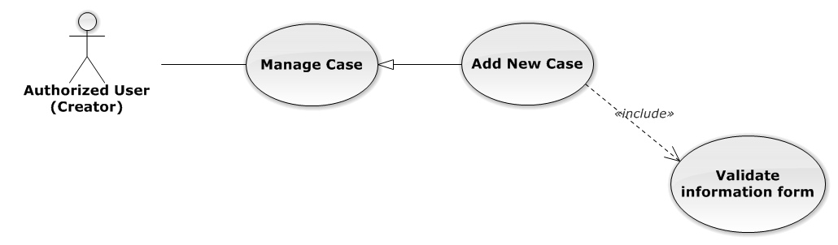

Figure 15: Add New Case Use-Case Diagram

###### Use-Case Specification

|  |  |  |  |
| --- | --- | --- | --- |
| USE-CASE SPECIFICATION | | | |
| Use-case No. | UC0012 | Use-case Version | 1.0 |
| Use-case Name | Add New Case | | |
| Author | Trần Anh Tuấn | | |
| Date | 09/10/2014 | Priority | High |
| Actor:  Authorized User have “Creator” role  Summary:  Staff can add new case by input data on form modal  Goal:  Helps Staff input information of a case when they add new one  Triggers:  Staff click on “Thêm mới” button in modal  Preconditions:   * Must be logged-in with “Creator” role * The page is fully loaded   Post Conditions:  Success:   * Add new case successful * Add current Staff to Lawyer Related of the new Case * Redirect to view detail page of new case   Failure: System display error message “Thêm hồ sơ thất bại!”  Main Success Scenario:   |  |  |  | | --- | --- | --- | | *Step* | *User* | *System* | | 1 | * Staff click on icon-plus button in “Trang chủ” page * Click on “Thêm hồ sơ tác nghiệp” button in “Danh sách hồ sơ” page | Modal popup is displayed with fields for input information of new case | | 2 | Input corresponding information in form then click “Thêm mới” button  [Alternative 1]  [Exception 1] | * Modal popup is close * System display successful message “Thêm hồ sơ thành công!” * Update list case on page |   Alternative Scenario:   |  |  |  | | --- | --- | --- | | *#* | *User* | *System* | | 1 | Click on [X] button, “Đóng” button, or click out of modal | Modal popup is close |   Exceptions:   |  |  |  | | --- | --- | --- | | *#* | *User* | *System* | | 1 | Leave empty require fields then click on “Thêm mới” button | Modal popup display validation for needed to input field |   Relationships:  Manage Case  Business Rules:   * Authorized User must have “Creator” role to use this function * After create case successfully, system will be automatically assign Creator into that new case | | | |

##### UC0013 - Search Case

###### Use-Case Diagram

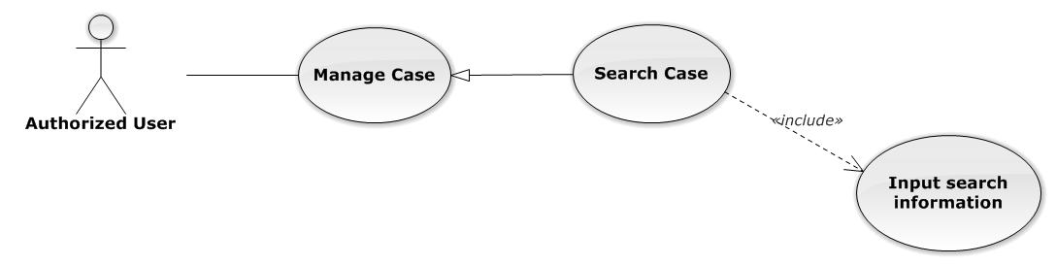

Figure 16: Search Case Use-Case Diagram

###### Use-Case Specification

|  |  |  |  |
| --- | --- | --- | --- |
| USE-CASE SPECIFICATION | | | |
| Use-case No. | UC0013 | Use-case Version | 1.0 |
| Use-case Name | Search Case | | |
| Author | Trần Anh Tuấn | | |
| Date | 09/10/2014 | Priority | Normal |
| Actor:  Authorized User  Summary:  Staff can search Cases by multi condition  Goal:  Helps Staff to search Cases of system more easy  Triggers:  Staff inputs key words on “Tìm kiếm” textbox at the top right of case list table to search follow key words inputted. When the key up, system will be automatic search.  Preconditions:   * Must be logged-in * The page is fully loaded * Inputs key words on “Tìm kiếm” textbox   Post Conditions:  Success: Cases of the system are displayed page by page  Failure: Do nothing  Main Success Scenario:   |  |  |  | | --- | --- | --- | | *Step* | *User* | *System* | | 1 | Input key words into textbox and then key up  [Alternative 1]  [Alternative 2]  [Alternative 3] | Display cases matches key words and multi condition |   Alternative Scenario:   |  |  |  | | --- | --- | --- | | *#* | *User* | *System* | | 1 | Select number result in page | Display many cases follow number result in page | | 2 | Click on another page number | Display many cases result in another page | | 3 | Click on “Mã hồ sơ” link | Redirect to view Case detail |   Exceptions:  N/A  Relationships:  Manage Case  Business Rules:  N/A | | | |

##### Manage Case Detail

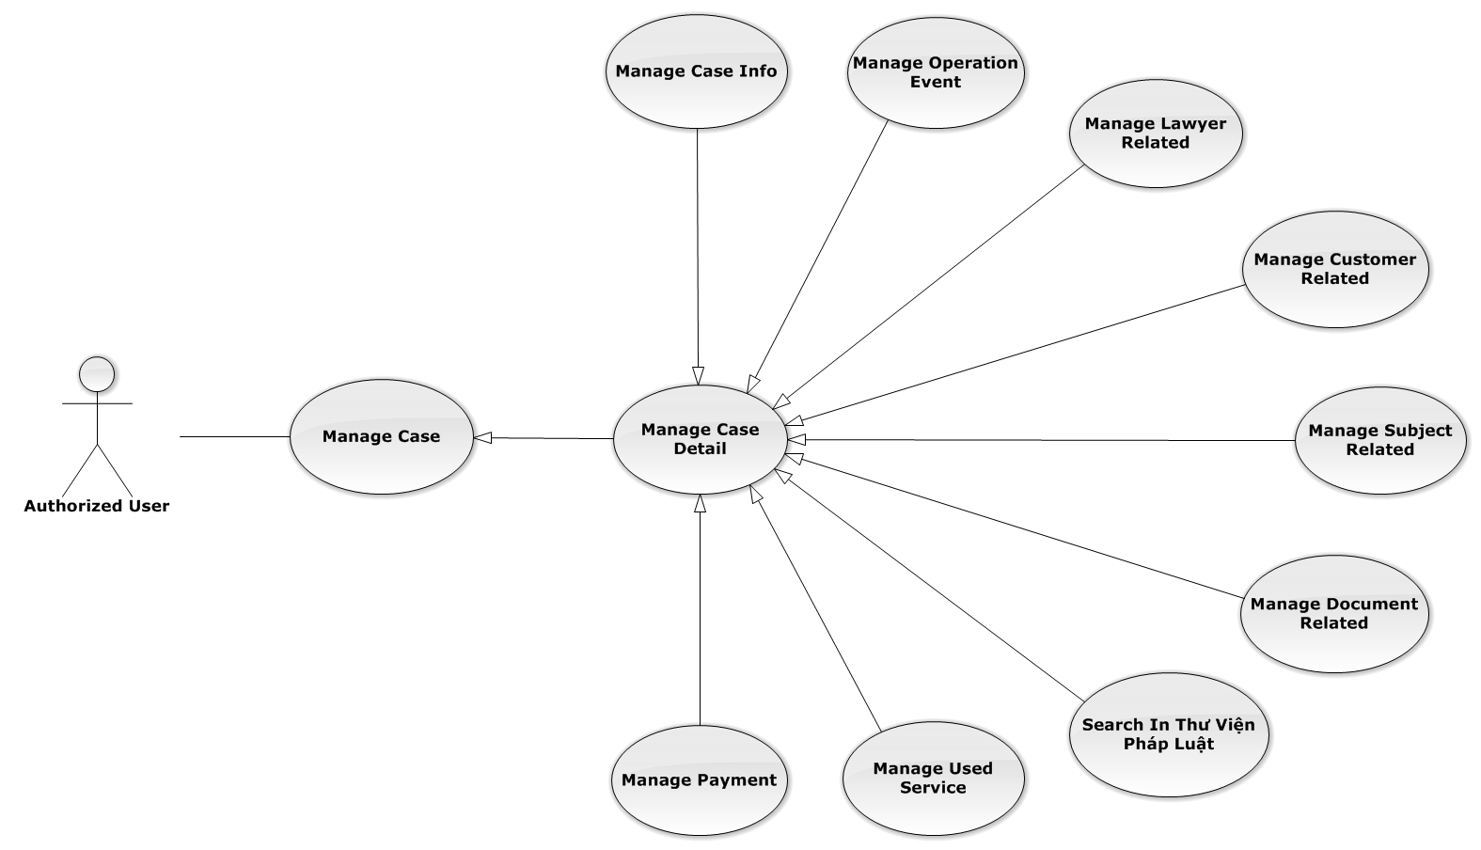

Figure 17: Manage Case Detail Use-Case Diagram

###### Manage Case Info

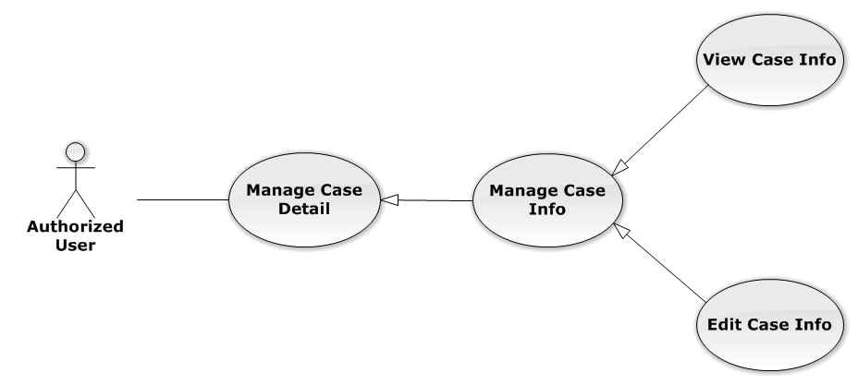

Figure 18: Manage Case Info Use-Case Diagram

UC0014 - View Case Info

Use-Case Diagram

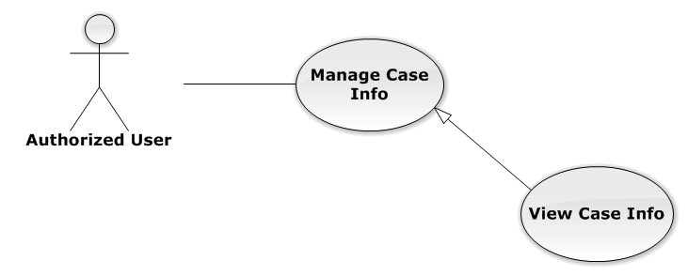

Figure 19: View Case Info Use-Case Diagram

Use-Case Specification

|  |  |  |  |
| --- | --- | --- | --- |
| USE-CASE SPECIFICATION | | | |
| Use-case No. | UC0014 | Use-case Version | 1.0 |
| Use-case Name | View Case Info | | |
| Author | Trần Anh Tuấn | | |
| Date | 09/10/2014 | Priority | Normal |
| Actor:  Authorized User  Summary:  Staff can view current case’s information  Goal:  Helps staff to get detail and main content of the case quickly  Triggers:   * Staff click on “Mã hồ sơ” link in “Danh sách hồ sơ” * Staff click on big button corresponding with each case on “Trang chủ”   Preconditions:   * Must be logged-in * The page is fully loaded * Must be in Case Detail page   Post Conditions:  Success: The case’s detail is displayed correctly and successfully  Failure: Do nothing  Main Success Scenario:   |  |  |  | | --- | --- | --- | | *Step* | *User* | *System* | | 1 | * Staff click on “Mã hồ sơ” link in “Danh sách hồ sơ” * Staff click on big button on “Trang chủ” | * System redirect to Case Detail page * Show detail of main case content |   Alternative Scenario:  N/A  Exceptions:  N/A  Relationships:  Manage Case Info  Business Rules:  N/A | | | |

UC0015 - Edit Case Info

Use-Case Diagram

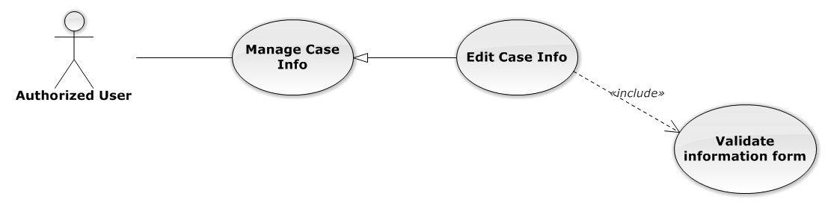

Figure 20: Edit Case Info Use-Case Diagram

Use-Case Specification

|  |  |  |  |
| --- | --- | --- | --- |
| USE-CASE SPECIFICATION | | | |
| Use-case No. | UC0015 | Use-case Version | 1.0 |
| Use-case Name | Edit Case Info | | |
| Author | Trần Anh Tuấn | | |
| Date | 09/10/2014 | Priority | Normal |
| Actor:  Authorized User who is assigned in current case  Summary:  Staff can edit and update case detail  Goal:  Helps Staff easy to update case information  Triggers:  Staff click on “Lưu chỉnh sửa” button  Preconditions:   * Must be logged-in * The page is fully loaded * Must be in Case Detail page * Click on edit icon beside “Thông tin chung” label before and the case have “Đang thụ lý” status   Post Conditions:  Success: The case detail will be updated and system display message “Cập nhật chi tiết hồ sơ thành công!”  Failure: System display message “Cập nhật chi tiết hồ sơ thất bại!”  Main Success Scenario:   |  |  |  | | --- | --- | --- | | *Step* | *User* | *System* | | 1 | Click on edit icon beside “Thông tin chung” label  [Exception 1] | * All off fields will enable to input * “Hủy chỉnh sửa” and “Lưu chỉnh sửa” button is display | | 2 | Input information and then click “Lưu chỉnh sửa” button  [Alternative 1]  [Exception 2] | * The case detail will be updated * System display message “Cập nhật chi tiết hồ sơ thành công!” * All off fields will disable * “Hủy chỉnh sửa” and “Lưu chỉnh sửa” button is hidden |   Alternative Scenario:   |  |  |  | | --- | --- | --- | | *#* | *User* | *System* | | 1 | Click on “Hủy chỉnh sửa” button | * The case detail will be reloaded * All off fields will disable * “Hủy chỉnh sửa” and “Lưu chỉnh sửa” button is hidden |   Exceptions:   |  |  |  | | --- | --- | --- | | *#* | *User* | *System* | | 1 | Click on edit icon when the case have “Đã thụ lý” status | System display message “Hồ sơ đã thụ lý!” | | 2 | Leave empty require fields then click on “Lưu chỉnh sửa” button | Display validation message for needed to input field |   Relationships:  Manage Case Info  Business Rules:  Only Administrator or Authorized User is assigned in current case can be use this function when status of case is “Đang thụ lý” and Office that have current case must is active. | | | |

###### Manage Operation Event

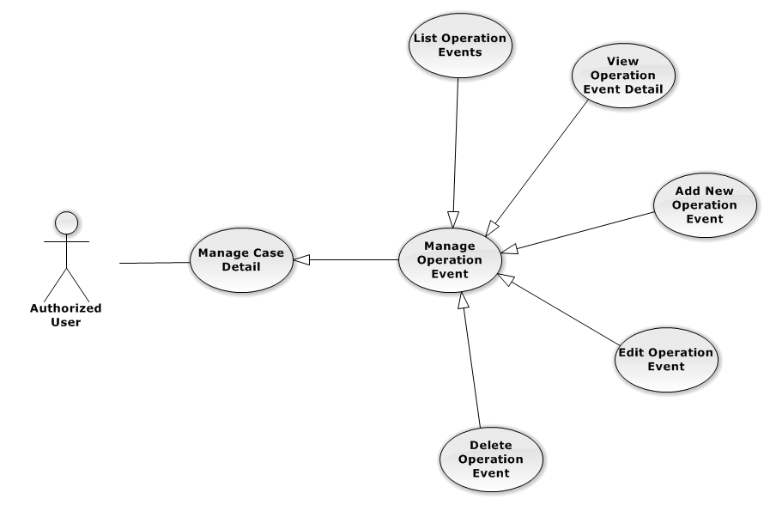

Figure 21: Manage Operation Event Use-Case Diagram

UC0016 - List Operation Events

Use-Case Diagram

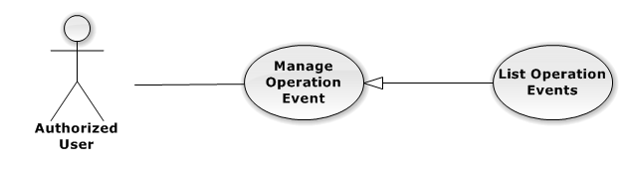

Figure 22: List Operation Events Use-Case Diagram

Use-Case Specification

|  |  |  |  |
| --- | --- | --- | --- |
| USE-CASE SPECIFICATION | | | |
| Use-case No. | UC0016 | Use-case Version | 1.0 |
| Use-case Name | List Operation Events | | |
| Author | Trần Anh Tuấn | | |
| Date | 09/10/2014 | Priority | Normal |
| Actor:  Authorized User  Summary:  Show all event of case.  Goal:  Help staff to view all event of case.  Triggers:  User click on “Sự kiện” link in Case Detail page  Preconditions:   * Must be logged-in * The page is fully loaded * Must be in Case Detail page   Post Conditions:  Success: List all event in current case  Failure: Do nothing  Main Success Scenario:   |  |  |  | | --- | --- | --- | | *Step* | *User* | *System* | | 1 | Click on “Sự kiện” link | Show all event in current case |   Alternative Scenario:  N/A  Exceptions:  N/A  Relationships:  Manage Operation Event  Business Rules:  N/A | | | |

UC0017 - View Operation Event Detail

Use-Case Diagram

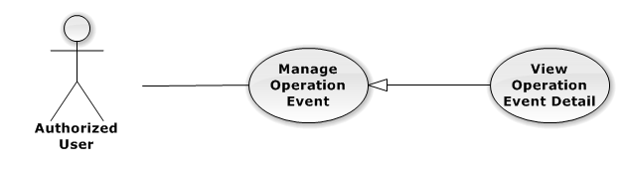

Figure 23: View Operation Event Detail Use-Case Diagram

Use-Case Specification

|  |  |  |  |
| --- | --- | --- | --- |
| USE-CASE SPECIFICATION | | | |
| Use-case No. | UC0017 | Use-case Version | 1.0 |
| Use-case Name | View operation event detail | | |
| Author | Trần Anh Tuấn | | |
| Date | 09/10/2014 | Priority | Normal |
| Actor:  Authorized User  Summary:  Staff can view detail of event information  Goal:  Helps staff to view event information  Triggers:   * Staff click on “Sự kiện” link * Click on one event * Click on “Mở rộng” button   Preconditions:   * Must be logged-in * The page is fully loaded * Must be in Lawyer related page   Post Conditions:  Success: The detail event information is displayed  Failure: Do nothing  Main Success Scenario:   |  |  |  | | --- | --- | --- | | *Step* | *User* | *System* | | 1 | Staff click on event day’s link  [Alternative 1], [Alternative 2] | The detail event information is displayed |   Alternative Scenario:   |  |  |  | | --- | --- | --- | | *#* | *User* | *System* | | 1 | Click on “Mở rộng” button | Display detail of all event of current case | | 2 | Click on “Thu nhỏ” button | Close all detail event of current case, back to list event screen. |   Exceptions:  N/A  Relationships:  Manage Operation Event  Business Rules:  N/A | | | |

UC0018 - Add New Operation Event

Use-Case Diagram

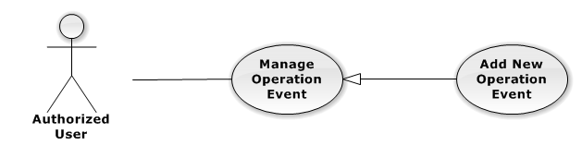

Figure 24: Add New Operation Event Use-Case Diagram

Use-Case Specification

|  |  |  |  |
| --- | --- | --- | --- |
| USE-CASE SPECIFICATION | | | |
| Use-case No. | UC0018 | Use-case Version | 1.0 |
| Use-case Name | Add New Operation Event | | |
| Author | Trần Anh Tuấn | | |
| Date | 09/10/2014 | Priority | High |
| Actor:  Authorized User, who is assigned in current case  Summary:  Staff can add new event into Case  Goal:  Helps Staff create event into Case  Triggers:   * Staff click on “Sự kiện” link in Case Detail page * Click on edit icon beside “Sư kiện tác nghiệp” button * Click on “Thêm mới” button to add new event to current case.   Preconditions:   * Must be logged-in * The page is fully loaded * Must be in event page * Click on edit icon beside “Sự kiện tác nghiệp” label before   Post Conditions:  Success:   * At new event into current Case * Show message successfully: “Thêm sự kiện thành công!”   Failure: System display error message “Thêm sự kiện thất bại!", "hãy kiểm tra lại kết nối database!”  Main Success Scenario:   |  |  |  | | --- | --- | --- | | *Step* | *User* | *System* | | 1 | Click on edit icon beside “Sự kiện tác nghiệp” label | Form, “Thêm sự kiện” and “Hoàn thành” button is display | | 2 | Click on the “Thêm sự kiện” button | Input form display , “Đóng” and “Tạo sự kiện” button is display | | 3 | Input information into fields and click button “Hoàn thành” button  [Alternative 1], [Exception 1] | System display message “Thêm sự kiện thành công!” |   Alternative Scenario:   |  |  |  | | --- | --- | --- | | *#* | *User* | *System* | | 1 | Click on “Đóng” button | Input form close back to list all event screen. |   Exceptions:   |  |  |  | | --- | --- | --- | | *#* | *User* | *System* | | 1 | System cannot insert event to data base. | Shows error message “Tạo sự kiện thất bại, hãy kiểm tra lại kết nối database”. |   Relationships:  Manage Operation Event  Business Rules:  Only Administrator or Authorized User is assigned in current case can be use this function when status of case is “Đang thụ lý” and Office that have current case must is active. | | | |

UC0019 - Edit Operation Event

Use-Case Diagram

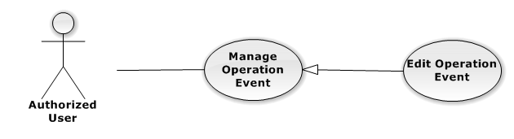

Figure 25: Edit Operation Event Use-Case Diagram

Use-Case Specification

|  |  |  |  |
| --- | --- | --- | --- |
| USE-CASE SPECIFICATION | | | |
| Use-case No. | UC0019 | Use-case Version | 1.0 |
| Use-case Name | Edit Operation Event | | |
| Author | Trần Anh Tuấn | | |
| Date | 09/10/2014 | Priority | Normal |
| Actor:  Authorized User, who is assigned in current case  Summary:  Staff can update event into Case  Goal:  Helps Staff update event into Case  Triggers:   * Staff click on “Sự kiện” link in Case Detail page * Click on edit icon beside “Sư kiện tác nghiệp” button * Click on “Edit” button to update event.   Preconditions:   * Must be logged-in * The page is fully loaded * Must be in event page * Click on edit icon beside “Sự kiện tác nghiệp” label before   Post Conditions:  Success:   * Update event into current Case * Show message successfully: “Sửa sự kiện thành công!”   Failure: System display error message “Sửa sự kiện thất bại!", "hãy kiểm tra lại kết nối database!”  Main Success Scenario:   |  |  |  | | --- | --- | --- | | *Step* | *User* | *System* | | 1 | Click on edit icon beside “Sự kiện tác nghiệp” label | List all event in current case, “Edit” and “Delete” icon is display, “Thêm sự kiện” and “Hoàn thành” button is display | | 2 | Click on the “Edit” button | Input form display , “Đóng” and “Lưu chỉnh sửa” button is display | | 3 | Edit information into fields and click button “Lưu chỉnh sửa” button  [Alternative 1] , [Exception 1] | System display message “Sửa sự kiện thành công!” |   Alternative Scenario:   |  |  |  | | --- | --- | --- | | *#* | *User* | *System* | | 1 | Click on “Đóng” button | Input form close back to list all event screen. |   Exceptions:   |  |  |  | | --- | --- | --- | | *#* | *User* | *System* | | 1 | While edit information of event click edit icon beside “Sư kiện tác nghiệp” button | Shows error message “Chỉnh sửa chưa hoàn thành! Hãy lưu hoặc đóng chỉnh sửa”. | | System cannot insert event to data base. | Shows error message “Chỉnh sửa sự kiện thất bại, hãy kiểm tra lại kết nối database”. |   Relationships:  Manage Operation Event  Business Rules:  Only Administrator or Authorized User is assigned in current case can be use this function when status of case is “Đang thụ lý” and Office that have current case must is active. | | | |

UC0020 - Delete Operation Event

Use-Case Diagram

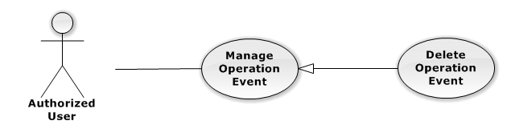

Figure 26: Delete Operation Event Use-Case Diagram

Use-Case Specification

|  |  |  |  |
| --- | --- | --- | --- |
| USE-CASE SPECIFICATION | | | |
| Use-case No. | UC0020 | Use-case Version | 1.0 |
| Use-case Name | Delete Operation Event | | |
| Author | Trần Anh Tuấn | | |
| Date | 09/10/2014 | Priority | Normal |
| Actor:  Authorized User, who is assigned in current case  Summary:  Staff can remove Event in Case  Goal:  Helps Staff remove Event in Case  Triggers:  Staff click on delete icon in the end table list  Preconditions:   * Must be logged-in * The page is fully loaded * Must be in Lawyer related page * Click on edit icon beside “Sự kiện tác nghiệp” label before   Post Conditions:  Success:   * Remove the Event out of current Case * Show message remove successfully: “Xóa sự kiện thành công!”   Failure: System display error message “Xóa sự kiện thất bại!”  Main Success Scenario:   |  |  |  | | --- | --- | --- | | *Step* | *User* | *System* | | 1 | Click on edit icon beside “Sự kiện tác nghiệp” label | Icon delete is display | | 2 | Click on icon delete corresponding with Event want to remove | Show a modal popup to confirm | | 3 | Click on “Xác nhận” button  [Alternative 1] | System display message “Xóa sự kiện thành công!” |   Alternative Scenario:   |  |  |  | | --- | --- | --- | | *#* | *User* | *System* | | 1 | Click on “Bỏ qua” button | Modal popup is close and system do not remove the Event |   Exceptions:  N/A  Relationships:  Manage Operation Event  Business Rules:  Only Administrator or Authorized User is assigned in current case can be use this function when status of case is “Đang thụ lý” and Office that have current case must is active. | | | |

###### Manage Lawyer Related

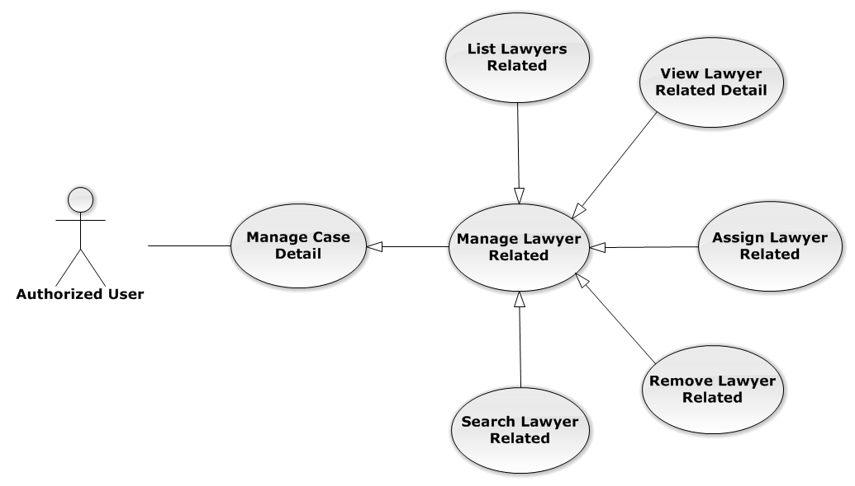

Figure 27: Manage Lawyer Related Use-Case Diagram

UC0021 - List Lawyers Related

Use-Case Diagram

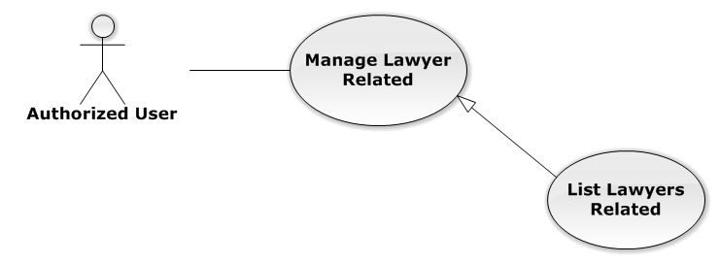

Figure 28: List Lawyers Related Use-Case Diagram

Use-Case Specification

|  |  |  |  |
| --- | --- | --- | --- |
| USE-CASE SPECIFICATION | | | |
| Use-case No. | UC0021 | Use-case Version | 1.0 |
| Use-case Name | List Lawyers Related | | |
| Author | Đặng Nguyễn Khiêm | | |
| Date | 09/10/2014 | Priority | Normal |
| Actor:  Authorized User  Summary:  Show all Lawyers, who is assigned in current case  Goal:  Help to view all Lawyers, who is assigned in current case  Triggers:   * User click on “Người liên quan” link in Case Detail page * Click on “Luật sư” link at right top page   Preconditions:   * Must be logged-in * The page is fully loaded * Must be in Case Detail page   Post Conditions:  Success: List all Staffs is assigned in current case  Failure: Do nothing  Main Success Scenario:   |  |  |  | | --- | --- | --- | | *Step* | *User* | *System* | | 1 | Click on “Người liên quan” link or “Luật sư” link | Show all Lawyers is assigned in current case |   Alternative Scenario:  N/A  Exceptions:  N/A  Relationships:  Manage Lawyer Related  Business Rules:  N/A | | | |

UC0022 - View Lawyer Related Detail

Use-Case Diagram

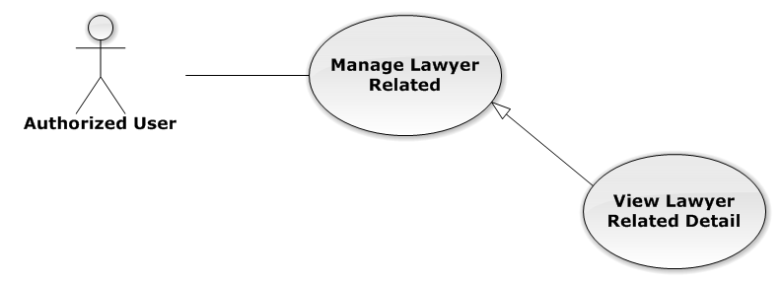

Figure 29: View Lawyer Related Detail Use-Case Diagram

Use-Case Specification

|  |  |  |  |
| --- | --- | --- | --- |
| USE-CASE SPECIFICATION | | | |
| Use-case No. | UC0022 | Use-case Version | 1.0 |
| Use-case Name | View Lawyer Related Detail | | |
| Author | Đặng Nguyễn Khiêm | | |
| Date | 09/10/2014 | Priority | Normal |
| Actor:  Authorized User  Summary:  Staff can view Lawyer related information  Goal:  Helps staff to view Lawyer related information  Triggers:   * Staff click on “Họ và tên” link * Click on avatar image   Preconditions:   * Must be logged-in * The page is fully loaded * Must be in “Người liên quan” page   Post Conditions:  Success: The popup modal have lawyer information is displayed  Failure: Do nothing  Main Success Scenario:   |  |  |  | | --- | --- | --- | | *Step* | *User* | *System* | | 1 | Staff click on “Họ và tên” link or avatar image | The popup modal have lawyer information is displayed  [Alternative 1] |   Alternative Scenario:   |  |  |  | | --- | --- | --- | | *#* | *User* | *System* | | 1 | Click on [X] button, “Đóng” button, or click out of modal | Modal popup is close |   Exceptions:  N/A  Relationships:  Manage Lawyer Related  Business Rules:  N/A | | | |

UC0023 - Assign Lawyer Related

Use-Case Diagram

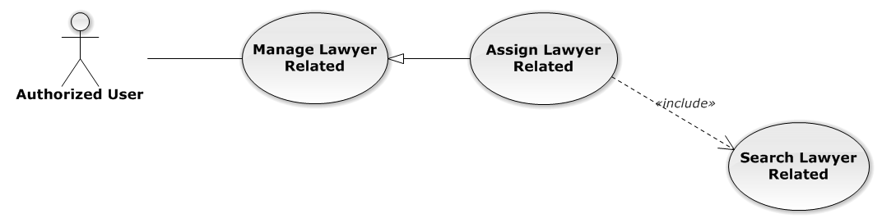

Figure 30: Assign Lawyer Related Use-Case Diagram

Use-Case Specification

|  |  |  |  |
| --- | --- | --- | --- |
| USE-CASE SPECIFICATION | | | |
| Use-case No. | UC0023 | Use-case Version | 1.0 |
| Use-case Name | Assign Lawyer Related | | |
| Author | Đặng Nguyễn Khiêm | | |
| Date | 09/10/2014 | Priority | High |
| Actor:  Authorized User, who create the current Case  Summary:  Staff can assign Lawyer into Case  Goal:  Helps Staff assign any Lawyers into Case  Triggers:  Staff click on “Thêm vào danh sách” button after choose Lawyer in search form beside  Preconditions:   * Must be logged-in * The page is fully loaded * Must be in “Người liên quan” page * Click on edit icon beside “Luật sư phụ trách” label and used Search Lawyer Related function before   Post Conditions:  Success:   * Assign the Lawyer in search form to current Case * Show message assign successfully: “Đã phân công luật sư!”   Failure: System display error message “Phân công luật sư thất bại!”  Main Success Scenario:   |  |  |  | | --- | --- | --- | | *Step* | *User* | *System* | | 1 | Click on edit icon beside “Luật sư phụ trách” label | Search form, “Thêm vào danh sách” and “Hoàn thành” button is display | | 2 | After search and choose a Lawyer, Staff click on “Thêm vào danh sách” button  [Alternative 1]  [Exception 1]  [Exception 2] | System display message “Đã phân công luật sư!” |   Alternative Scenario:   |  |  |  | | --- | --- | --- | | *#* | *User* | *System* | | 1 | Click on “Hoàn thành” button | Search form, “Thêm vào danh sách” and “Hoàn thành” button is hidden |   Exceptions:   |  |  |  | | --- | --- | --- | | *#* | *User* | *System* | | 1 | Not search lawyer then click on “Thêm vào danh sách” button | Display validation message for needed to search lawyer before: “Hãy chọn 1 luật sư!” | | 2 | Lawyer is exist in list lawyer related | Display message “Đã tồn tại luật sư!” |   Relationships:  Manage Lawyer Related  Business Rules:  Only Administrator or Authorized User, who create the current Case can be use this function when status of case is “Đang thụ lý” and Office that have current case must is active. | | | |

UC0024 - Remove Lawyer Related

Use-Case Diagram

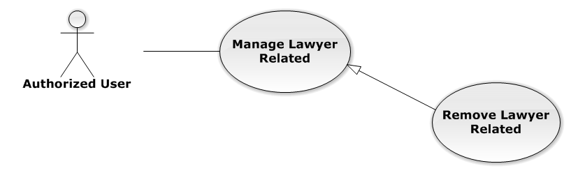

Figure 31: Remove Lawyer Related Use-Case Diagram

Use-Case Specification

|  |  |  |  |
| --- | --- | --- | --- |
| USE-CASE SPECIFICATION | | | |
| Use-case No. | UC0024 | Use-case Version | 1.0 |
| Use-case Name | Remove Lawyer Related | | |
| Author | Đặng Nguyễn Khiêm | | |
| Date | 09/10/2014 | Priority | Normal |
| Actor:  Authorized User, who create the current Case  Summary:  Staff can remove Lawyer related in Case  Goal:  Helps Staff remove Lawyer related in Case  Triggers:  Staff click on delete icon in the end table list  Preconditions:   * Must be logged-in * The page is fully loaded * Must be in “Người liên quan” page * Click on edit icon beside “Luật sư phụ trách” label before   Post Conditions:  Success:   * Remove the Lawyer out of current Case * Show message remove successfully: “Loại bỏ luật sư thành công!”   Failure: System display error message “Loại bỏ luật sư thất bại!”  Main Success Scenario:   |  |  |  | | --- | --- | --- | | *Step* | *User* | *System* | | 1 | Click on edit icon beside “Luật sư phụ trách” label | Icon delete is display | | 2 | Click on icon delete corresponding with Lawyer want to remove | Show a modal popup to confirm | | 3 | Click on “Xác nhận” button  [Alternative 1] | System display message “Loại bỏ luật sư thành công!” |   Alternative Scenario:   |  |  |  | | --- | --- | --- | | *#* | *User* | *System* | | 1 | Click on “Bỏ qua” button | Modal popup is close and system do not remove the Lawyer |   Exceptions:  N/A  Relationships:  Manage Lawyer Related  Business Rules:  Only Administrator or Authorized User, who create the current Case can be use this function when status of case is “Đang thụ lý” and Office that have current case must is active. | | | |

UC0025 - Search Lawyer Related

Use-Case Diagram

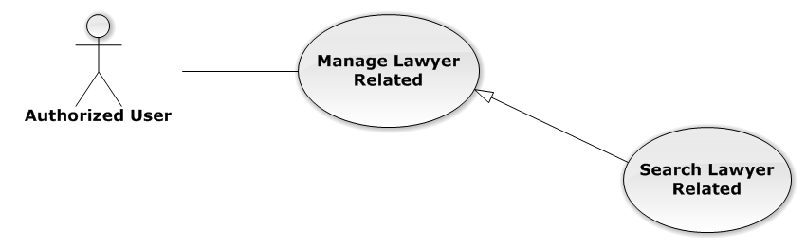

Figure 32: Search Lawyer Related Use-Case Diagram

Use-Case Specification

|  |  |  |  |
| --- | --- | --- | --- |
| USE-CASE SPECIFICATION | | | |
| Use-case No. | UC0025 | Use-case Version | 1.0 |
| Use-case Name | Search Lawyer Related | | |
| Author | Đặng Nguyễn Khiêm | | |
| Date | 09/10/2014 | Priority | Normal |
| Actor:  Authorized User, who create the current Case  Summary:  Staff can search Lawyer for assign into Case  Goal:  Helps Staff can assign Lawyer easily  Triggers:  Staff input key word is StaffName or Username of Lawyer. When the key up, system will be automatic search.  Preconditions:   * Must be logged-in * The page is fully loaded * Must be in “Người liên quan” page * Click on edit icon beside “Luật sư phụ trách” label before   Post Conditions:  Success: The lawyer has been choose in search form by StaffName or Username  Failure: Do nothing  Main Success Scenario:   |  |  |  | | --- | --- | --- | | *Step* | *User* | *System* | | 1 | Click on edit icon beside “Luật sư phụ trách” label | Search form is display | | 2 | Input key words into search form and then key up | Display lawyers matches key words by StaffName and Username | | 3 | Click on result have lawyer want to assign  [Alternative 1] | The lawyer has been choose, wait for assign |   Alternative Scenario:   |  |  |  | | --- | --- | --- | | *#* | *User* | *System* | | 1 | Click out of result list | Result list is clear |   Exceptions:  N/A  Relationships:  Manage Lawyer Related  Business Rules:  Only Administrator or Authorized User, who create the current Case can be use this function when status of case is “Đang thụ lý” and Office that have current case must is active. | | | |

###### Manage Customer Related

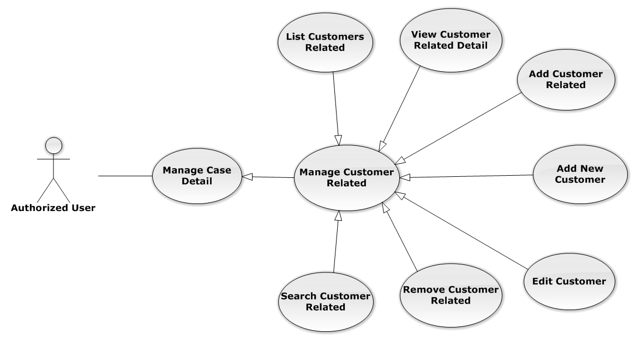

Figure 33: Manage Customer Related Use-Case Diagram

UC0026 - List Customers Related

Use-Case Diagram

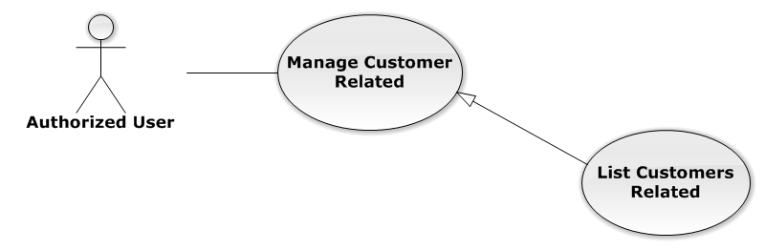

Figure 34: List Customers Related Use-Case Diagram

Use-Case Specification

|  |  |  |  |
| --- | --- | --- | --- |
| USE-CASE SPECIFICATION | | | |
| Use-case No. | UC0026 | Use-case Version | 1.0 |
| Use-case Name | List Customers Related | | |
| Author | Đặng Nguyễn Khiêm | | |
| Date | 09/10/2014 | Priority | Normal |
| Actor:  Authorized User  Summary:  List all Customers of current case, each case can have one or more customers  Goal:  Help to view all Customers related  Triggers:  User click on “Khách hàng” link at right top page  Preconditions:   * Must be logged-in * The page is fully loaded * Must be in “Người liên quan” page   Post Conditions:  Success: Show all Customers of current case in table  Failure: Do nothing  Main Success Scenario:   |  |  |  | | --- | --- | --- | | *Step* | *User* | *System* | | 1 | Click on “Khách hàng” link | Show all Customers of current case in table line by line |   Alternative Scenario:  N/A  Exceptions:  N/A  Relationships:  Manage Customer Related  Business Rules:  N/A | | | |

UC0027 - View Customer Related Detail

Use-Case Diagram

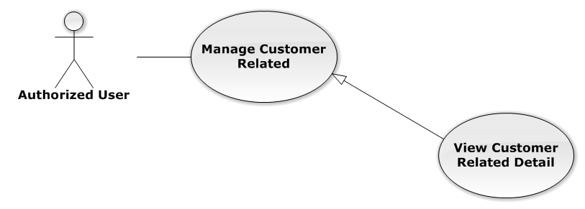

Figure 35: View Customer Related Detail Use-Case Diagram

Use-Case Specification

|  |  |  |  |
| --- | --- | --- | --- |
| USE-CASE SPECIFICATION | | | |
| Use-case No. | UC0027 | Use-case Version | 1.0 |
| Use-case Name | View Customer Related Detail | | |
| Author | Đặng Nguyễn Khiêm | | |
| Date | 09/10/2014 | Priority | Normal |
| Actor:  Authorized User  Summary:  Staff can view Customer related information  Goal:  Helps staff to view Customer related information  Triggers:  Staff click on “Họ và tên” link  Preconditions:   * Must be logged-in * The page is fully loaded * Must be in “Khách hàng” page   Post Conditions:  Success: The popup modal have customer information is displayed  Failure: Do nothing  Main Success Scenario:   |  |  |  | | --- | --- | --- | | *Step* | *User* | *System* | | 1 | Staff click on “Họ và tên” link | The popup modal have customer information is displayed  [Alternative 1] |   Alternative Scenario:   |  |  |  | | --- | --- | --- | | *#* | *User* | *System* | | 1 | Click on [X] button, “Đóng” button, or click out of modal | Modal popup is close |   Exceptions:  N/A  Relationships:  Manage Customer Related  Business Rules:  N/A | | | |

UC0028 - Add Customer Related

Use-Case Diagram

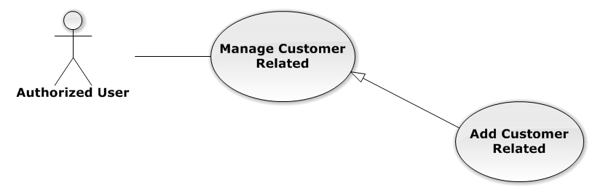

Figure 36: Add Customer Related Use-Case Diagram

Use-Case Specification

|  |  |  |  |
| --- | --- | --- | --- |
| USE-CASE SPECIFICATION | | | |
| Use-case No. | UC0028 | Use-case Version | 1.0 |
| Use-case Name | Add Customer Related | | |
| Author | Đặng Nguyễn Khiêm | | |
| Date | 09/10/2014 | Priority | Normal |
| Actor:  Authorized User, who is assigned in current case  Summary:  Staff can add a available customer on Database into Case  Goal:  Helps Staff add a available customer into Case  Triggers:  Staff click on “Thêm vào danh sách” button after choose Customer in search form beside  Preconditions:   * Must be logged-in * The page is fully loaded * Must be in “Khách hàng” page * Click on edit icon beside “Khách hàng” label and used Search Customer Related function before   Post Conditions:  Success:   * Add a customer into Case * Show message assign successfully: “Thêm khách hàng thành công!”   Failure: System display error message “Thêm khách hàng thất bại!”  Main Success Scenario:   |  |  |  | | --- | --- | --- | | *Step* | *User* | *System* | | 1 | Click on edit icon beside “Khách hàng” label | Search form, “Thêm vào danh sách” and “Hoàn thành” button is display | | 2 | After search and choose a Customer, Staff click on “Thêm vào danh sách” button  [Alternative 1]  [Exception 1]  [Exception 2] | System display message “Thêm khách hàng thành công!” |   Alternative Scenario:   |  |  |  | | --- | --- | --- | | *#* | *User* | *System* | | 1 | Click on “Hoàn thành” button | Search form, “Thêm vào danh sách” and “Hoàn thành” button is hidden |   Exceptions:   |  |  |  | | --- | --- | --- | | *#* | *User* | *System* | | 1 | Not search customer then click on “Thêm vào danh sách” button | Display validation message for needed to search lawyer before: “Hãy chọn 1 khách hàng!” | | 2 | Customer is exist in list customer related | Display message “Đã tồn tại khách hàng!” |   Relationships:  Manage Customer Related  Business Rules:  Only Administrator or Authorized User is assigned in current case can be use this function when status of case is “Đang thụ lý” and Office that have current case must is active. | | | |

Add New Customer

Reference to Add New Customer function in Manage Customer

Edit Customer

Reference to Edit Customer function in Manage Customer

UC0029 - Remove Customer Related

Use-Case Diagram

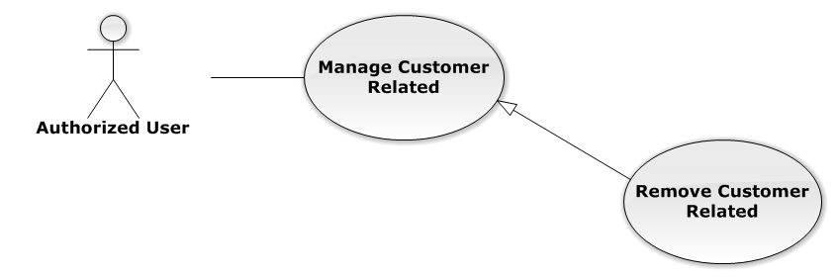

Figure 37: Remove Customer Related Use-Case Diagram

Use-Case Specification

|  |  |  |  |
| --- | --- | --- | --- |
| USE-CASE SPECIFICATION | | | |
| Use-case No. | UC0029 | Use-case Version | 1.0 |
| Use-case Name | Remove Customer Related | | |
| Author | Đặng Nguyễn Khiêm | | |
| Date | 09/10/2014 | Priority | Normal |
| Actor:  Authorized User, who is assigned in current case  Summary:  Staff can remove Customer related in Case  Goal:  Helps Staff remove Customer related in Case  Triggers:  Staff click on delete icon in the end table list  Preconditions:   * Must be logged-in * The page is fully loaded * Must be in “Khách hàng” page * Click on edit icon beside “Khách hàng” label before   Post Conditions:  Success:   * Remove the Customer out of current Case * Show message remove successfully: “Loại bỏ khách hàng thành công!”   Failure: System display error message “Loại bỏ khách hàng thất bại!”  Main Success Scenario:   |  |  |  | | --- | --- | --- | | *Step* | *User* | *System* | | 1 | Click on edit icon beside “Khách hàng” label | Icon delete is display | | 2 | Click on icon delete corresponding with Customer want to remove | Show a modal popup to confirm | | 3 | Click on “Xác nhận” button  [Alternative 1] | System display message “Loại bỏ khách hàng thành công!” |   Alternative Scenario:   |  |  |  | | --- | --- | --- | | *#* | *User* | *System* | | 1 | Click on “Bỏ qua” button | Modal popup is close and system do not remove the Customer |   Exceptions:  N/A  Relationships:  Manage Customer Related  Business Rules:  Only Administrator or Authorized User is assigned in current case can be use this function when status of case is “Đang thụ lý” and Office that have current case must is active. | | | |

UC0030 - Search Customer Related

Use-Case Diagram

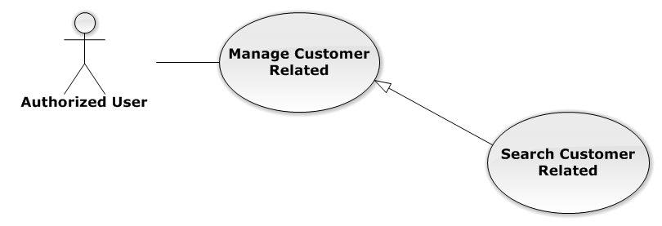

Figure 38: Search Customer Related Use-Case Diagram

Use-Case Specification

|  |  |  |  |
| --- | --- | --- | --- |
| USE-CASE SPECIFICATION | | | |
| Use-case No. | UC0030 | Use-case Version | 1.0 |
| Use-case Name | Search Customer Related | | |
| Author | Đặng Nguyễn Khiêm | | |
| Date | 09/10/2014 | Priority | Normal |
| Actor:  Authorized User, who is assigned in current case  Summary:  Staff can search Customer for add customer related  Goal:  Helps Staff can search Customer easily  Triggers:  Staff input key word is CustomerName or Address of Customer. When the key up, system will be automatic search after 500ms delay time.  Preconditions:   * Must be logged-in * The page is fully loaded * Must be in “Khách hàng” page * Click on edit icon beside “Khách hàng” label before   Post Conditions:  Success: The customer has been choose in search form by CustomerName or Address  Failure: Do nothing  Main Success Scenario:   |  |  |  | | --- | --- | --- | | *Step* | *User* | *System* | | 1 | Click on edit icon beside “Khách hàng” label | Search form is display | | 2 | Input key words into search form and then key up | Display customers matches key words by CustomerName or Address | | 3 | Click on result have customer want to add  [Alternative 1] | The customer has been choose, wait for add |   Alternative Scenario:   |  |  |  | | --- | --- | --- | | *Step* | *User* | *System* | | 1 | Click out of result list | Result list is clear |   Exceptions:  N/A  Relationships:  Manage Customer Related  Business Rules:  Only Administrator or Authorized User is assigned in current case can be use this function when status of case is “Đang thụ lý” and Office that have current case must is active. | | | |

###### Manage Subject Related

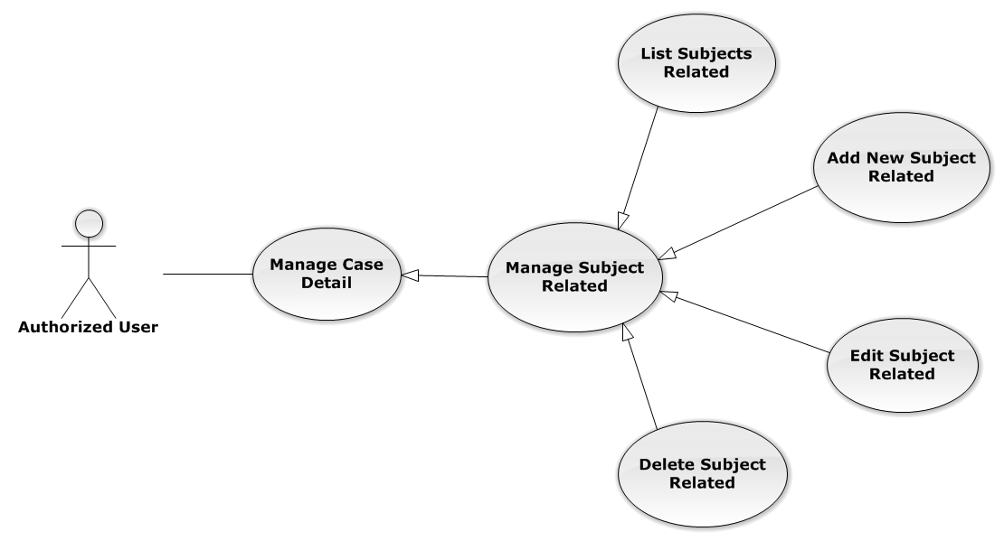

Figure 39: Manage Subject Related Use-Case Diagram

UC0031 - List Subjects Related

Use-Case Diagram

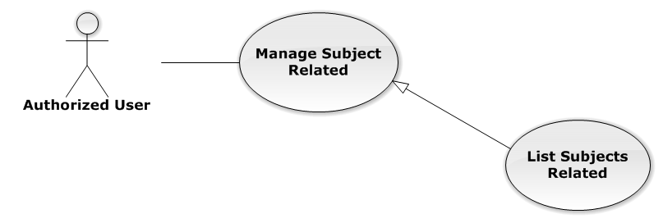

Figure 40: List Subjects Related Use-Case Diagram

Use-Case Specification

|  |  |  |  |
| --- | --- | --- | --- |
| USE-CASE SPECIFICATION | | | |
| Use-case No. | UC0031 | Use-case Version | 1.0 |
| Use-case Name | List Subjects Related | | |
| Author | Đặng Nguyễn Khiêm | | |
| Date | 09/10/2014 | Priority | Normal |
| Actor:  Authorized User  Summary:  List all Subjects of current case, each case can have one or more subjects  Goal:  Help to view all Subject related  Triggers:  User click on “Chủ thể” link at right top page  Preconditions:   * Must be logged-in * The page is fully loaded * Must be in “Người liên quan” page   Post Conditions:  Success: Show all Subjects of current case in table  Failure: Do nothing  Main Success Scenario:   |  |  |  | | --- | --- | --- | | *Step* | *User* | *System* | | 1 | Click on “Chủ thể” link | Show all Subjects of current case in table line by line |   Alternative Scenario:  N/A  Exceptions:  N/A  Relationships:  Manage Subject Related  Business Rules:  N/A | | | |

UC0032 - Add New Subject Related

Use-Case Diagram

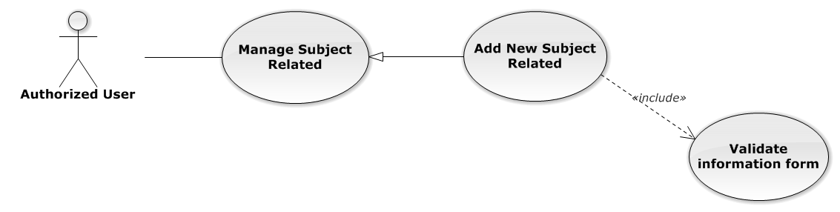

Figure 41: Add New Subject Related Use-Case Diagram

Use-Case Specification

|  |  |  |  |
| --- | --- | --- | --- |
| USE-CASE SPECIFICATION | | | |
| Use-case No. | UC0032 | Use-case Version | 1.0 |
| Use-case Name | Add New Subject Related | | |
| Author | Đặng Nguyễn Khiêm | | |
| Date | 09/10/2014 | Priority | Normal |
| Actor:  Authorized User, who is assigned in current case  Summary:  Staff can create new a subject related into case  Goal:  Helps Staff create new a subject easily  Triggers:  Staff click on “Tạo chủ thể” button at the bottom of table  Preconditions:   * Must be logged-in * The page is fully loaded * Must be in “Chủ thể” page * Click on edit icon beside “Chủ thể liên quan” label before   Post Conditions:  Success:   * Add new a subject into Case * Show message assign successfully: “Thêm chủ thể thành công!”   Failure: System display error message “Thêm chủ thể thất bại!”  Main Success Scenario:   |  |  |  | | --- | --- | --- | | *Step* | *User* | *System* | | 1 | Click on edit icon beside “Chủ thể liên quan” label | “Thêm chủ thể mới” button is display | | 2 | Staff click on “Tạo chủ thể” button | Modal popup is displayed with fields for input information of new subject  [Alternative 1] | | 3 | Input corresponding information in form then click “Thêm mới” button  [Exception 1] | * Modal popup is close * System display successful message “Thêm chủ thể thành công!” * Update list subject on page |   Alternative Scenario:   |  |  |  | | --- | --- | --- | | *#* | *User* | *System* | | 1 | Click on [X] button, “Đóng” button, or click out of modal | Modal popup is close |   Exceptions:   |  |  |  | | --- | --- | --- | | *#* | *User* | *System* | | 1 | Leave empty require fields then click on “Thêm mới” button | Modal popup display validation for needed to input field |   Relationships:  Manage Subject Related  Business Rules:   * Only Administrator or Authorized User is assigned in current case can be use this function when status of case is “Đang thụ lý” and Office that have current case must is active. * After create subject successfully, system will be automatically add new subject into that case | | | |

UC0033 - Edit Subject Related

Use-Case Diagram

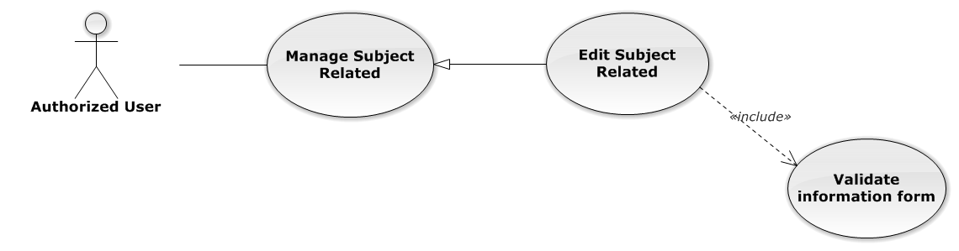

Figure 42: Edit Subject Related Use-Case Diagram

Use-Case Specification

|  |  |  |  |
| --- | --- | --- | --- |
| USE-CASE SPECIFICATION | | | |
| Use-case No. | UC0033 | Use-case Version | 1.0 |
| Use-case Name | Edit Subject Related | | |
| Author | Đặng Nguyễn Khiêm | | |
| Date | 09/10/2014 | Priority | Normal |
| Actor:  Authorized User, who is assigned in current case  Summary:  Staff can edit a available subject related  Goal:  Helps Staff edit a available subject information  Triggers:  Staff click on edit icon at the right table  Preconditions:   * Must be logged-in * The page is fully loaded * Must be in “Chủ thể” page * Click on edit icon beside “Chủ thể liên quan” label before   Post Conditions:  Success:   * Edit a subject information * Show message assign successfully: “Cập nhật chủ thể thành công!”   Failure: System display error message “Cập nhật chủ thể thất bại!”  Main Success Scenario:   |  |  |  | | --- | --- | --- | | *Step* | *User* | *System* | | 1 | Click on edit icon beside “Chủ thể liên quan” label | The icon to edit subject is display | | 2 | Staff click on edit icon | Modal popup is displayed with fields for input new information of subject  [Alternative 1] | | 3 | Input corresponding information in form then click “Lưu chỉnh sửa” button  [Exception 1] | * Modal popup is close * System display successful message “Cập nhật chủ thể thành công!” * Update list subject on page |   Alternative Scenario:   |  |  |  | | --- | --- | --- | | *#* | *User* | *System* | | 1 | Click on [X] button, “Đóng” button, or click out of modal | Modal popup is close |   Exceptions:   |  |  |  | | --- | --- | --- | | *#* | *User* | *System* | | 1 | Leave empty require fields then click on “Lưu chỉnh sửa” button | Modal popup display validation for needed to input field |   Relationships:  Manage Subject Related  Business Rules:  Only Administrator or Authorized User is assigned in current case can be use this function when status of case is “Đang thụ lý” and Office that have current case must is active. | | | |

UC0034 - Delete Subject Related

Use-Case Diagram

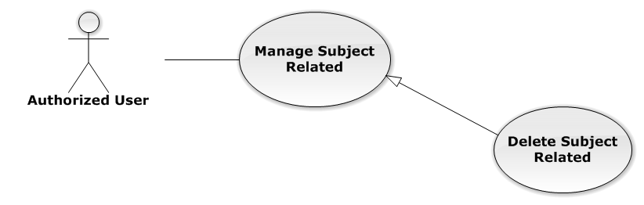

Figure 43: Delete Subject Related Use-Case Diagram

Use-Case Specification

|  |  |  |  |
| --- | --- | --- | --- |
| USE-CASE SPECIFICATION | | | |
| Use-case No. | UC0034 | Use-case Version | 1.0 |
| Use-case Name | Delete Subject Related | | |
| Author | Đặng Nguyễn Khiêm | | |
| Date | 09/10/2014 | Priority | Normal |
| Actor:  Authorized User, who is assigned in current case  Summary:  Staff can delete Subject related in Case  Goal:  Helps Staff delete Subject related  Triggers:  Staff click on delete icon in the end table list  Preconditions:   * Must be logged-in * The page is fully loaded * Must be in “Chủ thể” page * Click on edit icon beside “Chủ thể liên quan” label before   Post Conditions:  Success:   * Delete the subject out of current Case * Show message remove successfully: “Xóa chủ thể thành công!”   Failure: System display error message “Xóa chủ thể hàng thất bại!”  Main Success Scenario:   |  |  |  | | --- | --- | --- | | *Step* | *User* | *System* | | 1 | Click on edit icon beside “Chủ thể liên quan” label | Icon delete is display | | 2 | Click on icon delete corresponding with Subject want to delete | Show a modal popup to confirm | | 3 | Click on “Xác nhận” button  [Alternative 1] | System display message “Xóa chủ thể thành công!” |   Alternative Scenario:   |  |  |  | | --- | --- | --- | | *#* | *User* | *System* | | 1 | Click on “Bỏ qua” button | Modal popup is close and system do not remove the Subject |   Exceptions:  N/A  Relationships:  Manage Subject Related  Business Rules:  Only Administrator or Authorized User is assigned in current case can be use this function when status of case is “Đang thụ lý” and Office that have current case must is active. | | | |

###### Manage Document Related

Reference to DVD: <root>/Documents/LFMS Project Document - Full Report.docx

###### Manage Used Service

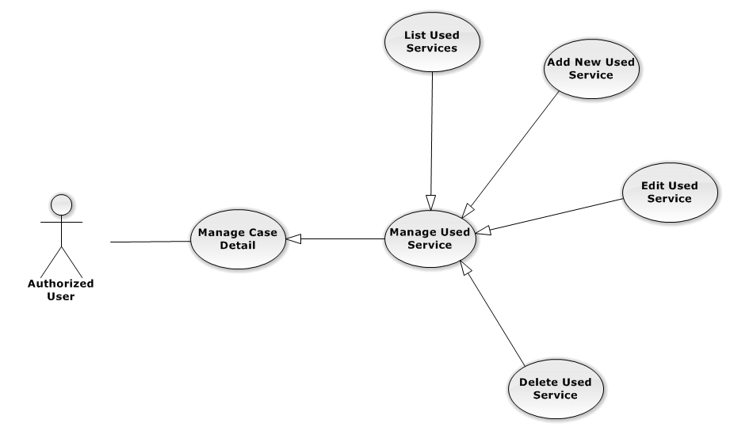

Figure 44: Manage Used Service Use-Case Diagram

UC0035 - List Used Services

Use-Case Diagram

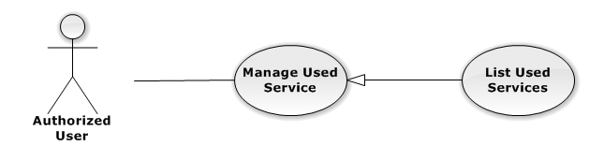

Figure 45: List Used Services Use-Case Diagram

Use-Case Specification

|  |  |  |  |
| --- | --- | --- | --- |
| USE-CASE SPECIFICATION | | | |
| Use-case No. | UC0035 | Use-case Version | 1.0 |
| Use-case Name | List Used Services | | |
| Author | Đặng Nguyễn Khiêm | | |
| Date | 09/10/2014 | Priority | Normal |
| Actor:  Authorized User  Summary:  Show all Used Service of case.  Goal:  Help staff to view all Used Service of case.  Triggers:  User click on “Hóa đơn” link in Case Detail page  Preconditions:   * Must be logged-in * The page is fully loaded * Must be in Case Detail page   Post Conditions:  Success:   * List all Used Service in current case include company name and customer name. * Display total money of list Used Service   Failure: Do nothing  Main Success Scenario:   |  |  |  | | --- | --- | --- | | *Step* | *User* | *System* | | 1 | Click on “Hóa đơn” link | Show all Used Service in current case |   Alternative Scenario:  N/A  Exceptions:  N/A  Relationships:  Manage Used Service  Business Rules:  In the end of Used Service table have fill name “Tổng chi phí” display total money of all Used Service.  In the end of table have fill name “Chưa Thanh Toán” display total money of all Used Service. | | | |

UC0036 - Add New Used Service

Use-Case Diagram

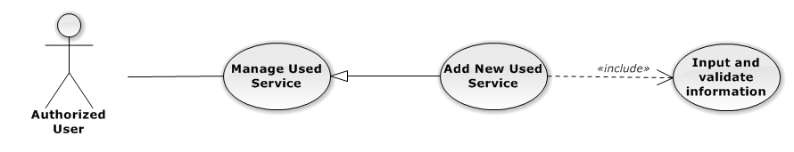

Figure 46: Add New Used Service Use-Case Diagram

Use-Case Specification

|  |  |  |  |
| --- | --- | --- | --- |
| USE-CASE SPECIFICATION | | | |
| Use-case No. | UC0036 | Use-case Version | 1.0 |
| Use-case Name | Add New Used Service | | |
| Author | Đặng Nguyễn Khiêm | | |
| Date | 09/10/2014 | Priority | Normal |
| Actor:  Authorized User, who is assigned in current case  Summary:  Staff can add new Used Service into Case  Goal:  Helps Staff create event into Case  Triggers:   * Staff click on “Hóa đơn” link in Case Detail page * Click on edit icon beside “Chi phí dịch vụ” button * Click on “Thêm dịch vụ” button to add new Used Service to current case.   Preconditions:   * Must be logged-in * The page is fully loaded * Must be in Used Service page * Click on edit icon beside “Chi phí dịch vụ” label before   Post Conditions:  Success:   * At new Used Service into current Case * Calculation and display the total money of Used Service to “Tổng Chi Phí” field and “Chưa Thanh Toán” fileld. * Show message successfully: “Thêm dịch vụ thành công!”   Failure: System display error message “Thêm dịch vụ thất bại!", "hãy kiểm tra lại kết nối database!”  Main Success Scenario:   |  |  |  | | --- | --- | --- | | *Step* | *User* | *System* | | 1 | Click on edit icon beside “Chi phí dịch vụ” label, click “Thêm dịch vụ” button | Pop-up input is display.  With two button “Đóng” and “Tạo dịch vụ” is display | | 2 | Input information into fields and click button “Tạo mới”  button  [Alternative 1], [Exception 1], [Exception 2] | System display message “Thêm dịch vụ thành công!” |   Alternative Scenario:   |  |  |  | | --- | --- | --- | | *#* | *User* | *System* | | 1 | Click on “Đóng” button | Input form close back to list all Used Service screen. |   Exceptions:   |  |  |  | | --- | --- | --- | | *#* | *User* | *System* | | 1 | Field “Loại Dịch Vụ”, are blank | Shows error message “Nhập vào tên dịch vụ!”. | | Field “Tên Dịch Vụ”, are blank | Shows error message “Chọn dịch vụ!”. | | Field “Chi Phí”, are blank | Shows error message “Nhập chi phí!”. | | Field “Nội dung”, are blank | Shows error message “Nhập nội dung!”. | | 2 | System cannot insert Used Service to data base. | Shows error message “Thêm thanh toán thất bại!", "Hãy kiểm tra lại kết nối database” |   Relationships:  Manage Used Service  Business Rules:  Only Administrator or Authorized User is assigned in current case can be use this function when status of case is “Đang thụ lý” and Office that have current case must is active. | | | |

UC0037 - Edit Used Service

Use-Case Diagram

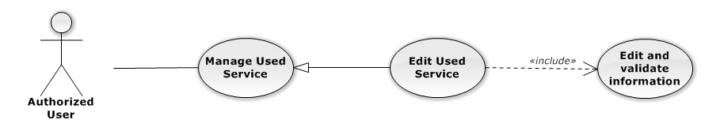

Figure 47: Edit Used Service Use-Case Diagram

Use-Case Specification

|  |  |  |  |
| --- | --- | --- | --- |
| USE-CASE SPECIFICATION | | | |
| Use-case No. | UC0037 | Use-case Version | 1.0 |
| Use-case Name | Edit Used Service | | |
| Author | Đặng Nguyễn Khiêm | | |
| Date | 09/10/2014 | Priority | Normal |
| Actor:  Authorized User, who is assigned in current case  Summary:  Staff can update Used Service into Case  Goal:  Helps Staff update Used Service into Case  Triggers:   * Staff click on “Hóa đơn” link in Case Detail page * Click on edit icon beside “Chi phí dịch vụ” button * Click on “Edit” button to update event.   Preconditions:   * Must be logged-in * The page is fully loaded * Must be in Used Service page * Click on edit icon beside “Chi phí dịch vụ” label before   Post Conditions:  Success:   * Update Used Service into current Case * Show message successfully: “Sửa dịch vụ thành công!” * Calculation and display the total money of Used Service to “Tổng Chi Phí” field and “Chưa Thanh Toán” fileld   Failure: System display error message “Sửa dịch vụ thất bại!", "hãy kiểm tra lại kết nối database!”  Main Success Scenario:   |  |  |  | | --- | --- | --- | | *Step* | *User* | *System* | | 1 | Click on edit icon beside “Chi phí dịch vụ” label | List all Used Service in current case, “Edit” and “Delete” icon is display, “Thêm dịch vụ” and “Hoàn thành” button is display | | 2 | Click on the “Edit” button | Pop-up “Sửa chi phí” is display load detail of 1 Used Service, “Đóng” and “Sửa chi phí” button is display | | 3 | Edit information into fields and click button “Sửa chi phí” button  [Alternative 1], [Exception 1], [Exception 2] | System display message “Sửa dịch vụ thành công!” |   Alternative Scenario:   |  |  |  | | --- | --- | --- | | *#* | *User* | *System* | | 1 | Click on “Đóng” button | Input form close back to list all event screen. |   Exceptions:   |  |  |  | | --- | --- | --- | | *#* | *User* | *System* | | 1 | Field “Chi Phí”, are blank | Shows error message “Nhập chi phí!”. | | Field “Nội dung”, are blank | Shows error message “Nhập nội dung!”. | | 2 | System cannot insert event to data base. | Shows error message “Sửa dịch vụ thất bại!", "Hãy kiểm tra lại kết nối database”. |   Relationships:  Manage Used Service  Business Rules:  Only Administrator or Authorized User is assigned in current case can be use this function when status of case is “Đang thụ lý” and Office that have current case must is active. | | | |

UC0038 - Delete Used Service

Use-Case Diagram

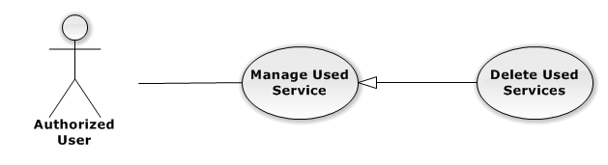

Figure 48: Delete Used Service Use-Case Diagram

Use-Case Specification

|  |  |  |  |
| --- | --- | --- | --- |
| USE-CASE SPECIFICATION | | | |
| Use-case No. | UC0038 | Use-case Version | 1.0 |
| Use-case Name | Delete Used Service | | |
| Author | Đặng Nguyễn Khiêm | | |
| Date | 09/10/2014 | Priority | Normal |
| Actor:  Authorized User, who is assigned in current case  Summary:  Staff can remove Used Service in Case  Goal:  Helps Staff remove Used Service in Case  Triggers:  Staff click on delete icon in the end table list  Preconditions:   * Must be logged-in * The page is fully loaded * Must be in Lawyer related page * Click on edit icon beside “Chi phí dịch vụ” label before   Post Conditions:  Success:   * Remove the Event out of current Case * Show message remove successfully: “Xóa dịch vụ thành công!” * Calculation and display the total money of Used Service to “Tổng Chi Phí” field and “Chưa Thanh Toán” fileld   Failure: System display error message “Xóa dịch vụ thất bại!", "Hãy kiểm tra lại kết nối database”  Main Success Scenario:   |  |  |  | | --- | --- | --- | | *Step* | *User* | *System* | | 1 | Click on edit icon beside “Chi phí dịch vụ” label | Icon delete is display | | 2 | Click on icon delete corresponding with Used Service want to remove | Show a modal popup to confirm | | 3 | Click on “Xác nhận” button  [Alternative 1] | System display message “Xóa dịch vụ thành công!” |   Alternative Scenario:   |  |  |  | | --- | --- | --- | | *#* | *User* | *System* | | 1 | Click on “Bỏ qua” button | Modal popup is close and system do not remove the Event |   Exceptions:  N/A  Relationships:  Manage Used Service  Business Rules:  Only Administrator or Authorized User is assigned in current case can be use this function when status of case is “Đang thụ lý” and Office that have current case must is active. | | | |

###### Manage Payment

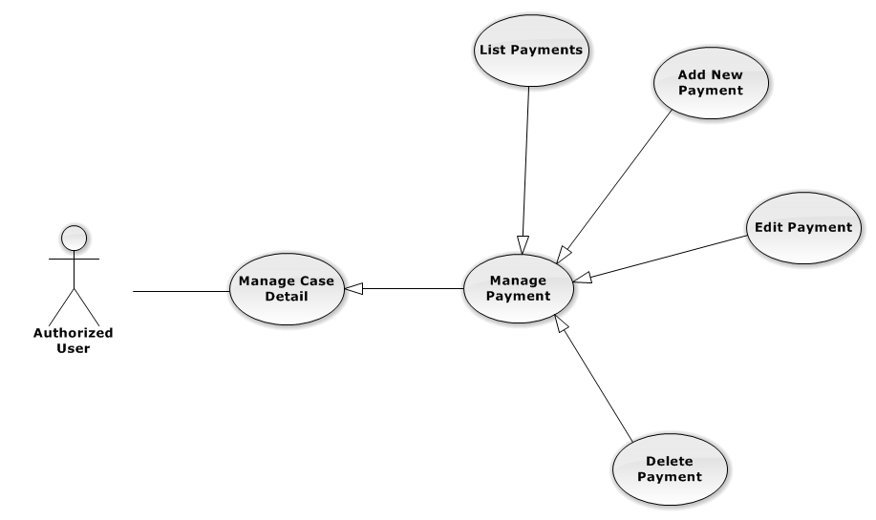

Figure 49: Manage Payment Use-Case Diagram

UC0039 - List Payments

Use-Case Diagram

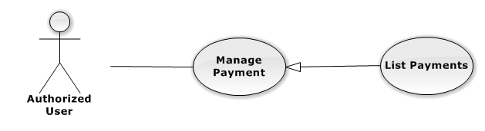

Figure 50: List Payments Use-Case Diagram

Use-Case Specification

|  |  |  |  |
| --- | --- | --- | --- |
| USE-CASE SPECIFICATION | | | |
| Use-case No. | UC0039 | Use-case Version | 1.0 |
| Use-case Name | List Payments | | |
| Author | Đặng Nguyễn Khiêm | | |
| Date | 09/10/2014 | Priority | Normal |
| Actor:  Authorized User  Summary:  Show all payment of case.  Goal:  Help staff to view all payment of case.  Triggers:  User click on “Hóa đơn” link in Case Detail page  Preconditions:   * Must be logged-in * The page is fully loaded * Must be in Case Detail page   Post Conditions:  Success:   * List all payment in current case include * Display total money of list payment.   Failure: Do nothing  Main Success Scenario:   |  |  |  | | --- | --- | --- | | *Step* | *User* | *System* | | 1 | Click on “Hóa đơn” link [Alternative 1], [Alternative 2] | Show all payment in current case |   Alternative Scenario:   |  |  |  | | --- | --- | --- | | *#* | *User* | *System* | | 1 | If total Payment > total Used Services | Display total money Unpaid in field “Số dư” | | 2 | If total Payment < total Used Services | Display total money balance in field “Chưa thanh toán” |   Exceptions:  N/A  Relationships:  Manage Payment  Business Rules:  In the end of Used Service table have fill name “Tổng chi phí” display total money of all Used Service. | | | |

UC0040 - Add New Payment

Use-Case Diagram

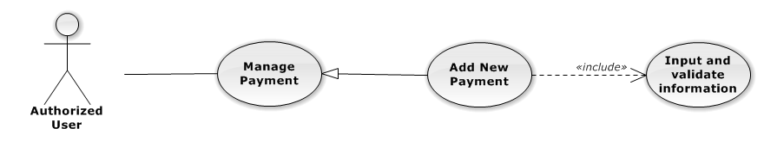

Figure 51: Add New Payment Use-Case Diagram

Use-Case Specification

|  |  |  |  |
| --- | --- | --- | --- |
| USE-CASE SPECIFICATION | | | |
| Use-case No. | UC0040 | Use-case Version | 1.0 |
| Use-case Name | Add New Payment | | |
| Author | Đặng Nguyễn Khiêm | | |
| Date | 09/10/2014 | Priority | High |
| Actor:  Authorized User, who is assigned in current case  Summary:  Staff can add new payment into Case  Goal:  Helps Staff create payment into Case  Triggers:   * Staff click on “Hóa đơn” link in Case Detail page * Click on edit icon beside “Hóa đơn thanh toán” button * Click on “Thêm thanh toán button to add new payment to current case.   Preconditions:   * Must be logged-in * The page is fully loaded * Must be in payment page * Click on edit icon beside “Hóa đơn thanh toán” label before   Post Conditions:  Success:   * At new Used Service into current Case * Calculation and display the total money of Payment and display total of money unpaid or balancein field “Chưa thanh toán” , “Số dư”. * Show message successfully: “Thêm thanh toán thành công!”   Failure: System display error message “Thêm thanh toán thất bại!", "hãy kiểm tra lại kết nối database!”  Main Success Scenario:   |  |  |  | | --- | --- | --- | | *Step* | *User* | *System* | | 1 | Click on edit icon beside “Hóa đơn thanh toán” label, click “Thêm thanh toán” button | Pop-up input is display. | | 2 | Input information into fields and click button “Tạo thanh toán” button  [Alternative 1], [Exception 1], [Exception 2] | System display message “Thêm thanh toán thành công!” |   Alternative Scenario:   |  |  |  | | --- | --- | --- | | *#* | *User* | *System* | | 1 | Click on “Đóng” button | Input form close back to list all Used Service screen. |   Exceptions:   |  |  |  | | --- | --- | --- | | *#* | *User* | *System* | | 1 | Field “Thanh Toán”, are blank | Shows error message “Nhập số tiền thanh toán!”. | | Field “Nội dung”, are blank | Shows error message “Nhập nội dung!”. | | 2 | System cannot insert payment to data base. | Shows error message “Thêm thanh toán thất bại!", "Hãy kiểm tra lại kết nối database” |   Relationships:  Manage Payment  Business Rules:  Only Administrator or Authorized User is assigned in current case can be use this function when status of case is “Đang thụ lý” and Office that have current case must is active. | | | |

UC0041 - Edit Payment

Use-Case Diagram

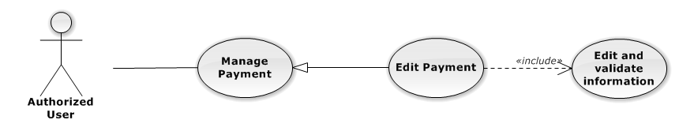

Figure 52: Edit Payment Use-Case Diagram

Use-Case Specification

|  |  |  |  |
| --- | --- | --- | --- |
| USE-CASE SPECIFICATION | | | |
| Use-case No. | UC0041 | Use-case Version | 1.0 |
| Use-case Name | Edit Payment | | |
| Author | Đặng Nguyễn Khiêm | | |
| Date | 09/10/2014 | Priority | Normal |
| Actor:  Authorized User, who is assigned in current case  Summary:  Staff can update payment service into Case  Goal:  Helps Staff update payment service into Case  Triggers:   * Staff click on “Hóa đơn” link in Case Detail page * Click on edit icon beside “Hóa đơn thanh toán” button * Click on “Edit” button to update event.   Preconditions:   * Must be logged-in * The page is fully loaded * Must be in Used Service page * Click on edit icon beside “Hóa đơn thanh toán” label before   Post Conditions:  Success:   * Update Used Service into current Case * Show message successfully: “Sửa thanh toán thành công!” * Calculation and display the total money of Payment and display total of money unpaid or balancein field “Chưa thanh toán” , “Số dư”.   Failure: System display error message “Sửa thanh toán thất bại!", "hãy kiểm tra lại kết nối database!”  Main Success Scenario:   |  |  |  | | --- | --- | --- | | *Step* | *User* | *System* | | 1 | Click on edit icon beside “Hóa đơn thanh toán” label | List all payment in current case, “Edit” and “Delete” icon is display, “Thêm dịch vụ” and “Hoàn thành” button is display | | 2 | Click on the “Edit” button | Pop-up “Sửa thanh toán” is display load detail of 1 Used Service, “Đóng” and “Sửa chi phí” button is display | | 3 | Edit information into fields and click button “Sửa thanh toán” button  [Alternative 1], [Exception 1] ,[Exception 2] | System display message “Sửa thanh toán thành công!” |   Alternative Scenario:   |  |  |  | | --- | --- | --- | | *#* | *User* | *System* | | 1 | Click on “Đóng” button | Input form close back to list all event screen. |   Exceptions:   |  |  |  | | --- | --- | --- | | *#* | *User* | *System* | | 1 | Field “Thanh Toán”, are blank | Shows error message “Nhập số tiền thanh toán!”. | | Field “Nội dung”, are blank | Shows error message “Nhập nội dung!”. | | 2 | System cannot insert event to data base. | Shows error message “Sửa thanh toán thất bại!", "Hãy kiểm tra lại kết nối database”. |   Relationships:  Manage Payment  Business Rules:  Only Administrator or Authorized User is assigned in current case can be use this function when status of case is “Đang thụ lý” and Office that have current case must is active. | | | |

UC0042 - Delete Payment

Use-Case Diagram

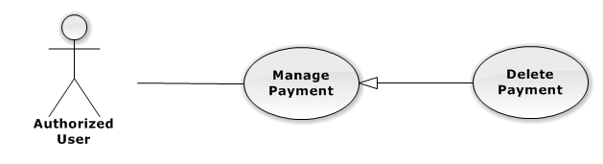

Figure 53: Delete Payment Use-Case Diagram

Use-Case Specification

|  |  |  |  |
| --- | --- | --- | --- |
| USE-CASE SPECIFICATION | | | |
| Use-case No. | UC0042 | Use-case Version | 1.0 |
| Use-case Name | Delete Payment | | |
| Author | Đặng Nguyễn Khiêm | | |
| Date | 09/10/2014 | Priority | Normal |
| Actor:  Authorized User, who is assigned in current case  Summary:  Staff can remove payment in Case  Goal:  Helps Staff remove payment in Case  Triggers:  Staff click on delete icon in the end table list  Preconditions:   * Must be logged-in * The page is fully loaded * Must be in Lawyer related page * Click on edit icon beside “Hóa đơn thanh toán” label before   Post Conditions:  Success:   * Remove the Event out of current Case * Show message remove successfully: “Xóa thanh toán thành công!” * Calculation and display the total money of payment   Failure: System display error message “Xóa thanh toán thất bại!", "Hãy kiểm tra lại kết nối database”  Main Success Scenario:   |  |  |  | | --- | --- | --- | | *Step* | *User* | *System* | | 1 | Click on edit icon beside “Chi phí dịch vụ” label | Icon delete is display | | 2 | Click on icon delete corresponding with Used Service want to remove | Show a modal popup to confirm | | 3 | Click on “Xác nhận” button  [Alternative 1] | System display message “Xóa thanh toán thành công!” |   Alternative Scenario:   |  |  |  | | --- | --- | --- | | *#* | *User* | *System* | | 1 | Click on “Bỏ qua” button | Modal popup is close and system do not remove the Event |   Exceptions:  N/A  Relationships:  Manage Payment  Business Rules:  Only Administrator or Authorized User is assigned in current case can be use this function when status of case is “Đang thụ lý” and Office that have current case must is active. | | | |

#### Manage Customer Group

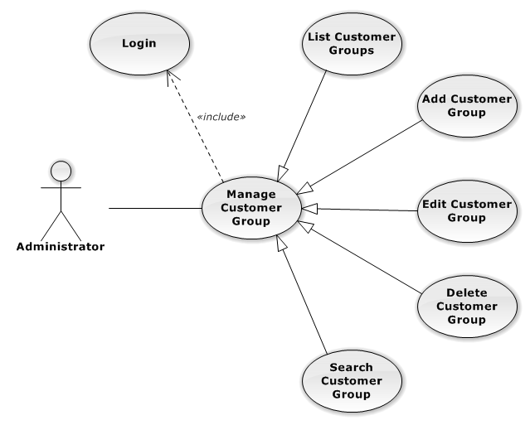

Figure 54: Manage Customer Group Use-Case Diagram

##### UC0043 - List Customer Groups

###### Use-Case Diagram

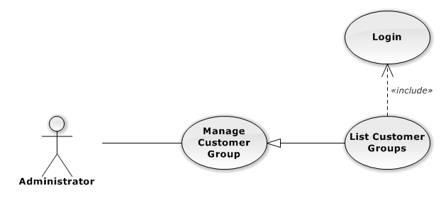

Figure 55: List Customer Groups Use-Case Diagram

###### List Customer Groups Use-Case Specification

|  |  |  |  |
| --- | --- | --- | --- |
| USE CASE SPECIFICATION | | | |
| Use-case No. | UC0043 | Use-case Version | 1.0 |
| Use-case Name | List Customer Groups | | |
| Author | Đặng Nguyễn Khiêm | | |
| Date | 09/10/2014 | Priority | Normal |
| Actor:  Administrator  Summary:  List All Customer Group.  Goal:  The purpose of List Customer Group use case is allowing Admin to view all Customer Groups.  Triggers:  User choose “Quản lý Nhóm Khách Hàng” in menu.  Preconditions:  User is authenticated and has role “admin”.  The page is fully loaded.  Post Conditions:  Success: All Customer Groups are listed.  Failure: N/A  Main Success Scenario:   |  |  |  | | --- | --- | --- | | *Step* | *User* | *System* | | 1 | Click “Quản lý Nhóm Khách Hàng” in menu. | All Customer Groups are loaded. |   Alternative Scenario:  N/A  Exceptions:  N/A  Relationships:  Manage Customer Group  Business Rules:  N/A | | | |

##### UC0044 - Add New Customer Group

###### Use-Case Diagram

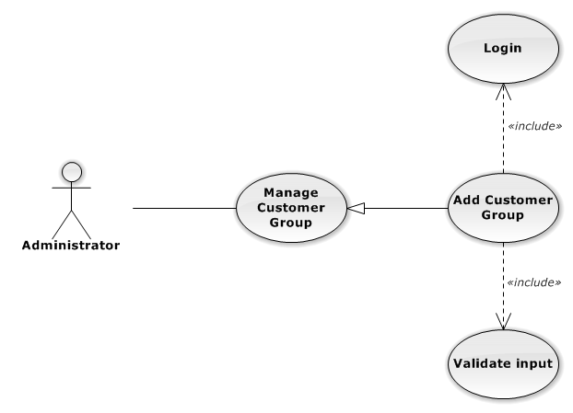

Figure 56: Add New Customer Group Use-Case Diagram

###### Use-Case Specification

|  |  |  |  |
| --- | --- | --- | --- |
| USE CASE SPECIFICATION | | | |
| Use-case No. | UC0044 | Use-case Version | 1.0 |
| Use-case Name | Add Customer Group | | |
| Author | Đặng Nguyễn Khiêm | | |
| Date | 09/10/2014 | Priority | Normal |
| Actor:  Administrator  Summary:  Add new Customer Group.  Goal:  The purpose of Add Customer Group use case is allowing Admin to add new Customer Group.  Triggers:  User choose “Quản lý Nhóm Khách Hàng” in menu.  Preconditions:  User is authenticated and has role “admin”.  Post Conditions:  Success: New Customer Group is created.  Failure: No Customer Group is created and Error message will be showed.  Main Success Scenario:   |  |  |  | | --- | --- | --- | | *Step* | *User* | *System* | | 1 | Click “Thêm Nhóm Khách Hàng” button. | Show add new customer group pop-up. | | 2 | Enters the Customer Group Name and Description |  | | 3 | Presses “Thêm Nhóm Khách Hàng” button.  [Alternative: 1] | Checks validate, add new Customer Group to database.  Show success message.  [Exception: 1]  [Exception: 2]  [Exception: 3] |   Alternative Scenario:   |  |  |  | | --- | --- | --- | | *#* | *User* | *System* | | 1 | Presses “Đóng”, “X” button or click outside pop-up. | The Add New Customer Group pop-up is close. |   Exceptions:   |  |  |  | | --- | --- | --- | | *#* | *User* | *System* | | 1 | Customer Group Name is missing. | Show error “Nhập tên nhóm khách hang” to user. | | 2 | Add Customer group fail. | The Add New Customer Group is closed and display error message “Tạo nhóm khách hàng thất bại!", "Hãy kiểm tra lại kết nối database." | | 3 | Add Customer group error. | The Add New Customer Group is closed and display error message "Tạo nhóm khách hàng thất bại!", "Có lỗi xảy ra trong quá trình tạo nhóm khách hàng." |   Relationships:  Manage Customer Group  Business Rules:  N/A | | | |

##### UC0045 - Edit Customer Group

###### Use-Case Diagram

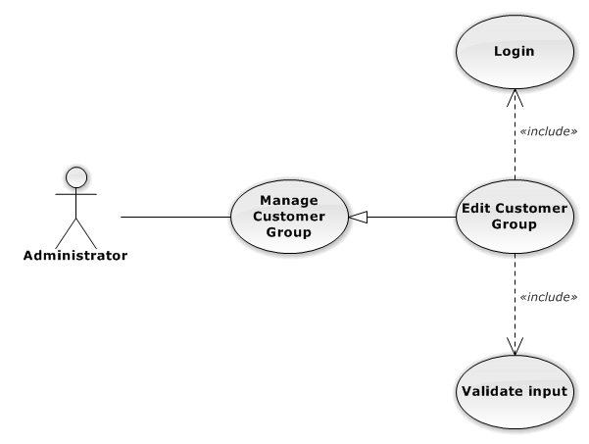

Figure 57: Edit Customer Group Use-Case Diagram

###### Use-Case Specification

|  |  |  |  |
| --- | --- | --- | --- |
| USE CASE SPECIFICATION | | | |
| Use-case No. | UC0045 | Use-case Version | 1.0 |
| Use-case Name | Delete Customer Group | | |
| Author | Đặng Nguyễn Khiêm | | |
| Date | 09/10/2014 | Priority | Normal |
| Actor:  Administrator  Summary:  Update Customer Group.  Goal:  The purpose of Update Customer Group use case is allowing Admin to update Customer Group.  Triggers:  User choose “Quản lý Nhóm Dịch Vụ” in menu.  Preconditions:  User is authenticated and has role “admin”.  Post Conditions:  Success: The Customer Group id Updated.  Failure: The Customer Group is not updated and Error message will be showed.  Main Success Scenario:   |  |  |  | | --- | --- | --- | | *Step* | *User* | *System* | | 1 | Click Update icon. |  | | 2 | Enters the new Customer Group Name and Description |  | | 3 | Presses “Lưu chỉnh sửa” button.  [Alternative: 1] | Checks validate, update Customer Group to database.  Show success message.  [Exception: 1]  [Exception: 2]  [Exception: 3] |   Alternative Scenario:   |  |  |  | | --- | --- | --- | | *#* | *User* | *System* | | 1 | Presses “Đóng”, “X” button or click outside pop-up. | The Update Customer Group pop-up is close. |   Exceptions:   |  |  |  | | --- | --- | --- | | *#* | *User* | *System* | | 1 | Customer Group Name is missing. | Show error “Nhập tên nhóm khách hàng” to user. | | 2 | Update Customer group fail. | The Update Customer Group is closed and display error message “Chỉnh sửa nhóm khách hàng thất bại!", "Hãy kiểm tra lại kết nối database." | | 3 | Update Customer group error. | The Update Customer Group is closed and display error message "Chỉnh sửa nhóm khách hàng thất bại!", "Có lỗi xảy ra trong quá trình tạo nhóm khách hàng." |   Relationships:  Manage Customer Group  Business Rules:  N/A | | | |

##### UC0046 - Delete Customer Group

###### Use-Case Diagram

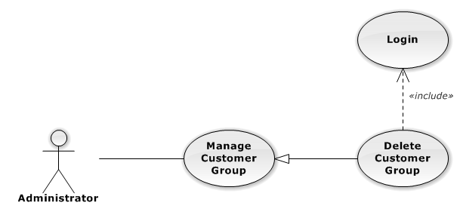

Figure 58: Delete Customer Group Use-Case Diagram

###### Use-Case Specification

|  |  |  |  |
| --- | --- | --- | --- |
| USE CASE SPECIFICATION | | | |
| Use-case No. | UC0046 | Use-case Version | 1.0 |
| Use-case Name | Delete Customer Group | | |
| Author | Đặng Nguyễn Khiêm | | |
| Date | 09/10/2014 | Priority | Normal |
| Actor:  Administrator  Summary:  Delete Customer Group.  Goal:  The purpose of Delete Customer Group use case is allowing Admin to delete Customer Group.  Triggers:  User choose “Quản lý Nhóm Khách Hàng” in menu.  Preconditions:  User is authenticated and has role “admin”.  Post Conditions:  Success: The Customer Group is deleted.  Failure: The Customer Group is not delete and Error message will be showed.  Main Success Scenario:   |  |  |  | | --- | --- | --- | | *Step* | *User* | *System* | | 1 | Click Delete icon. | Show confirm pop-up | | 2 | Presses “Đồng ý” button.  [Alternative: 1] | Delete Customer Group from database.  Show success message.  [Exception: 1]  [Exception: 2] |   Alternative Scenario:   |  |  |  | | --- | --- | --- | | *#* | *User* | *System* | | 1 | Presses “Đóng”, “X” button or click outside pop-up. | The confirm pop-up is close. |   Exceptions:   |  |  |  | | --- | --- | --- | | *#* | *User* | *System* | | 1 | Delete Customer group fail. | The Add New Customer Group is closed and display error message “Xóa nhóm khách hàng thất bại!", "Hãy kiểm tra lại kết nối database." | | 2 | Delete Customer group error. | The Add New Customer Group is closed and display error message "Xóa nhóm khách hàng thất bại!", "Có lỗi xảy ra trong quá xóa nhóm khách hàng." |   Relationships:  Manage Customer Group  Business Rules:  N/A | | | |

##### UC0047 - Search Customer Group

###### Use-Case Diagram

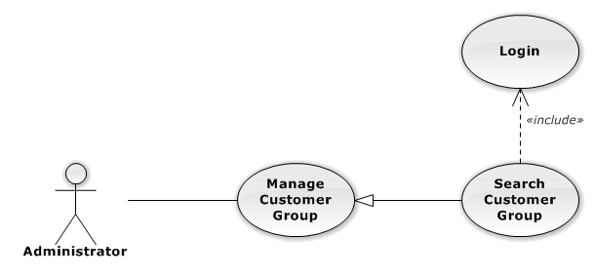

Figure 59: Search Customer Group Use-Case Diagram

###### Use-Case Specification

|  |  |  |  |
| --- | --- | --- | --- |
| USE CASE SPECIFICATION | | | |
| Use-case No. | UC0050 | Use-case Version | 1.0 |
| Use-case Name | Search Customer Group | | |
| Author | Đặng Nguyễn Khiêm | | |
| Date | 09/10/2014 | Priority | Normal |
| Actor:  Administrator  Summary:  Search Customer Group.  Goal:  The purpose of Search Customer Group use case is allowing Admin to search Customer.  Triggers:  User choose “Quản lý Nhóm khách hàng” in menu.  Preconditions:  User is authenticated and has role “admin”.  Post Conditions:  Success: List of Customer Group with search key words is displayed.  Failure: No record is displayed.  Main Success Scenario:   |  |  |  | | --- | --- | --- | | *Step* | *User* | *System* | | 1 | In “Quản lý Nhóm khách hàng” screen, input key word at “Tìm kiếm” textbox. | List of Customer Group with search key words is displayed. |   Alternative Scenario:  N/A  Exceptions:  N/A  Relationships:  Manage Customer Group  Business Rules:  N/A | | | |

#### Manage Customer

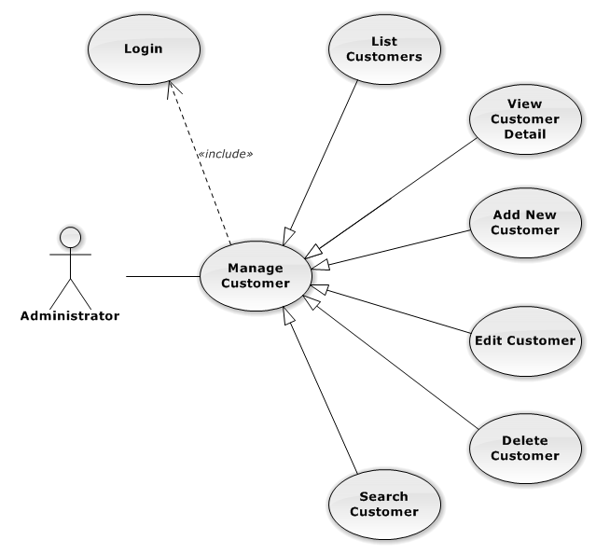

Figure 60: Manage Customer Use-Case Diagram

##### UC0048 - List Customers

###### Use-Case Diagram

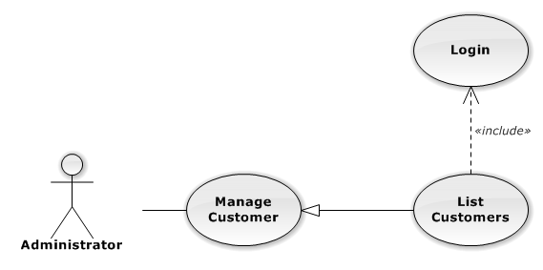

Figure 61: List Customers Use-Case Diagram

###### Use-Case Specification

|  |  |  |  |
| --- | --- | --- | --- |
| USE CASE SPECIFICATION | | | |
| Use-case No. | UC0048 | Use-case Version | 1.0 |
| Use-case Name | List Customers | | |
| Author | Đặng Nguyễn Khiêm | | |
| Date | 09/10/2014 | Priority | Normal |
| Actor:  Administrator  Summary:  List All Customer.  Goal:  The purpose of List Customers use case is allowing Admin to view all Customers.  Triggers:  User choose “Quản lý Khách Hàng” in menu.  Preconditions:  User is authenticated and has role “admin”.  The page is fully loaded.  Post Conditions:  Success: All Customer is listed.  Failure: N/A  Main Success Scenario:   |  |  |  | | --- | --- | --- | | *Step* | *User* | *System* | | 1 | Click “Quản lý Khách Hàng” in menu. | All Customers are loaded. |   Alternative Scenario:  N/A  Exceptions:  N/A  Relationships:  Manage Customer  Business Rules:  N/A | | | |

##### UC0049 - View Customer Detail

###### Use-Case Diagram

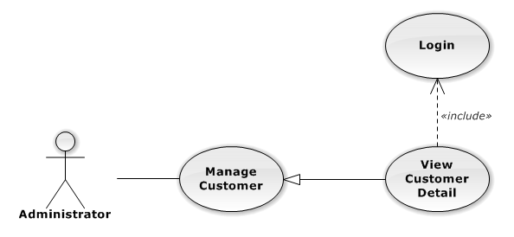

Figure 62: View Customer Detail Use-Case Diagram

###### Use-Case Specification

|  |  |  |  |
| --- | --- | --- | --- |
| USE CASE SPECIFICATION | | | |
| Use-case No. | UC0049 | Use-case Version | 1.0 |
| Use-case Name | View Customer Detail | | |
| Author | Đặng Nguyễn Khiêm | | |
| Date | 09/10/2014 | Priority | Normal |
| Actor:  Administrator  Summary:  View Customer Detail.  Goal:  The purpose of View Customer Detail use case is allowing Admin to view a Customer detail.  Triggers:  User choose “Quản lý Khách Hàng” in menu. Then click “View detail” icon.  Preconditions:  User is authenticated and has role “admin”.  Post Conditions:  Success: Customer Detail is showed.  Failure: Do nothing.  Main Success Scenario:   |  |  |  | | --- | --- | --- | | *Step* | *User* | *System* | | 1 | In Manage Customer page, click “View detail” icon | The Customer Detail is showed. |   Alternative Scenario:  N/A  Exceptions:  N/A  Relationships:  Manage Customer  Business Rules:  N/A | | | |

##### UC0050 - Add New Customer

###### Use-Case Diagram

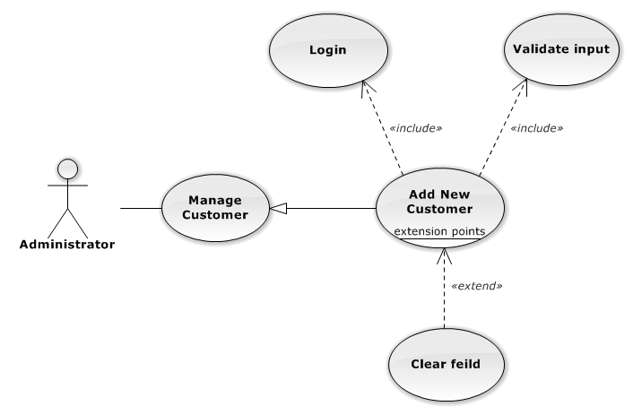

Figure 63: Add New Customer Use-Case Diagram

###### Use-Case Specification

|  |  |  |  |
| --- | --- | --- | --- |
| USE CASE SPECIFICATION | | | |
| Use-case No. | UC0050 | Use-case Version | 1.0 |
| Use-case Name | Add New Customer | | |
| Author | Đặng Nguyễn Khiêm | | |
| Date | 09/10/2014 | Priority | Normal |
| Actor:  Administrator  Summary:  Add Customer.  Goal:  The purpose of Add Customer use case is allowing Admin to add new Customer.  Triggers:  User choose “Quản lý Khách Hàng” in menu.  Preconditions:  User is authenticated and has role “admin”.  Post Conditions:  Success: New Customer is created.  Failure: No Customer is created and Error message will be showed.  Main Success Scenario:   |  |  |  | | --- | --- | --- | | *Step* | *User* | *System* | | 1 | Click “Thêm Khách Hàng” button. | Show add Customer pop-up. | | 2 | Enters the Customer detail. |  | | 3 | Presses “Thêm Khách Hàng” button.  [Alternative: 1] | Checks validate, add new Customer to database.  Show success message.  [Exception: 1]  [Exception: 2]  [Exception: 3] |   Alternative Scenario:   |  |  |  | | --- | --- | --- | | *#* | *User* | *System* | | 1 | Presses “Đóng”, “X” button or click outside pop-up. | The Add New Customer pop-up is close. |   Exceptions:   |  |  |  | | --- | --- | --- | | *#* | *User* | *System* | | 1 | Customer Name is missing. | Show error “"Nhập tên khách hàng!" to user. | | Represent-Person is missing. | Show error “"Nhập tên người đại diện!” to user. | | Customer Group is not chosen. | Show error “"Chọn nhóm khách hàng!” to user. | | Address is missing. | Show error “"Nhập địa chỉ!" to user. | | Email format is wrong. | Show error “Email chưa đúng định dạng!" to user. | | Mobile is missing. | Show error “Nhập số điện thoại di động!” to user. | | 2 | Add Customer fail. | The Add New Customer is closed and display error message “Tạo khách hàng thất bại!", "Hãy kiểm tra lại kết nối database." | | 3 | Add Customer error. | The Add New Customer is closed and display error message "Tạo khách hàng thất bại!", "Có lỗi xảy ra trong quá trình tạo khách hàng." |   Relationships:  Manage Customer  Business Rules:  N/A | | | |

##### UC0051 - Edit Customer

###### Use-Case Diagram

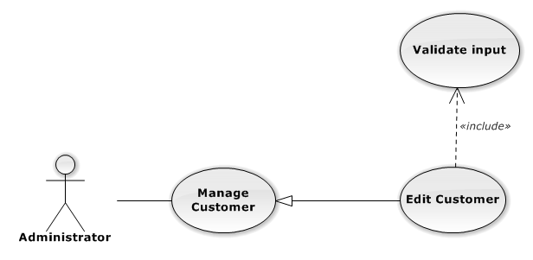

Figure 64: Edit Customer Use-Case Diagram

###### Use-Case Specification

|  |  |  |  |
| --- | --- | --- | --- |
| USE CASE SPECIFICATION | | | |
| Use-case No. | UC0051 | Use-case Version | 1.0 |
| Use-case Name | Edit Customer | | |
| Author | Đặng Nguyễn Khiêm | | |
| Date | 09/10/2014 | Priority | Normal |
| Actor:  Administrator  Summary:  Update Customer.  Goal:  The purpose of Update Customer use case is allowing Admin to update Customer.  Triggers:  User choose “Quản lý Khách Hàng” in menu.  Preconditions:  User is authenticated and has role “admin”.  Post Conditions:  Success: The Customer is Updated.  Failure: The Customer is not updated and Error message will be showed.  Main Success Scenario:   |  |  |  | | --- | --- | --- | | *Step* | *User* | *System* | | 1 | Click Update icon. | Show update Customer pop-up. | | 2 | Enters the new Customer’s detail. |  | | 3 | Presses “Lưu chỉnh sửa” button.  [Alternative: 1] | Checks validate, update Customer to database.  Show success message.  [Exception: 1]  [Exception: 2]  [Exception: 3] |   Alternative Scenario:   |  |  |  | | --- | --- | --- | | *#* | *User* | *System* | | 1 | Presses “Đóng”, “X” button or click outside pop-up. | The Update Customer pop-up is close. |   Exceptions:   |  |  |  | | --- | --- | --- | | *#* | *User* | *System* | | 1 | Customer Name is missing. | Show error “"Nhập tên khách hàng!" to user. | | Represent-Person is missing. | Show error “"Nhập tên người đại diện!” to user. | | Customer Group is not chosen. | Show error “"Chọn nhóm khách hàng!” to user. | | Address is missing. | Show error “"Nhập địa chỉ!" to user. | | Email format is wrong. | Show error “Email chưa đúng định dạng!" to user. | | Mobile is missing. | Show error “Nhập số điện thoại di động!” to user. | | 2 | Update Customer fail. | The Update Customer pop-up is closed and display error message “Chỉnh sửa khách hàng thất bại!", "Hãy kiểm tra lại kết nối database." | | 3 | Update Customer error. | The Update Customer pop-up is closed and display error message "Chỉnh sửa khách hàng thất bại!", "Có lỗi xảy ra trong quá trình chỉnh sửa khách hàng." |   Relationships:  Manage Customer  Business Rules:  N/A | | | |

##### UC0052 - Delete Customer

###### Use-Case Diagram

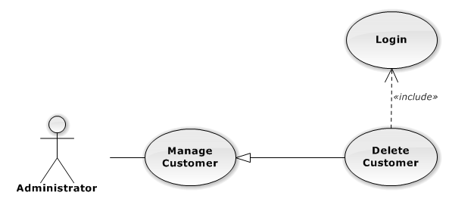

Figure 65: Delete Customer Use-Case Diagram

###### Use-Case Specification

|  |  |  |  |
| --- | --- | --- | --- |
| USE CASE SPECIFICATION | | | |
| Use-case No. | UC0052 | Use-case Version | 1.0 |
| Use-case Name | Delete Customer | | |
| Author | Đặng Nguyễn Khiêm | | |
| Date | 09/10/2014 | Priority | Normal |
| Actor:  Administrator  Summary:  Delete Customer.  Goal:  The purpose of Delete Customer use case is allowing Admin to delete Customer.  Triggers:  User choose “Quản lý Khách Hàng” in menu.  Preconditions:  User is authenticated ans has role “admin”.  Post Conditions:  Success: The Customer is deleted.  Failure: The Customer is not delete and Error message will be showed.  Main Success Scenario:   |  |  |  | | --- | --- | --- | | *Step* | *User* | *System* | | 1 | Click Delete icon. | Show confirm pop-up | | 2 | Presses “Đồng ý” button.  [Alternative: 1] | Delete Customer from database.  Show success message.  [Exception: 1]  [Exception: 2] |   Alternative Scenario:   |  |  |  | | --- | --- | --- | | *#* | *User* | *System* | | 1 | Presses “Đóng”, “X” button or click outside pop-up. | The confirm pop-up is close. |   Exceptions:   |  |  |  | | --- | --- | --- | | *#* | *User* | *System* | | 1 | Delete Customer fail. | The confirm pop-up is closed and display error message “Xóa nhóm dịch vụ thất bại!", "Hãy kiểm tra lại kết nối database." | | 2 | Delete Customer error. | The confirm pop-up is closed and display error message “Xóa nhóm dịch vụ thất bại!", "Có lỗi xảy ra trong quá trình xóa khách hàng." |   Relationships:  Manage Customer  Business Rules:  N/A | | | |

##### UC0053 - Search Customer

###### Use-Case Diagram

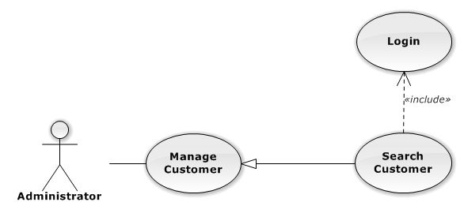

Figure 66: Search Customer Use-Case Diagram

###### Use-Case Specification

|  |  |  |  |
| --- | --- | --- | --- |
| USE CASE SPECIFICATION | | | |
| Use-case No. | UC0053 | Use-case Version | 1.0 |
| Use-case Name | Search Customer | | |
| Author | Đặng Nguyễn Khiêm | | |
| Date | 09/10/2014 | Priority | Normal |
| Actor:  Administrator  Summary:  Search Customer.  Goal:  The purpose of Search Customer use case is allowing Admin to search Customer.  Triggers:  User choose “Quản lý Khách hàng” in menu.  Preconditions:  User is authenticated and has role “admin”.  Post Conditions:  Success: List of Customer with search key words is displayed.  Failure: No record is displayed.  Main Success Scenario:   |  |  |  | | --- | --- | --- | | *Step* | *User* | *System* | | 1 | In “Quản lý Khách hàng” screen, input key word at “Tìm kiếm” textbox. | List of Customer with search key words is displayed. |   Alternative Scenario:  N/A  Exceptions:  N/A  Relationships:  N/A  Business Rules:  N/A | | | |

#### Manage Staff Group

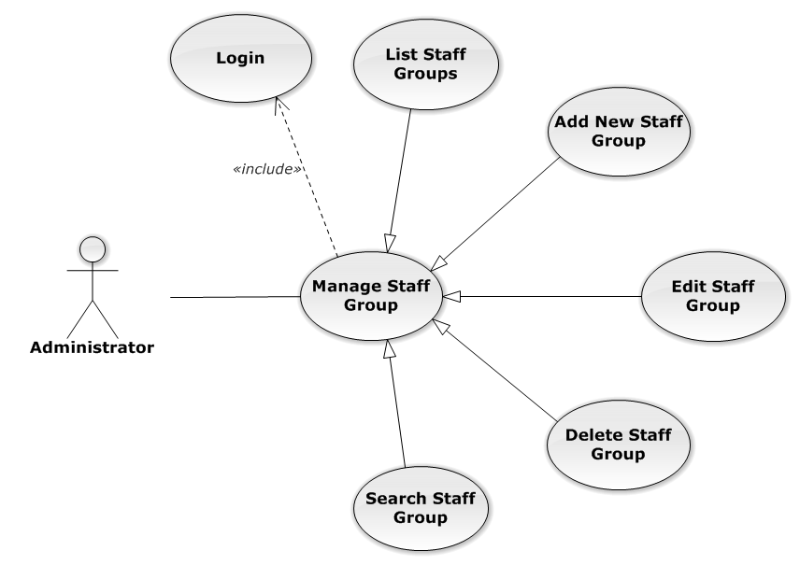

Figure 67: Manage Staff Group Use-Case Diagram

##### UC0054 - List Staff Groups

###### Use-Case Diagram

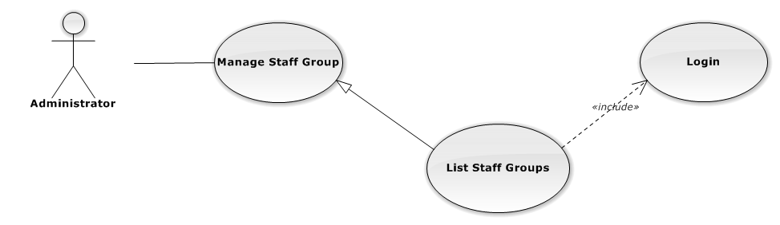

Figure 68: List Staff Groups Use-Case Diagram

###### Use-Case Specification

|  |  |  |  |
| --- | --- | --- | --- |
| USE-CASE SPECIFICATION | | | |
| Use-case No. | UC0054 | Use-case Version | 1.0 |
| Use-case Name | List Staff Groups | | |
| Author | Đặng Nguyễn Khiêm | | |
| Date | 09/10/2014 | Priority | Normal |
| Actor:  Administrator  Summary:  Redirect user to “Quản lí nhóm nhân viên” page and list all staff group.  Goal:  To allowing Administrator view any detail information of all staff group.  Triggers:   * User click on User Control Panel and then click on “Quản lí nhân viên” link * On sub menu click on “nhóm nhân viên”.   Preconditions:   * Must be logged-in with “Admin” role. * The page is fully loaded   Post Conditions:  Success: System redirects user to “Quản lí nhóm nhân viên” page.  Failure: Do nothing.  Main Success Scenario:   |  |  |  | | --- | --- | --- | | *Step* | *User* | *System* | | 1 | Click on “Quản lí nhóm nhân viên” link | Redirect to “Quản lí nhóm nhân viên” page  Show all staff group. |   Alternative Scenario:  N/A  Exceptions:  N/A  Relationships:  Manage Staff Group  Business Rules:  Only Staff with role =”Admin” can be use this function. | | | |

##### UC0055 - Add New Staff Group

###### Use-Case Diagram

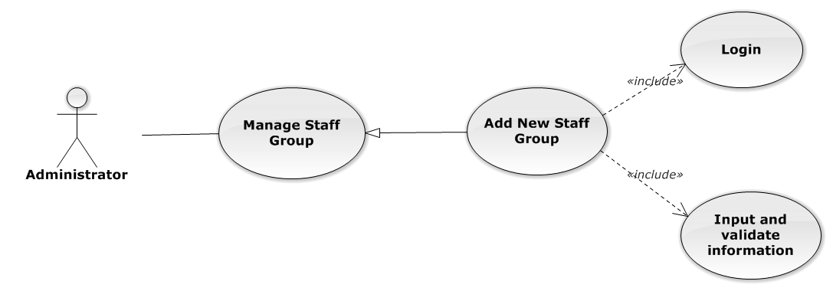

Figure 69: Add New Staff Group Use-Case Diagram

###### Use-Case Specification

|  |  |  |  |
| --- | --- | --- | --- |
| USE CASE SPECIFICATION | | | |
| Use-case No. | UC0055 | Use-case Version | 1.0 |
| Use-case Name | Add New Staff Group | | |
| Author | Đặng Nguyễn Khiêm | | |
| Date | 09/10/2014 | Priority | Normal |
| Actor:  Administrator.  Summary:  Administrator can insert new staff group in the system.  **Goal:**  Add new staff group.  Triggers:  At “Quản lí nhóm nhân viên” page click “Thêm nhóm nhân viên” button, fill information and click button “Thêm mới”.  Preconditions:   * Logged-in as “Admin” role. * The page is fully loaded   Post Conditions:  Success: New staff group is inserted into database, message show “Tạo nhóm nhân viên mới thành công!” and display on “Quản lí nhân viên” screen.  Failure: Show message “Tạo nhóm nhân viên mới thất bại!”  Main Success Scenario:   |  |  |  | | --- | --- | --- | | *Step* | *User* | *System* | | 1 | Administrator click on “Thêm nhóm nhân viên” button at “Quản lí Nhóm nhân viên” page. | Modal popup is displayed with fields for input information of new staff group. | |  | Fill information into fields and click button “Thêm mới”  [Alternative 1]  [Exception 1], [Exception 2], [Exception 3] | Modal popup is close  System display successful message “Tạo nhóm nhân viên mới thành công!”  Update list staff group on page |   Alternative Scenario:   |  |  |  | | --- | --- | --- | | *#* | *User* | *System* | | 1 | Click on [X] button, “Đóng” button, or click out of modal | Modal popup is close |   Exceptions:   |  |  |  | | --- | --- | --- | | *#* | *User* | *System* | | 1 | Field “Tên nhóm nhân viên” are blank | Shows error message “Nhập tên nhóm nhân viên!”. | | Field “Chi tiết nhóm nhân viên”, are blank | Shows error message “Nhập chi tiết chi tiết nhân viên!” | | 2 | System cannot insert staff group to data base. | Shows error message “Tạo nhóm nhân viên thất bại!” | | 3 | System fail insert staff group to data base. | Shows error message “Tạo nhóm nhân viên thất bại!", "Hãy kiểm tra lại kết nối database!”. |   Relationships:  Manage Staff Group  Business Rules:  Only Staff with role=”Admin” can be use this function. | | | |

##### UC0056 - Edit Staff Group

###### Use-Case Diagram

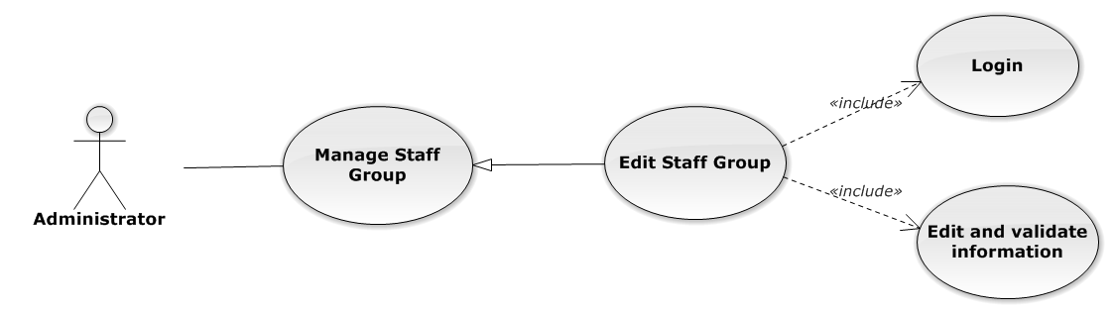

Figure 70: Edit Staff Group Use-Case Diagram

###### Use-Case Specification

|  |  |  |  |
| --- | --- | --- | --- |
| USE CASE SPECIFICATION | | | |
| Use-case No. | UC0056 | Use-case Version | 1.0 |
| Use-case Name | Edit Staff Group | | |
| Author | Đặng Nguyễn Khiêm | | |
| Date | 09/10/2014 | Priority | Normal |
| Actor:  Administrator.  Summary:  Administrator can update information of staff group.  **Goal:**  Administrator can update information of staff group and save to database system.  Triggers:   * Administrator goes to “Chi tiết nhóm nhân viên” Popup and click “Chỉnh Sửa” button and modify information, after that click button “Lưu Chỉnh Sửa”. * Administrator goes to “Nhóm nhân viên” screen, click “Chỉnh Sửa” button and modify information, after that click button “Lưu Chỉnh Sửa”.   Preconditions:   * User has logged-in as “Admin” role. * The page is fully loaded   Post Conditions:  Success:  Information of staff group is updated and saves to database, message show “Cập nhật chi tiết nhóm nhân viên thành công!” and display information after update on “Quản lý nhóm nhân viên” screen.  Failure:  Show message “Cập nhật chi tiết nhóm nhân viên thất bại!”  Main Success Scenario:   |  |  |  | | --- | --- | --- | | *Step* | *User* | *System* | | 1 | Manager click on “Chỉnh sửa” button at “Quản lí nhóm nhân viên” screen. | Modal popup is displayed with fields for detil information of staff group. | | 2 | Edit information into fields and click button “Lưu chỉnh sửa”  [Alternative 1]  [Exception 1], [Exception 1], [Exception 3] | Modal popup is close  System display successful message “Cập nhật chi tiết nhóm nhân viên thành công!”  Update list staff group on page |   Alternative Scenario:   |  |  |  | | --- | --- | --- | | *#* | *User* | *System* | | 1 | Click on [X] button, “Đóng” button, or click out of modal | Modal popup is close |   Exceptions:   |  |  |  | | --- | --- | --- | | *#* | *User* | *System* | | 1 | Field “Tên nhóm nhân viên” are blank | Shows error message “Nhập tên nhóm nhân viên!”. | | Field “Chi tiết nhóm nhân viên”, are blank | Shows error message “Nhập chi tiết chi tiết nhân viên!”. | | 2 | System cannot update staff to data base. | Shows error message “Cập nhật chi tiết nhóm nhân viên thất bại!”. | | 3 | System fail insert staff to data base. | Shows error message “Cập nhật chi tiết nhóm nhân viên thất bại!", "Hãy kiểm tra lại kết nối database!”. |   Relationships:  Manage Staff Group  Business Rules:  Only Staff with role=”Admin” can be use this function. | | | |

##### UC0057 - Delete Staff Group

###### Use-Case Diagram

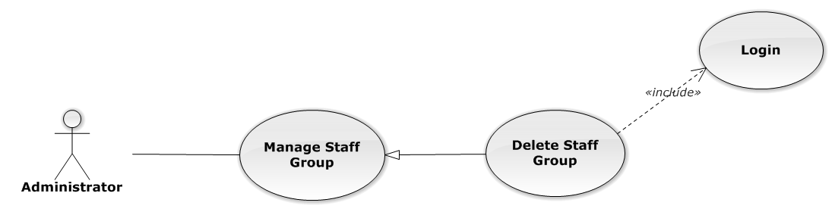

Figure 71: Delete Staff Group Use-Case Diagram

###### Use-Case Specification

|  |  |  |  |
| --- | --- | --- | --- |
| USE CASE SPECIFICATION | | | |
| Use-case No. | UC0057 | Use-case Version | 1.0 |
| Use-case Name | Delete Staff Group | | |
| Author | Đặng Nguyễn Khiêm | | |
| Date | 09/10/2014 | Priority | Normal |
| Actor:  Administrator.  Summary:  Administrator can delete staff group.  **Goal:**  Helps Administrator delete staff group if it didn’t use in Staff manager and save to database system.  Triggers:  Administrator goes to “Quản lí nhóm nhân viên ”page click button “Xóa”. After that click on “Bỏ qua” or“Xác nhận” button to confirm delete staff group.  Preconditions:   * User has logged-in as Admin role. * The page is fully loaded   Post Conditions:  Success:  Delete staff group and save to database system, display message “Xóa nhóm nhân viên thành công!”  Failure:  Show message “Xóa nhóm nhân viên thất bại!","Nhóm nhân viên này hiện đang được sử dụng!”.  Main Success Scenario:   |  |  |  | | --- | --- | --- | | *Step* | *User* | *System* | | 1 | Supper admin click on “Xóa” button at “Quản lí nhóm nhân viên” screen. | Show Pop-up confirm “Bạn có muốn thực hiện thao tác này” with two button “Xác nhận” and “Bỏ qua” | | 2 | User click “Bỏ qua” button | Staff group not delete, comeback to “Chi tiết nhóm nhân viên” screen. | | 3 | User click “ Xác nhận” button  [Exception 1], [Exception 2] | Show message “Xóa nhóm nhân viên thành công!” |   Alternative Scenario:  N/A  Exceptions:   |  |  |  | | --- | --- | --- | | *#* | *User* | *System* | | 1 | Delete staff group fail because staff group is use. | Shows error message “Xóa nhóm nhân viên thất bại!","Nhóm nhân viên này hiện đang được sử dụng!” | | 2 | Delete staff group error because staff group is use. | Shows error message “Xóa nhóm nhân viên thất bại!", "Có lỗi xảy ra trong quá trình xóa nhóm nhân viên”. |   Relationships:  Manage Staff Group  Business Rules:  Only Staff with role=”Admin” can be use this function. | | | |

##### UC0058 - Search Staff Group

###### Use-Case Diagram

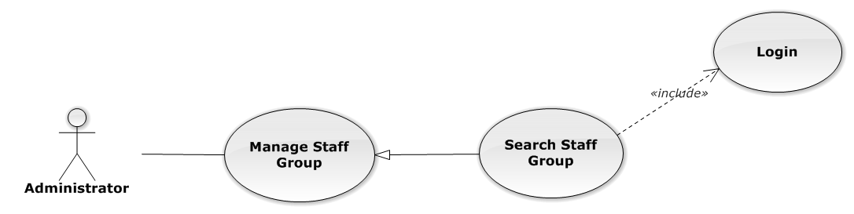

Figure 72: Search Staff Group Use-Case Diagram

###### Use-Case Specification

|  |  |  |  |
| --- | --- | --- | --- |
| USE CASE SPECIFICATION | | | |
| Use-case No. | UC0058 | Use-case Version | 1.0 |
| Use-case Name | Search Staff Group | | |
| Author | Đặng Nguyễn Khiêm | | |
| Date | 09/10/2014 | Priority | Normal |
| Actor:  Administrator.  Summary:  Administrator search staff in list of staff group.  **Goal:**  Helps Administrator search staff group.  Triggers:   * Administrator wants to search staff group. * Administrator goes to “Quản lý nhóm nhân viên” screen, input word into “Tìm Kiếm” textbox.   Preconditions:   * User has logged-in as Admin role. * The page is fully loaded   Post Conditions:  Success:  List of staff group map with word search is displayed.  Failure:  Do nothing  Main Success Scenario:   |  |  |  | | --- | --- | --- | | *Step* | *User* | *System* | | 1 | In “Quản lý nhóm nhân viên” screen, input key word at “Tìm kiếm” textbox. | List of staff group mapping with word search is display. |   Alternative Scenario:  N/A  Exceptions:  N/A  Relationships:  Manage Staff Group  Business Rules:  Only Staff with role=”Admin” can be use this function. | | | |

#### Manage Staff

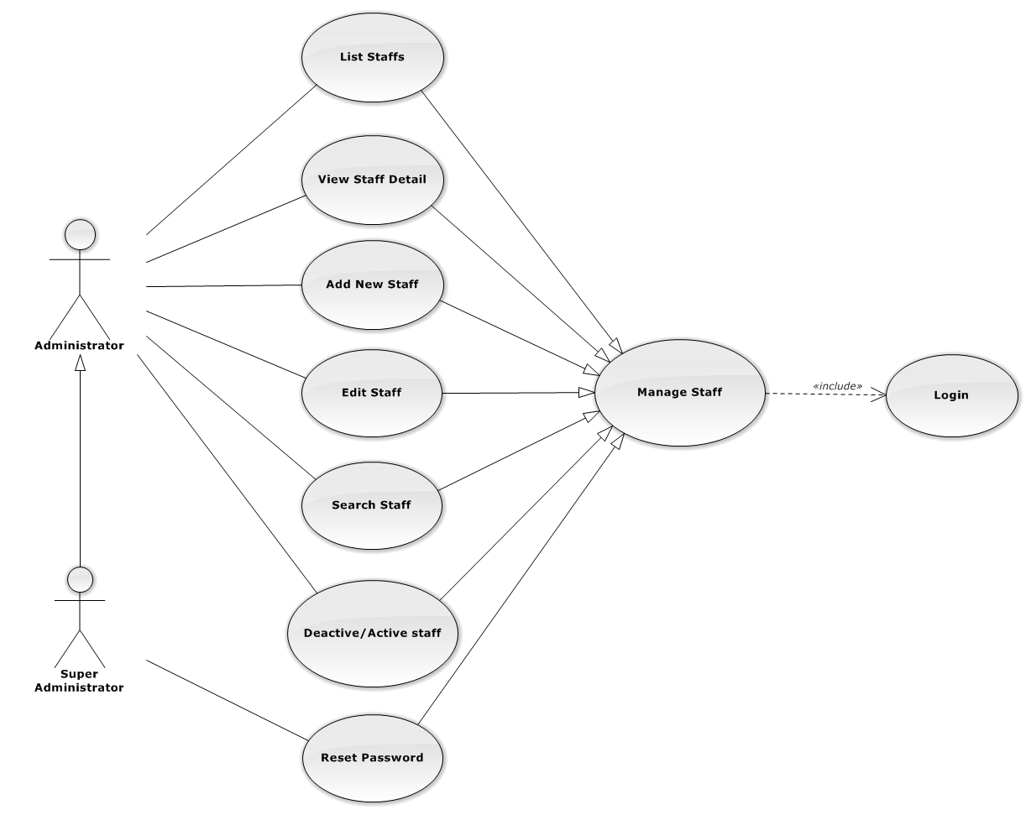

Figure 73: Manage Staff Use-Case Diagram

##### UC0059 - List Staffs

###### Use-Case Diagram

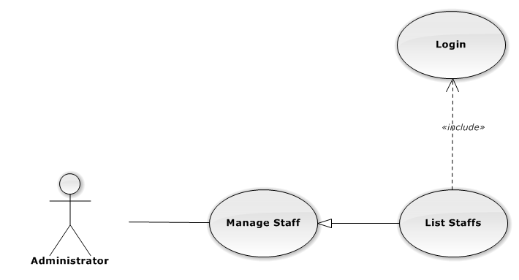

Figure 74: List Staffs Use-Case Diagram

###### Use-Case Specification

|  |  |  |  |
| --- | --- | --- | --- |
| USE-CASE SPECIFICATION | | | |
| Use-case No. | UC0059 | Use-case Version | 1.0 |
| Use-case Name | List Staffs | | |
| Author | Đặng Nguyễn Khiêm | | |
| Date | 09/10/2014 | Priority | Normal |
| Actor:  Administrator  Summary:  Redirect user to “Quản lí nhân viên” page and list all staff.  Goal:  To allowing Administrator view any detail information of all staff.  Triggers:  User click on User Control Panel and then click on “Quản lí nhân viên” link  Preconditions:   * Must be logged-in with “Admin” role. * The page is fully loaded   Post Conditions:  Success: System redirects user to “Quản lí nhân viên” page.  Failure: Do nothing.  Main Success Scenario:   |  |  |  | | --- | --- | --- | | *Step* | *User* | *System* | | 1 | Click on “Quản lí nhân viên” link | Redirect to “Quản lí nhân viên” page. Show all staff. |   Alternative Scenario:  N/A  Exceptions:  N/A  Relationships:  Manage Staff  Business Rules:  Only Staff login with role “Admin” can be use this function. | | | |

##### UC0060 - View Staff Detail

###### Use-Case Diagram

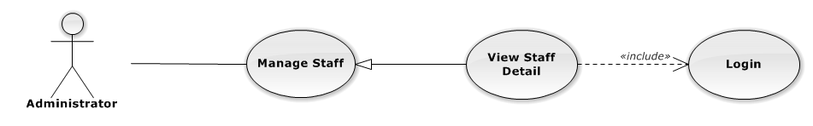

Figure 75: View Staff Detail Use-Case Diagram

###### Use-Case Specification

|  |  |  |  |
| --- | --- | --- | --- |
| USE-CASE SPECIFICATION | | | |
| Use-case No. | UC0060 | Use-case Version | 1.0 |
| Use-case Name | View Staff Detail | | |
| Author | Đặng Nguyễn Khiêm | | |
| Date | 09/10/2014 | Priority | Normal |
| Actor:  Administrator  Summary:  Administrator can view detail of staff information  Goal:  Helps Administrator view staff information  Triggers:   * On User Control Panel click on “Quản lí nhân viên**”,** * Click click on “Chi tiết” button * Click on image staff.   Preconditions:   * Must be logged-in with “Admin” role * The page is fully loaded   Post Conditions:  Success: The detail staff information is displayed  Failure: Do nothing  Main Success Scenario:   |  |  |  | | --- | --- | --- | | *Step* | *User* | *System* | | 1 | Staff click on “chi tiết” button or click on image link  [Alternative 1] ,[Alternative 2]  [Alternative 3] ,[Alternative 4] | The detail staff information is displayed. |   Alternative Scenario:   |  |  |  | | --- | --- | --- | | *#* | *User* | *System* | | 1 | Click on [X] button, “Đóng” button, or click out of modal | Modal popup is close | | 2 | If staff login with Id=”1”, Click on “Chỉnh sửa” button | Administrator can update information of office (ref 3.2.2.2.4. Update staff) | | 3 | If staff login with Id=”1”, Click on “Hoạt động lại” or “Ngừng hoạt động” link | Administrator can Deactivate/Activate staff (ref 3.2.2.2.5. Deactivate/Activate staff) | | 4 | If staff login with Id=”1”, Click on “Đặt lại mật khẩu” link | Administrator can reset password staff (ref 3.2.2.2.7. Reset Password staff) |   Exceptions:  N/A  Relationships:  Manage Staff  Business Rules:  Only Staff login with role “Admin” can be use this function. | | | |

##### UC0061 - Add New Staff

###### Use-Case Diagram

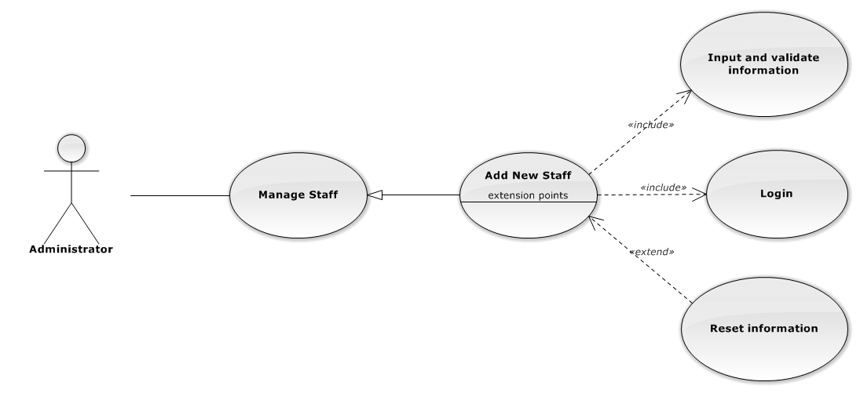

Figure 76: Add New Staff Use-Case Diagram

###### Use-Case Specification

|  |  |  |  |
| --- | --- | --- | --- |
| USE CASE SPECIFICATION | | | |
| Use-case No. | UC0061 | Use-case Version | 1.0 |
| Use-case Name | Add New Staff | | |
| Author | Đặng Nguyễn Khiêm | | |
| Date | 09/10/2014 | Priority | High |
| Actor:  Administrator.  Summary:  Administrator can insert new staff into the system.  **Goal:**  Add new staff.  Triggers:  At “Quản lí nhân viên” page, Administrator click on “Thêm nhân viên” button and fill information after that click button “Thêm mới” button.  Preconditions:   * User has logged-in as “Admin” role. * The page is fully loaded   Post Conditions:  Success:   * Add new case successful and message show “Thêm nhân viên thành công”. * Add current staff’s office to data system. * New staff’s status is “Đang hoạt động”. * Add current with username and default password is “123456” to data system.   Failure:  Show message “Thêm nhân viên thất bại, hãy kiểm tra lại kết nối database”.  Main Success Scenario:   |  |  |  | | --- | --- | --- | | *Step* | *User* | *System* | | 1 | Administrator click on “Thêm nhân viên” button at “Quản lí nhân viên” page. | Modal popup is displayed with fields for input information of new staff. | | 2 | Fill information into fields and click button “Thêm mới”  [Alternative 1]  [Exception 1], [Exception 2], [Exception 3], [Exception 4] | Modal popup is closed.  System display successful message “Thêm nhân viên thành công!”  Update list staff on page |   Alternative Scenario:   |  |  |  | | --- | --- | --- | | *#* | *User* | *System* | | 1 | Click “Làm trống” button | All input field reset to blank. |   Exceptions:   |  |  |  | | --- | --- | --- | | *#* | *User* | *System* | | 1 | Field “Tên nhân viên” are blank | Shows error message “Nhập tên nhân viên!”. | | Field “Tên đăng nhập”, are blank | Shows error message “Nhập vào tên đăng nhập!”. | | Field “Nhóm nhân viên” are blank | Shows error message “Chọn nhóm cho nhân viên!”. | | Field “Ngày sinh” are blank | Shows error message “Chọn ngày sinh của nhân viên!”. | | Field “Điện thoại di động” are blank | Shows error message “Nhập vào số điện thoại nhân viên!”. | | Field “Email” are blank | Shows error message “Hãy nhập Email của nhân viên!”. | | Input “Email” not follow the rule | Shows error message “Hãy nhập địa chỉ email đúng!”. | | Field “Địa chỉ liên hệ” are blank | Shows error message “Nhập địa chỉ của nhân viên!”. | | Field “Thuộc văn phòng ” are blank | Shows error message “Chọn một văn phòng!”. | | Field “Vai trò nhân viên” are blank | Shows error message “Chọn vai trò cho nhân viên!”. | | Field “CMND” are blank | Shows error message “Nhập vào số chứng minh nhân dân!”. | | Field “Ngày cấp CMND” are blank | Shows error message “Chọn ngày cấp chứng minh nhân dân!“. | | Field “Nơi cấp CMND” are blank | Shows error message “Nhập vào nơi cấp chứng minh nhân dân!”. | | Input “Tên đăng nhập” not follow the rule | Shows error message “Tên đăng nhập không được chứa ký tự đặc biệt!”. | | 2 | Input “Tên đăng nhập” is existed in Database | Shows error message “Tên đăng nhập nhân viên đã tồn tại!”. | | 3 | System cannot insert staff to data base. | Shows error message “Tạo nhân viên thất bại!” | | 4 | System error insert staff to data base. | Shows error message “Tạo nhân viên thất bại!", "Hãy kiểm tra lại kết nối database!”. |   Relationships:  Manage Staff.  Manage Staff Group  Business Rules:  Only Staff login with role “Admin” can be use this function. | | | |

##### UC0062 - Edit Staff

###### Use-Case Diagram

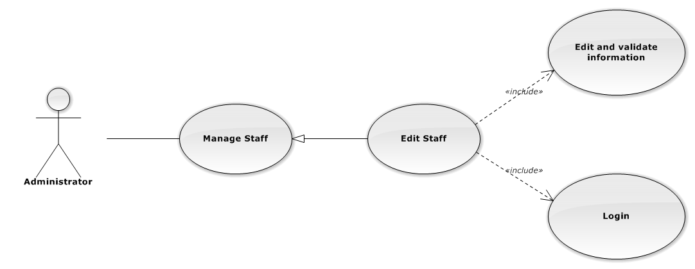

Figure 77: Edit Staff Use-Case Diagram

###### Use-Case Specification

|  |  |  |  |
| --- | --- | --- | --- |
| USE CASE SPECIFICATION | | | |
| Use-case No. | UC0062 | Use-case Version | 1.0 |
| Use-case Name | Edit Staff | | |
| Author | Đặng Nguyễn Khiêm | | |
| Date | 09/10/2014 | Priority | Normal |
| Actor:  Administrator.  Summary:  Administrator can update information of staff.  **Goal:**  Administrator can update information of staff and save to database system.  Triggers:   * Administrator goes to “Quản lý nhân viên” screen, click button “Chỉnh Sửa” button and modify information, after that click button “Lưu Chỉnh Sửa”. * Manager goes to “Chi tiết nhân viên” Popup screen, click on “Chỉnh Sửa” button and modify information, after that click button “Lưu Chỉnh Sửa”.   Preconditions:   * Logged-in as “Admin” role. * The page is fully loaded   Post Conditions:  Success:   * Information of Office is updated and saves to database * Message show “Cập nhật chi tiết nhân viên thành công” and display information after update on “Quản lý nhân viên” screen.   Failure:  Show message “Cập nhật chi tiết nhân viên thất bại!", "Hãy kiểm tra lại kết nối database.”  Main Success Scenario:   |  |  |  | | --- | --- | --- | | *Step* | *User* | *System* | | 1 | Manager click on “Chỉnh sửa” button at “Quản lí nhân viên” screen. | Modal popup is displayed with fields for detail information of new staff. | | 2 | Edit information into fields and click button “Lưu chỉnh sửa”  [Alternative 1]  [Exception 1], [Exception 2], [Exception 3] | Modal popup is close  System display successful message “Cập nhật chi tiết nhân viên thành công!”  Update list staff on page |   Alternative Scenario:   |  |  |  | | --- | --- | --- | | *#* | *User* | *System* | | 1 | Click on [X] button, “Đóng” button, or click out of modal | Modal popup is close |   Exceptions:   |  |  |  | | --- | --- | --- | | *#* | *User* | *System* | | 1 | Field “Tên nhân viên” are blank | Shows error message “Nhập tên nhân viên!”. | | Field “Tên đăng nhập”, are blank | Shows error message “Nhập vào tên đăng nhập!”. | | Field “Nhóm nhân viên” are blank | Shows error message “Chọn nhóm cho nhân viên!”. | | Field “Ngày sinh” are blank | Shows error message “Chọn ngày sinh của nhân viên!”. | | Field “Điện thoại di động” are blank | Shows error message “Nhập vào số điện thoại nhân viên!”. | | Field “Email” are blank | Shows error message “Hãy nhập Email của nhân viên!” | | Input “Email” not a regular expression | Shows error message “Hãy nhập địa chỉ email đúng!” | | Field “Địa chỉ liên hệ” are blank | Shows error message “Nhập địa chỉ của nhân viên!”. | | Field “Thuộc văn phòng ” are blank | Shows error message “Chọn một văn phòng!”. | | Field “Vai trò nhân viên” are blank | Shows error message “Chọn vai trò cho nhân viên!”. | | Field “CMND” are blank | Shows error message “Nhập vào số chứng minh nhân dân!” | | Field “Ngày cấp CMND” are blank | Shows error message “Chọn ngày cấp chứng minh nhân dân!” | | Field “Nơi cấp CMND” are blank | Shows error message “Nhập vào nơi cấp chứng minh nhân dân!” | | 2 | System cannot insert staff to data base. | Shows error message “Cập nhật chi tiết nhân viên thất bại!” | | 3 | System error insert staff to data base. | Shows error message “Cập nhật chi tiết nhân viên thất bại!", "Hãy kiểm tra lại kết nối database!” |   Relationships:  Manage Staff  Business Rules:  Only Staff login with role “Admin” can be use this function. | | | |

##### UC0063 - Deactivate/Activate staff

###### Use-CaseDiagram

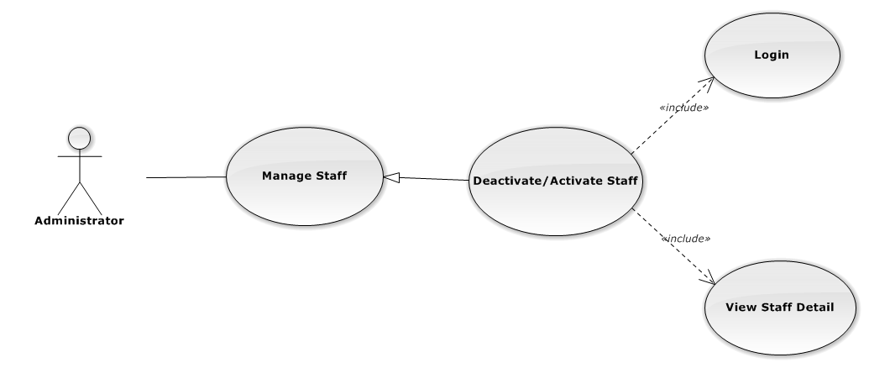

Figure 78: Deactivate/Activate Staff Use-Case Diagram

###### Use-Case Specification

|  |  |  |  |
| --- | --- | --- | --- |
| USE CASE SPECIFICATION | | | |
| Use-case No. | UC0063 | Use-case Version | 1.0 |
| Use-case Name | Deactivate/Activate staff | | |
| Author | Đặng Nguyễn Khiêm | | |
| Date | 09/10/2014 | Priority | Normal |
| Actor:  Administrator.  Summary:  Administrator can change status of Staff.  **Goal:**  Helps Administrator update Status of staff and save to database system.  Triggers:  Administrator goes “Chi tiết nhân viên” Pop-Up screen , Click button “Ngừng hoạt động” or “Hoạt động lại”. After that click on “Bỏ qua” or “Xác nhận” button to confirm change status Staff.  Preconditions:   * Logged-in as “Admin” role * The page is fully loaded   Post Conditions:  Success:  Information of Staff is updated and saves to database, message show “[…] đã hoạt động lại!” or “[…] đã ngừng hoạt động!” and display information after update on “Quản lý nhân viên” screen.  Failure:  Show message “Thay đổi hoạt động nhân viên thất bại!", "Hãy kiểm tra lại kết nối database”.  Main Success Scenario:   |  |  |  | | --- | --- | --- | | *Step* | *User* | *System* | | 1 | Supper admin click on “Chỉnh sửa” button at “Quản lí nhân viên” screen. | Show “Chi tiết nhân viên” Pop-up information. | | 2 | On “Chi tiết văn phòng” Pop-up click button “Ngừng hoạt động ” if Staff have status “Đang hoạt động” or Click button “Hoạt động lại” if staff have status "Ngừng hoạt động”.  [Alternative 1] | Display message box confirm “Bạn có muốn thực hiện thao tác này” with two button “Xác nhận” and “Bỏ qua” | | 3 | User click “Bỏ qua” button | Status of staff not change comeback to “Chi tiết nhân viên” Pop-up screen. | | 4 | User click “ Xác nhận” button  [Exception 1] ,[Exception 2] | Status of staff is change and comeback to “Quản lí nhân viên”screen |   Alternative Scenario:  Alternative:   |  |  |  | | --- | --- | --- | | *#* | *User* | *System* | | 1 | Click on [X] button, “Đóng” button, or click out of modal | Modal popup is close |   Exceptions:   |  |  |  | | --- | --- | --- | | *#* | *User* | *System* | | 1 | System fail change status of staff | Shows error message “Thay đổi hoạt động nhân viên thất bại!", "Có lỗi xảy ra trong quá trình xóa nhân viên.”. | | 2 | System error change status of staff. | Shows error message “Thay đổi hoạt động nhân viên thất bại!", "Hãy kiểm tra lại kết nối database”. |   Relationships:  Manage Staff  Business Rules:  Only Staff login with role “Admin” can be use this function. | | | |

##### UC0064 - Search Staff

###### Use-Case Diagram

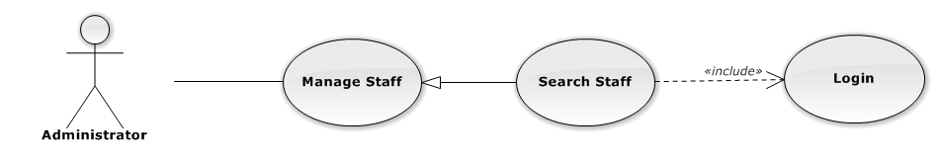

Figure 79: Search Staff Use-Case Diagram

###### Use-Case Specification

|  |  |  |  |
| --- | --- | --- | --- |
| USE CASE SPECIFICATION | | | |
| Use-case No. | UC0064 | Use-case Version | 1.0 |
| Use-case Name | Search Staff | | |
| Author | Đặng Nguyễn Khiêm | | |
| Date | 09/10/2014 | Priority | Normal |
| Actor:  Administrator.  Summary:  Administrator search staff in list of staff  **Goal:**  Helps Administrator search staff.  Triggers:   * Administrator wants to search staff. * Administrator input key word is StaffName. When the key up, system will be automatic search.   Preconditions:   * Logged-in as “Admin” role. * The page is fully loaded   Post Conditions:  Success: List of staff map with word search is displayed.  Failure: Do nothing.  Main Success Scenario:   |  |  |  | | --- | --- | --- | | *Step* | *User* | *System* | | 1 | In “Quản lý nhân viên” screen, input key word at “Tìm kiếm” textbox. | List of staff mapping with word search is display. |   Alternative Scenario:  N/A  Exceptions:  N/A  Relationships:  Manage Staff  Business Rules:  Only Staff with role=”Admin” can be use this function. | | | |

##### UC0065 - Reset Password

###### Use-Case Diagram

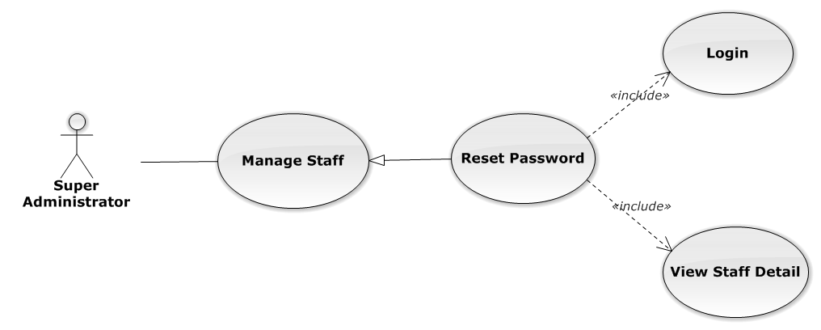

Figure 80: Reset Password Use-Case Diagram

###### Use-Case Specification

|  |  |  |  |
| --- | --- | --- | --- |
| USE CASE SPECIFICATION | | | |
| Use-case No. | UC0065 | Use-case Version | 1.0 |
| Use-case Name | Reset Password | | |
| Author | Đặng Nguyễn Khiêm | | |
| Date | 09/10/2014 | Priority | Normal |
| Actor:  Supper Administrator.  Summary:  Supper Administrator can reset password of all staff to default.  **Goal:**  Helps Supper Administrator reset password to default is “123456”.  Triggers:  Supper Supper Administrator wants to reset password staff.  Supper Administrator goes to “Staff detail” screen, and click to button “Đặt lại mật khẩu”  Preconditions:   * Logged-in to system. * The page is fully loaded   Post Conditions:  Success: Default password “123456” is save to database, message show “Khôi phục mật khẩu thành công  Failure:   * The user is presented with an error message on screen. * Show message “Khôi phục mật mật khẩu thất bại!”.   Main Success Scenario:   |  |  |  | | --- | --- | --- | | *Step* | *User* | *System* | | 1 | Supper admin click on “Chi tiết” button at “Quản lí nhân viên” screen. | Show “Chi tiết nhân viên” Pop-up information. | | 2 | On “Chi tiết văn phòng” Pop-up click button “Đặt lại mật khẩu”  [Alternative 1] | Display message box confirm “Bạn muốn khôi phục mật khẩu nhân viên này về mặc định?” with two button “Xác nhận” and “Bỏ qua” | | 3 | User click “Bỏ qua” button | Password of staff not change comeback to “Chi tiết nhân viên” Pop-up screen. | | 4 | User click “ Xác nhận” button  [Exception 1], [Exception 2] | Password of staff is reset to default “123456” and comeback to “Quản lí nhân viên” screen |   Alternative Scenario:   |  |  |  | | --- | --- | --- | | *#* | *User* | *System* | | 1 | Click on [X] button, “Đóng” button, or click out of modal | Modal popup is close |   Exceptions:   |  |  |  | | --- | --- | --- | | *#* | *User* | *System* | | 1 | System cannot reset password staff. | Shows error message “Khôi phục mật mật khẩu thất bại!” | | 2 | System fail reset password staff. | Shows error message “"Khôi phục mật khẩu thất bại", "Hãy kiểm tra lại kết nối database.”. |   Relationships:  Manage Staff  Business Rules:  Only Staff with id=”1” (Super Administrator) can be use this function. | | | |

#### Manage Service Type

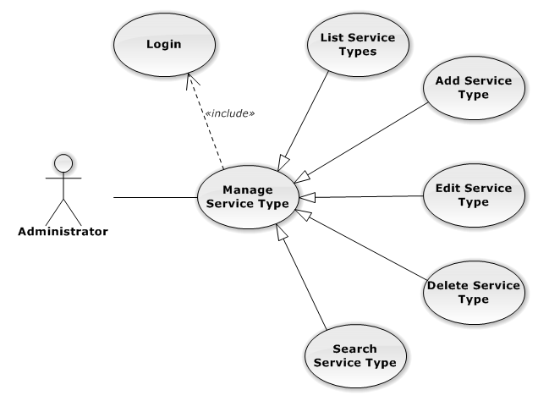

Figure 81: Manage Service Type Use-Case Diagram

##### UC0066 - List Service Types

###### Use-Case Diagram

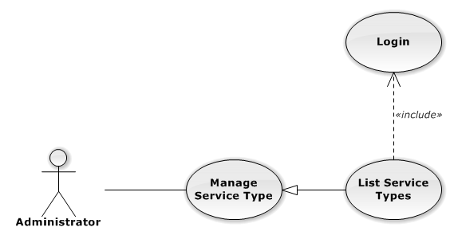

Figure 82: List Service Types Use-Case Diagram

###### Use-Case Specification

|  |  |  |  |
| --- | --- | --- | --- |
| USE CASE SPECIFICATION | | | |
| Use-case No. | UC0066 | Use-case Version | 1.0 |
| Use-case Name | List Service Types | | |
| Author | Trần Anh Tuấn | | |
| Date | 09/10/2014 | Priority | Normal |
| Actor:  Administrator  Summary:  List All Service Type.  Goal:  The purpose of List Service Type use case is allowing Admin to view all Services Type.  Triggers:  User choose “Quản lý Loại Dịch Vụ” in menu.  Preconditions:  User is authenticated and has role “admin”.  The page is fully loaded.  Post Conditions:  Success: All Services Type is listed.  Failure: Do nothing.  Main Success Scenario:   |  |  |  | | --- | --- | --- | | *Step* | *User* | *System* | | 1 | Click “Quản lý Loại Dịch Vụ” in menu. | All Service Types are loaded. |   Alternative Scenario:  N/A  Exceptions:  N/A  Relationships:  Manage Service Type  Business Rules:  N/A | | | |

##### UC0067 - Add New Service Type

###### Use-Case Diagram

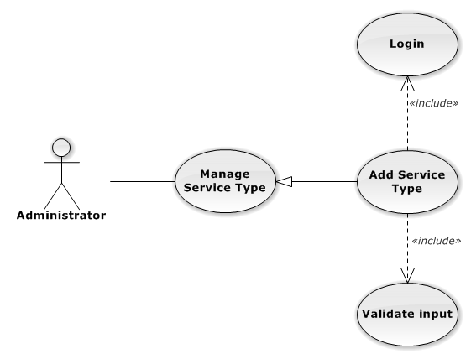

Figure 83: Add New Service Type Use-Case Diagram

###### Use-Case Specification

|  |  |  |  |
| --- | --- | --- | --- |
| USE CASE SPECIFICATION | | | |
| Use-case No. | UC0067 | Use-case Version | 1.0 |
| Use-case Name | Add New Service Type | | |
| Author | Trần Anh Tuấn | | |
| Date | 09/10/2014 | Priority | Normal |
| Actor:  Administrator  Summary:  Add Service Type.  Goal:  The purpose of Add Service Type use case is allowing Admin to add Service Type.  Triggers:  User choose “Quản lý Nhóm Dịch Vụ” in menu. Then click “Thêm loại dịch vụ” button.  Preconditions:  User is authenticated and has role “admin”.  Post Conditions:  Success: New Service Type is created.  Failure: No Service Type is created and Error message will be showed.  Main Success Scenario:   |  |  |  | | --- | --- | --- | | *Step* | *User* | *System* | | 1 | Click “Thêm loại dịch vụ” button. | Show add Service type pop-up. | | 2 | Enters the Service Type Name and Description |  | | 3 | Presses “Thêm mới” button.  [Alternative: 1] | Checks validate, add new Service Type to database.  Show success message.  [Exception: 1]  [Exception: 2]  [Exception: 3] |   Alternative Scenario:   |  |  |  | | --- | --- | --- | | *#* | *User* | *System* | | 1 | Presses “Đóng”, “X” button or click outside pop-up. | The Add New Service Type pop-up is close. |   Exceptions:   |  |  |  | | --- | --- | --- | | *#* | *User* | *System* | | 1 | Service Type Name is missing. | Show error “Nhập tên loại dịch vụ” | | 2 | Add Service type fail. | The Add New Service Type is closed and display error message “Tạo loại dịch vụ thất bại!", "Hãy kiểm tra lại kết nối database." | | 1 | Add Service type error. | The Add New Service Type is closed and display error message "Tạo loại dịch vụ thất bại!", "Có lỗi xảy ra trong quá trình tạo loại dịch vụ." |   Relationships:  Manage Service Type  Business Rules:  N/A | | | |

##### UC0068 - Edit Service Type

###### Use-Case Diagram

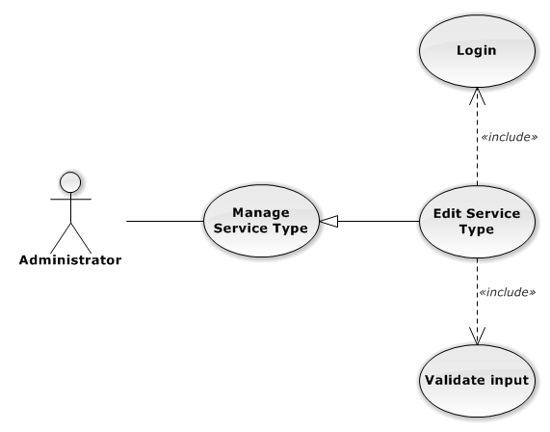

Figure 84: Edit Service Type Use-Case Diagram

###### Use-Case Specification

|  |  |  |  |
| --- | --- | --- | --- |
| USE CASE SPECIFICATION | | | |
| Use-case No. | UC0068 | Use-case Version | 1.0 |
| Use-case Name | Edit Service Type | | |
| Author | Trần Anh Tuấn | | |
| Date | 09/10/2014 | Priority | Normal |
| Actor:  Administrator  Summary:  Update Service Type.  Goal:  The purpose of Update Service Type use case is allowing Admin to update Service Type.  Triggers:  User choose “Quản lý Loại Dịch Vụ” in menu. Then click update icon.  Preconditions:  User is authenticated and has role “admin”.  Post Conditions:  Success: The Service Type is Updated.  Failure: The Service Type is not updated and Error message will be showed.  Main Success Scenario:   |  |  |  | | --- | --- | --- | | *Step* | *User* | *System* | | 1 | Click Update icon. | Show update Service type pop-up. | | 2 | Enters the new Service Type Name and Description |  | | 3 | Presses “Lưu chỉnh sửa” button.  [Alternative: 1] | Checks validate, update Service Type to database.  Show success message.  [Exception: 1]  [Exception: 2]  [Exception: 3] |   Alternative Scenario:   |  |  |  | | --- | --- | --- | | *#* | *User* | *System* | | 1 | Presses “Đóng”, “X” button or click outside pop-up. | The Update Service Type pop-up is close. |   Exceptions:   |  |  |  | | --- | --- | --- | | *#* | *User* | *System* | | 1 | Service Type Name is missing. | Show error “Nhập tên loại dịch vụ!” to user. | | 2 | Update Service type fail. | The Add New Service Type is closed and display error message “Chỉnh sửa loại dịch vụ thất bại!", "Hãy kiểm tra lại kết nối database." | | 3 | Update Service type error. | The Add New Service Type is closed and display error message "Chỉnh sửa loại dịch vụ thất bại!", "Có lỗi xảy ra trong quá trình tạo loại dịch vụ." |   Relationships:  Manage Service Type  Business Rules:  N/A | | | |

##### UC0069 - Delete Service Type

###### Use-Case Diagram

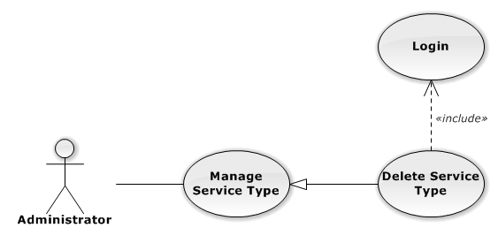

Figure 85: Delete Service Type Use-Case Diagram

###### Use-Case Specification

|  |  |  |  |
| --- | --- | --- | --- |
| USE CASE SPECIFICATION | | | |
| Use-case No. | UC0069 | Use-case Version | 1.0 |
| Use-case Name | Delete Service Type | | |
| Author | Trần Anh Tuấn | | |
| Date | 09/10/2014 | Priority | Normal |
| Actor:  Administrator  Summary:  Delete Service Type.  Goal:  The purpose of Delete Service Type use case is allowing Admin to delete Service Type.  Triggers:  User choose “Quản lý Dịch Vụ” in menu.  Preconditions:  User is authenticated and has role “admin”.  Post Conditions:  Success: The Service Type is deleted.  Failure: The Service Type is not delete and Error message will be showed.  Main Success Scenario:   |  |  |  | | --- | --- | --- | | *Step* | *User* | *System* | | 1 | Click Delete icon. | Show confirm pop-up | | 2 | Presses “Đồng ý” button.  [Alternative: 1] | Delete Service Type from database.  Show success message.  [Exception: 1]  [Exception: 2] |   Alternative Scenario:   |  |  |  | | --- | --- | --- | | *#* | *User* | *System* | | 1 | Presses “Hủy bỏ”, “X” button. | The confirm pop-up is close. |   Exceptions:   |  |  |  | | --- | --- | --- | | *#* | *User* | *System* | | 1 | Delete Service type fail. | The Add New Service Type is closed and display error message “Xóa loại dịch vụ thất bại!", "Hãy kiểm tra lại kết nối database." | | 2 | Delete Service type error. | The Add New Service is closed and display error message "Xóa loại dịch vụ thất bại!", "Có lỗi xảy ra trong quá xóa loại dịch vụ." |   Relationships:  Manage Service Type  Business Rules:  N/A | | | |

##### UC0070 - Search Service Type

###### Use-Case Diagram

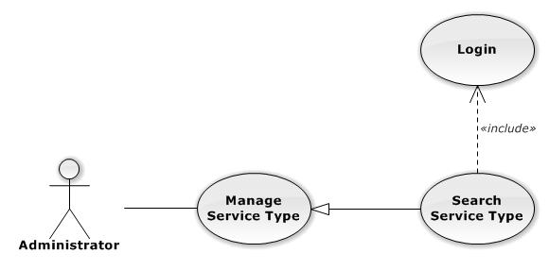

Figure 86: Search Service Type Use-Case Diagram

###### Use-Case Specification

|  |  |  |  |
| --- | --- | --- | --- |
| USE CASE SPECIFICATION | | | |
| Use-case No. | UC0070 | Use-case Version | 1.0 |
| Use-case Name | Search Service Type | | |
| Author | Trần Anh Tuấn | | |
| Date | 09/10/2014 | Priority | Normal |
| Actor:  Administrator  Summary:  Search Service Type.  Goal:  The purpose of Search Service Type use case is allowing Admin to search Service Type.  Triggers:  User choose “Quản lý Dịch Vụ” in menu.  Preconditions:  User is authenticated and has role “admin”.  Post Conditions:  Success: List of Service Type with search key words is displayed.  Failure: No record is displayed.  Main Success Scenario:   |  |  |  | | --- | --- | --- | | *Step* | *User* | *System* | | 1 | In “Quản lý loại dịch vụ” screen, input key word at “Tìm kiếm” textbox. | List of Service Type with search key words is displayed. |   Alternative Scenario:  N/A  Exceptions:  N/A  Relationships:  Manage Service Type  Business Rules:  N/A | | | |

#### Manage Service

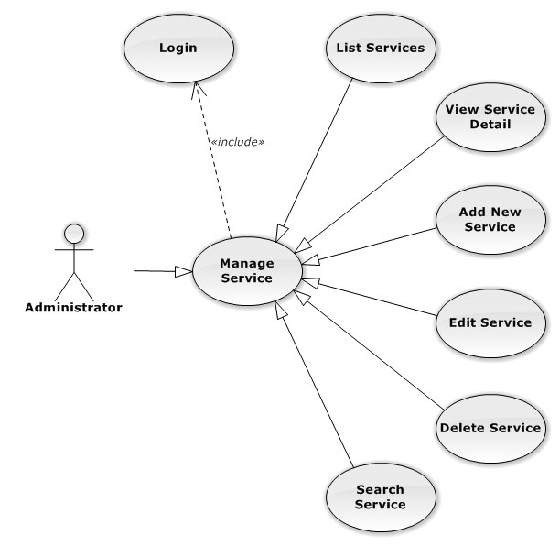

Figure 87: Manage Service Use-Case Diagram

##### UC0071 - List Services

###### Use-Case Diagram

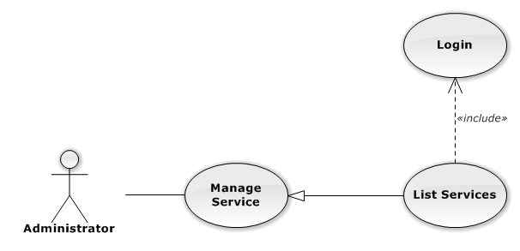

Figure 88: List Services Use-Case Diagram

###### Use-Case Specification

|  |  |  |  |
| --- | --- | --- | --- |
| USE CASE SPECIFICATION | | | |
| Use-case No. | UC0071 | Use-case Version | 1.0 |
| Use-case Name | List Services | | |
| Author | Trần Anh Tuấn | | |
| Date | 09/10/2014 | Priority | Normal |
| Actor:  Administrator  Summary:  List All Service.  Goal:  The purpose of List Service use case is allowing Admin to view all Services.  Triggers:  User choose “Quản lý Dịch Vụ” in menu.  Preconditions:  User is authenticated and has role “admin”.  The page is fully loaded.  Post Conditions:  Success: All Services is listed.  Failure: Do nothing.  Main Success Scenario:   |  |  |  | | --- | --- | --- | | *Step* | *User* | *System* | | 1 | Click “Quản lý Dịch Vụ” in menu. | All Services are loaded. |   Alternative Scenario:  N/A  Exceptions:  N/A  Relationships:  Manage Service  Business Rules:  N/A | | | |

##### UC0072 - View Service Detail

###### Use-Case Diagram

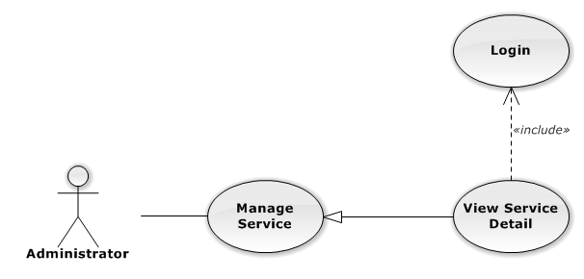

Figure 89: View Service Detail Use-Case Diagram

###### Use-Case Specification

|  |  |  |  |
| --- | --- | --- | --- |
| USE CASE SPECIFICATION | | | |
| Use-case No. | UC0072 | Use-case Version | 1.0 |
| Use-case Name | View Service Detail | | |
| Author | Trần Anh Tuấn | | |
| Date | 09/10/2014 | Priority | Normal |
| Actor:  Administrator  Summary:  View Service Detail.  Goal:  The purpose of View Service Detail use case is allowing Admin to view a Service detail.  Triggers:  User choose “Quản lý Dịch Vụ” in menu. Then click “View detail” icon.  Preconditions:  User is authenticated and has role “admin”.  Post Conditions:  Success: Service Detail is showed.  Failure: Do nothing.  Main Success Scenario:   |  |  |  | | --- | --- | --- | | *Step* | *User* | *System* | | 1 | In Manage Service page, click “View detail” icon | The Service Detail is showed. |   Alternative Scenario:  N/A  Exceptions:  N/A  Relationships:  Manage Service  Business Rules:  N/A | | | |

##### UC0073 - Add New Service

###### Use-Case Diagram

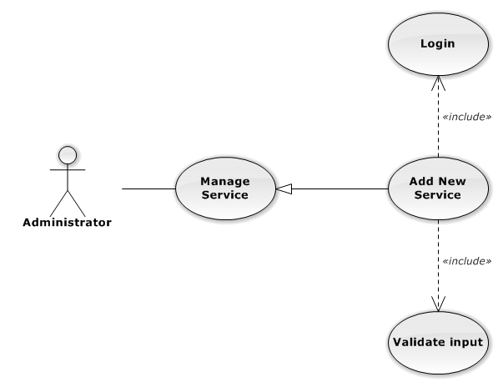

Figure 90: Add New Service Use-Case Diagram

###### Use-Case Specification

|  |  |  |  |
| --- | --- | --- | --- |
| USE CASE-n SPECIFICATION | | | |
| Use-case No. | UC0073 | Use-case Version | 1.0 |
| Use-case Name | Add New Service | | |
| Author | Trần Anh Tuấn | | |
| Date | 09/10/2014 | Priority | Normal |
| Actor:  Administrator  Summary:  Add new Service.  Goal:  The purpose of Add Service use case is allowing Admin to add new Service.  Triggers:  User choose “Quản lý Dịch Vụ” in menu. Then click “Thêm dịch vụ mới” button.  Preconditions:  User is authenticated and has role “admin”.  Post Conditions:  Success: New Service is created.  Failure: No Service is created and Error message will be showed.  Main Success Scenario:   |  |  |  | | --- | --- | --- | | *Step* | *User* | *System* | | 1 | Click “Thêm dịch vụ mới” button. | Show add Service pop-up. | | 2 | Enters the Service Name and Description |  | | 3 | Presses “Thêm mới” button.  [Alternative: 1] | Checks validate, add new Service to database.  Show success message.  [Exception: 1]  [Exception: 2]  [Exception: 3] |   Alternative Scenario:   |  |  |  | | --- | --- | --- | | *#* | *User* | *System* | | 1 | Presses “Đóng”, “X” button or click outside pop-up. | The Add New Service pop-up is close. |   Exceptions:   |  |  |  | | --- | --- | --- | | *#* | *User* | *System* | | 1 | Service Name is missing. | Show error “Nhập tên dịch vụ!” to user. | | Service Group is not chosen. | Show error “Chọn loại dịch vụ!” to user. | | 2 | Add Service fail. | The Add New Service is closed and display error message “Tạo dịch vụ thất bại!", "Hãy kiểm tra lại kết nối database." | | 3 | Add Service error. | The Add New Service is closed and display error message "Tạo dịch vụ thất bại!", "Có lỗi xảy ra trong quá trình tạo dịch vụ." |   Relationships:  Manage Service  Business Rules:  N/A | | | |

##### UC0074 - Edit Service

###### Use-Case Diagram

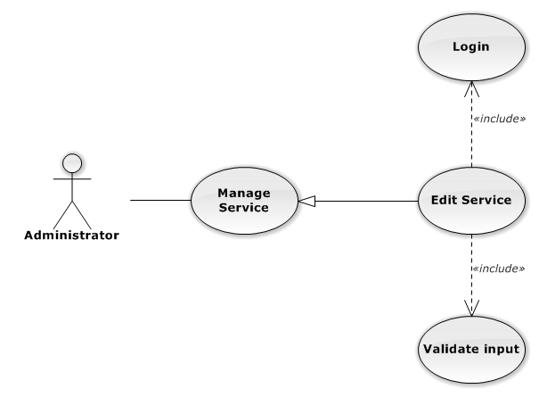

Figure 91: Edit Service Use-Case Diagram

###### Use-Case Specification

|  |  |  |  |
| --- | --- | --- | --- |
| USE CASE SPECIFICATION | | | |
| Use-case No. | UC0074 | Use-case Version | 1.0 |
| Use-case Name | Edit Service | | |
| Author | Trần Anh Tuấn | | |
| Date | 09/10/2014 | Priority | Normal |
| Actor:  Administrator  Summary:  Update Service.  Goal:  The purpose of Update Service use case is allowing Admin to update Service.  Triggers:  User choose “Quản lý Dịch Vụ” in menu. Then click update icon.  Preconditions:  User is authenticated and has role “admin”.  Post Conditions:  Success: The Service is Updated.  Failure: The Service is not updated and Error message will be showed.  Main Success Scenario:   |  |  |  | | --- | --- | --- | | *Step* | *User* | *System* | | 1 | Click Update icon. | Show update Service pop-up. | | 2 | Enters the new Service Name and Description |  | | 3 | Presses “Lưu chỉnh sửa” button.  [Alternative: 1] | Checks validate, update Service to database.  Show success message.  [Exception: 1]  [Exception: 2]  [Exception: 3] |   Alternative Scenario:   |  |  |  | | --- | --- | --- | | *#* | *User* | *System* | | 1 | Presses “Đóng”, “X” button or click outside pop-up. | The Update Service pop-up is close. |   Exceptions:   |  |  |  | | --- | --- | --- | | *#* | *User* | *System* | | 1 | Service Name is missing. | Show error “Nhập tên dịch vụ!” to user. | | 2 | Update Service fail. | The Add New Service is closed and display error message “Chỉnh sửa dịch vụ thất bại!", "Hãy kiểm tra lại kết nối database." | | 1 | Update Service error. | The Add New Service is closed and display error message "Chỉnh sửa dịch vụ thất bại!", "Có lỗi xảy ra trong quá trình chỉnh sửa dịch vụ." |   Relationships:  Manage Service  Business Rules:  N/A | | | |

##### UC0075 - Delete Service

###### Use-Case Diagram

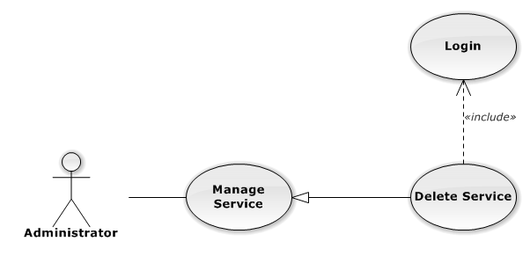

Figure 92: Delete Service Use-Case Diagram

###### Use-Case Specification

|  |  |  |  |
| --- | --- | --- | --- |
| USE CASE SPECIFICATION | | | |
| Use-case No. | UC0075 | Use-case Version | 1.0 |
| Use-case Name | Delete Service | | |
| Author | Trần Anh Tuấn | | |
| Date | 09/10/2014 | Priority | Normal |
| Actor:  Administrator  Summary:  Delete Service.  Goal:  The purpose of Delete Service use case is allowing Admin to delete Service.  Triggers:  User choose “Quản lý Dịch Vụ” in menu. Then click delete icon.  Preconditions:  User is authenticated and has role “admin”.  Post Conditions:  Success: The Service is deleted.  Failure: The Service is not delete and Error message will be showed.  Main Success Scenario:   |  |  |  | | --- | --- | --- | | *Step* | *User* | *System* | | 1 | Click Delete icon. | Show confirm pop-up | | 2 | Presses “Xác nhận” button.  [Alternative: 1] | Delete Service from database.  Show success message.  [Exception: 1]  [Exception: 2] |   Alternative Scenario:   |  |  |  | | --- | --- | --- | | *#* | *User* | *System* | | 1 | Presses “Bỏ qua” or “X” button. | The confirm pop-up is close. |   Exceptions:   |  |  |  | | --- | --- | --- | | *#* | *User* | *System* | | 1 | Delete Service fail. | The Add New Service is closed and display error message “Xóa dịch vụ thất bại!", "Hãy kiểm tra lại kết nối database." | | 2 | Delete Service error. | The Add New Service is closed and display error message "Xóa dịch vụ thất bại!", "Có lỗi xảy ra trong quá xóa dịch vụ." |   Relationships:  Manage Service  Business Rules:  N/A | | | |

##### UC0076 - Search Service

###### Use-Case Diagram

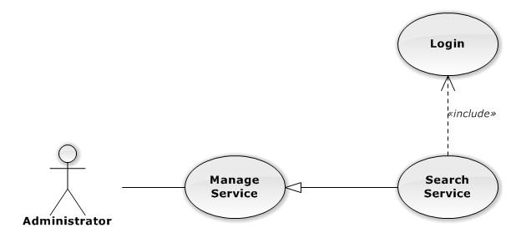

Figure 93: Search Service Use-Case Diagram

###### Use-Case Specification

|  |  |  |  |
| --- | --- | --- | --- |
| USE CASE SPECIFICATION | | | |
| Use-case No. | UC0076 | Use-case Version | 1.0 |
| Use-case Name | Search Service | | |
| Author | Trần Anh Tuấn | | |
| Date | 09/10/2014 | Priority | Normal |
| Actor:  Administrator  Summary:  Search Service.  Goal:  The purpose of Search Service use case is allowing Admin to search Service.  Triggers:  User choose “Quản lý Dịch Vụ” in menu.  Preconditions:  User is authenticated and has role “admin”.  Post Conditions:  Success: List of Service with search key words is displayed.  Failure: No record is displayed.  Main Success Scenario:   |  |  |  | | --- | --- | --- | | *Step* | *User* | *System* | | 1 | In “Quản lý dịch vụ” screen, input key word at “Tìm kiếm” textbox. | List of Service with search key words is displayed. |   Alternative Scenario:  N/A  Exceptions:  N/A  Relationships:  Manage Service  Business Rules:  N/A | | | |

#### Manage Office

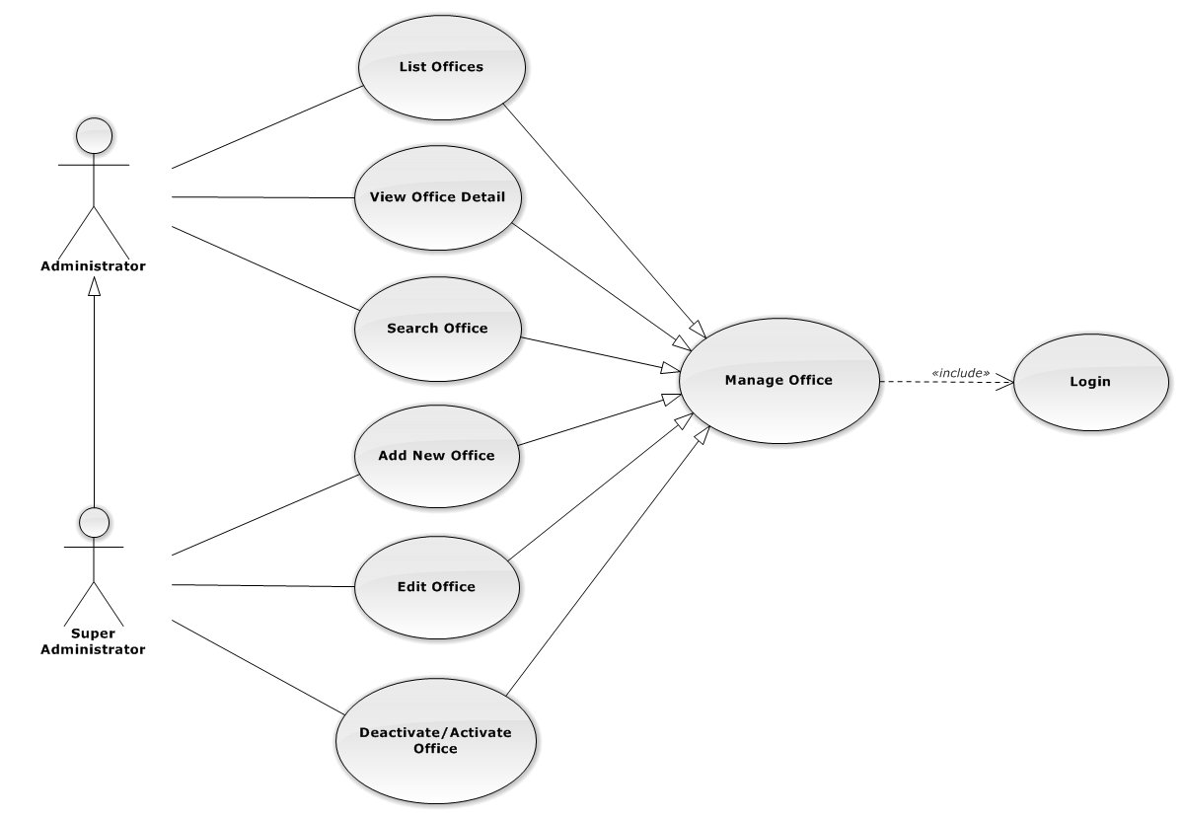

Figure 94: Manage Office Use-Case Diagram

##### UC0077 - List Offices

###### Use-Case Diagram

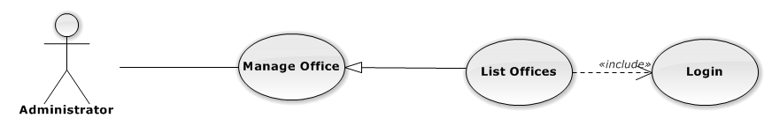

Figure 95: List Offices Use-Case Diagram

###### Use-Case Specification

|  |  |  |  |
| --- | --- | --- | --- |
| USE-CASE SPECIFICATION | | | |
| Use-case No. | UC0077 | Use-case Version | 1.0 |
| Use-case Name | List Offices | | |
| Author | Trần Anh Tuấn | | |
| Date | 09/10/2014 | Priority | Normal |
| Actor:  Administrator  Summary:  Redirect user to “Quản lí văn phòng” page and list all offfice.  Goal:  To allowing Administrator view any detail information of all Office.  Triggers:   * User click on User Control Panel and then click on “Quản lí văn phòng” link   Preconditions:   * Must be logged-in with “Admin” role. * The page is fully loaded   Post Conditions:  Success: System redirects user to “Quản lí văn phòng” page.  Failure: Do nothing.  Main Success Scenario:   |  |  |  | | --- | --- | --- | | *Step* | *User* | *System* | | 1 | Click on “Quản lí văn phòng” link | Redirect to “Quản lí văn phòng” page.Show all Office |   Alternative Scenario:  N/A  Exceptions:  N/A  Relationships:  Management Office  Business Rules:  Only Staff with role =”Admin” can be use this function. | | | |

##### UC0078 - View Office Detail

###### Use-Case Diagram

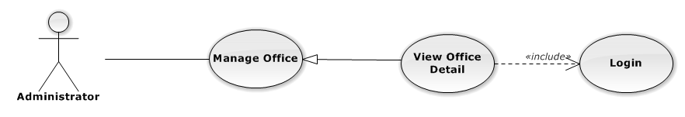

Figure 96: View Office Detail Use-Case Diagram

###### Use-Case Specification

|  |  |  |  |
| --- | --- | --- | --- |
| USE-CASE SPECIFICATION | | | |
| Use-case No. | UC0078 | Use-case Version | 1.0 |
| Use-case Name | View Office Detail | | |
| Author | Trần Anh Tuấn | | |
| Date | 09/10/2014 | Priority | Normal |
| Actor:  Administrator  Summary:  Staff can view detail of office information  Goal:  Helps staff to view offfice information  Triggers:   * On User Control Panel click on “Quản lí văn phòng**”,** * Click click on “Chi tiết” button * Click on name’s office link.   Preconditions:   * Must be logged-in * The page is fully loaded   Post Conditions:  Success: The detail offfice information is displayed  Failure: Do nothing  Main Success Scenario:   |  |  |  | | --- | --- | --- | | *Step* | *User* | *System* | | 1 | Staff click on “chi tiết” button or click on name’s offfce link  [Alternative 1], [Alternative 2], [Alternative 3] | The detail offfice information is displayed |   Alternative Scenario:   |  |  |  | | --- | --- | --- | | *#* | *User* | *System* | | 1 | Click on [X] button, “Đóng” button, or click out of modal | Modal popup is close | | 2 | If staff login with Id=”1”, Click on “Chỉnh sửa” button | Staff can update information of office (ref 3.2.2.2.4. Update office) | | 3 | If staff login with Id=”1”, Click on “Hoạt động lại” or “Ngừng hoạt động” link | Staff can Deactivate/Activate office (ref 3.2.2.2.5. Deactivate/Activate office) |   Exceptions:  N/A  Relationships:  Management office.  Business Rules:  Only Staff login with role “Admin” can be use this function. | | | |

##### UC0079 - Add New Office

###### Use-Case Diagram

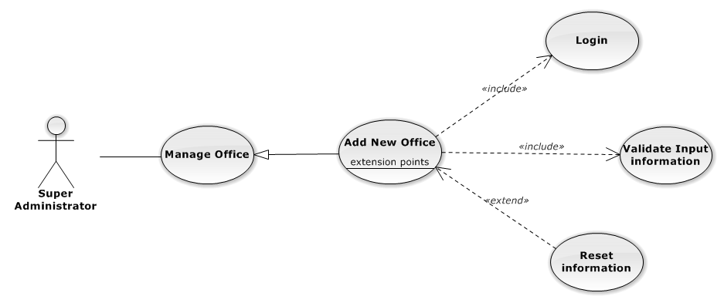

Figure 97: Add New Office Use-Case Diagram

###### Use-Case Specification

|  |  |  |  |
| --- | --- | --- | --- |
| USE CASE SPECIFICATION | | | |
| Use-case No. | UC0079 | Use-case Version | 1.0 |
| Use-case Name | Add New Office | | |
| Author | Trần Anh Tuấn | | |
| Date | 09/10/2014 | Priority | Normal |
| Actor:  Supper Administrator.  Summary:  Insert new office in the system.  **Goal:**  Add new office.  Triggers:  On User Control Panel click on “Quản lí nhân viên” link, at “Quản lí nhân viên” page click on “Thêm văn phòng” button.  Preconditions:   * Logged-in to system. * The page is fully loaded   Post Conditions:  Success:   * New office is inserted into database, message show “Thêm văn phòng thành công” and display on “Quản lí văn phòng” screen. * New office’s status is “Đang hoạt động”.   Failure:  Show error message “Thêm văn phòng thất bại, hãy kiểm tra lại kết nối database”.  Main Success Scenario:   |  |  |  | | --- | --- | --- | | *Step* | *User* | *System* | | 1 | Administrator click on “Thêm văn phòng” button at “Quản lí văn phòng”page. | Modal popup is displayed with fields for input information of new office. | | 2 | Fill information into fields and click button “Thêm mới”  [Alternative 1]  [Exception 2], [Exception 3] | Modal popup is close  System display successful message “Thêm văn phòng thành công!”  Update list office on page |   Alternative Scenario:   |  |  |  | | --- | --- | --- | | *#* | *User* | *System* | | 1 | Click “Làm trống” button | All input field reset to blank. |   Exceptions:   |  |  |  | | --- | --- | --- | | *Step* | *User* | *System* | | 1 | Field “Tên văn phòng” are blank | Shows error message “Nhập tên văn phòng!” | | Field “Địa chỉ văn phòng”, are blank | Shows error message “Nhập địa chỉ văn phòng!” | | Field “Người quản lí” are blank | Shows error message “Nhập tên người quản lí văn phòng!” | | Field “Ðiện thoại” are blank | Shows error message “Nhập số điện thoại văn phòng!” | | Field “Email” are blank | Shows error message “Hãy nhập Email của văn phòng!” | | Input “Email” not follow the rule | Shows error message “Hãy nhập địa chỉ email đúng!” | | 2 | System cannot insert office to data base. | Shows error message “Thêm văn phòng thất bại!” | | 3 | System error insert office to data base. | Shows error message “Thêm văn phòng thất bại!", "Hãy kiểm tra lại kết nối data base”. |   Relationships:  Manage Office  Business Rules:  Only Staff with id=”1” (Supper Administrator)can be use this function. | | | |

##### UC0080- Edit Office

###### Use-Case Diagram

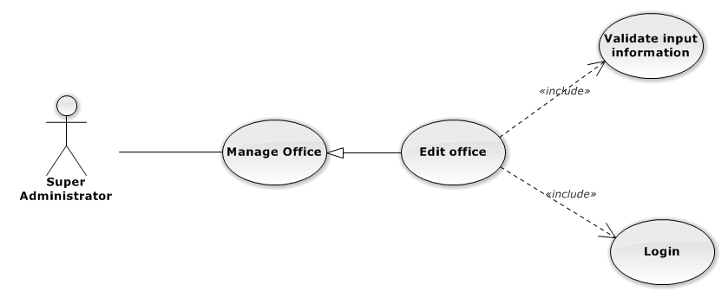

Figure 98: Edit Office Use-Case Diagram

###### Use-Case Specification

|  |  |  |  |
| --- | --- | --- | --- |
| USE CASE SPECIFICATION | | | |
| Use-case No. | UC0080 | Use-case Version | 1.0 |
| Use-case Name | Edit Office | | |
| Author | Trần Anh Tuấn | | |
| Date | 09/10/2014 | Priority | Normal |
| Actor:  Supper Administrator.  Summary:  Supper Administrator can update information of office.  **Goal:**  Helps Supper Administrator update information of office and save to database system.  Triggers:   * Supper Administrator goes to “Quản lý văn phòng” screen, click button “Chỉnh Sửa” and modify information, after that click button “Lưu Chỉnh Sửa”. * Supper Administrator goes to “Chi tiết nhân viên” Popup screen, click on “Chỉnh Sửa” button and modify information, after that click button “Lưu Chỉnh Sửa”.   Preconditions:   * Logged-in to system. * The page is fully loaded   Post Conditions:  Success:  Information of office is updated and saves to database, message show “Cập nhật chi tiết văn phòng thành công” and display information after update on “Quản lý văn phòng” screen.  Failure:  Show error message “Cập nhật chi tiết văn phòng thất bại!”  Main Success Scenario:   |  |  |  | | --- | --- | --- | | *Step* | *User* | *System* | | 1 | Administrator click on “Chỉnh sửa” button at “Quản lí văn phòng” screen. | Modal popup is displayed with fields for input information of new office. | | 2 | Edit information into fields and click button “Lưu chỉnh sửa”  [Alternative 1]  [Exception 1], [Exception 2], [Exception 3] | Modal popup is close  System display successful message “Cập nhật chi tiết văn phòng thành công!”  Update list office on page |   Alternative Scenario:   |  |  |  | | --- | --- | --- | | *#* | *User* | *System* | | 1 | Click on [X] button, “Đóng” button, or click out of modal | Modal popup is close. |   Exceptions:   |  |  |  | | --- | --- | --- | | *Step* | *User* | *System* | | 1 | Field “Tên văn phòng” are blank | Shows error message “Nhập tên văn phòng!” | | Field “Địa chỉ văn phòng”, are blank | Shows error message “Nhập địa chỉ văn phòng!” | | Field “Người quản lí” are blank | Shows error message “Nhập tên người quản lí văn phòng!” | | Field “Ðiện thoại” are blank | Shows error message “Nhập số điện thoại văn phòng!” | | Field “Email” are blank | Shows error message “Hãy nhập Email của văn phòng!” | | Input “Email” not follow the rule | Shows error message “Hãy nhập địa chỉ email đúng!” | | 2 | System cannot update office to data base. | Shows error message “Cập nhật chi tiết văn phòng thất bại!” | | 3 | System error update office to data base. | Shows error message “Cập nhật chi tiết văn phòng thất bại! ", "Hãy kiểm tra lại kết nối database”. |   Relationships:  Manage Office  Business Rules:  Only Staff with id=”1”( Supper Administrator) can be use this function. | | | |

##### UC0081 - Deactivate/Activate Office

###### Use-Case Diagram

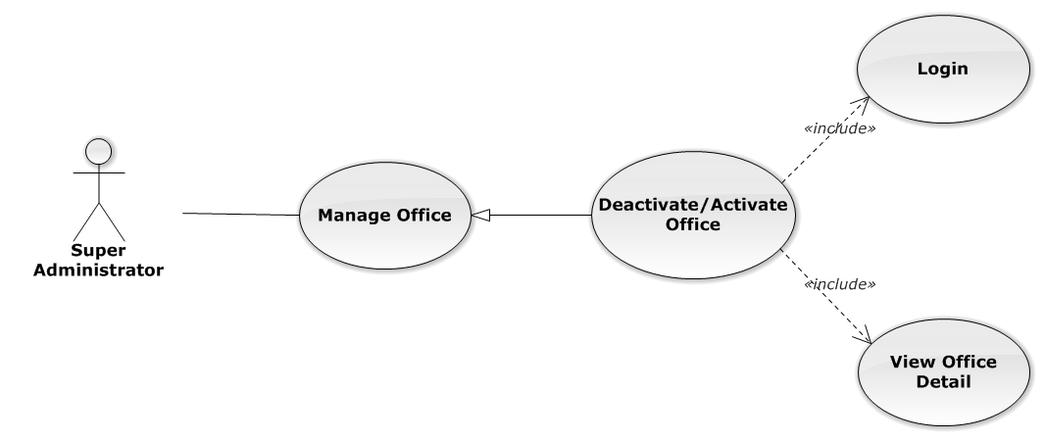

Figure 99: Deactivate/Activate Office Use-Case Diagram

###### Use-Case Specification

|  |  |  |  |
| --- | --- | --- | --- |
| USE CASE SPECIFICATION | | | |
| Use-case No. | UC0081 | Use-case Version | 1.0 |
| Use-case Name | Deactivate/Activate office | | |
| Author | Trần Anh Tuấn | | |
| Date | 09/10/2014 | Priority | Normal |
| Actor:  Supper Administrator.  Summary:  Supper Administrator can change status of Office to De active or Active.  **Goal:**  Helps Supper Administrator update Status of Office and save to database system.  Triggers:   * Supper Administrator wants to update Status of office. * Supper Administrator goes “Chi tiết văn phòng” screen Pop-Up, Click button “Ngừng hoạt động văn phòng” or “Hoạt động lại”. After that click on “Bỏ qua” or “Xác nhận” button to confirm change status Office.   Preconditions:   * Logged-in to system. * The page is fully loaded   Post Conditions:  Success:  Information of Office is updated and saves to database, message show “Văn phòng đã hoạt động lại!” or “Văn phòng đã ngừng hoạt động!” and display information after update on “Quản lý văn phòng” screen.  Failure:  Show error message “Chỉnh hoạt động văn phòng thất bại!  Main Success Scenario:   |  |  |  | | --- | --- | --- | | *Step* | *User* | *System* | | 1 | Administrator click on “Chỉnh sửa” button at “Quản lí văn phòng” screen. | Show “Chi tiết văn phòng” Pop-up information. | | 2 | On “Chi tiết văn phòng” Pop-up click button “Ngừng hoạt động văn phòng” if Office have status “Đang hoạt động” or Click button “Hoạt động lại” if Office have status "Ngừng hoạt động”.  [Alternative 1] | Display message box confirm “Bạn có muốn thực hiện thao tác này” with two button “Xác nhận” and “Bỏ qua” | | 3 | User click “Bỏ qua” button | Status of Office not change comeback to “Chi tiết văn phòng” Pop-up screen. | | 4 | User click “ Xác nhận” button  [Exception 1], [Exception 2] | Status of Office is change and comeback to “Quản lí văn phòng” screen |   Alternative Scenario:   |  |  |  | | --- | --- | --- | | *#* | *User* | *System* | | 1 | Click on [X] button, “Đóng” button, or click out of modal | Modal popup is close |   Exceptions:   |  |  |  | | --- | --- | --- | | *#* | *User* | *System* | | 1 | System error update status office to data base. | Shows error message “Chỉnh hoạt động văn phòng thất bại!", "Hãy kiểm tra lại kết nối database!”. | | 2 | System error update status office to data base. | Shows error message “Chỉnh hoạt động văn phòng thất bại!", "Có lỗi xảy ra trong quá trình xóa văn phòng!”. |   Relationships:  Manage Office  Business Rules:  Only Staff with id=”1”( Supper Administrator) can be use this function. | | | |

##### UC0082 - Search Office

###### Use-Case Diagram

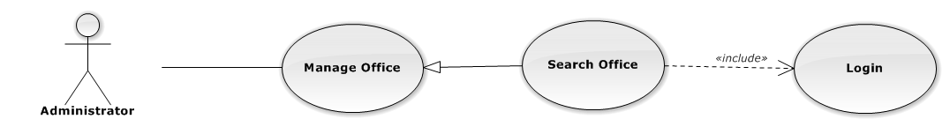

Figure 100: Search Office Use-Case Diagram

###### Use-Case Specification

|  |  |  |  |
| --- | --- | --- | --- |
| USE CASE SPECIFICATION | | | |
| Use-case No. | UC0082 | Use-case Version | 1.0 |
| Use-case Name | Search Office | | |
| Author | Trần Anh Tuấn | | |
| Date | 09/10/2014 | Priority | Normal |
| Actor:  Administrator.  Summary:  Administrator search Office in list of office  **Goal:**  Helps Administrator search Office.  Triggers:   * Manager wants to search office. * Manager goes to “Quản lý văn phòng” screen, input word into “Tìm Kiếm” textbox.   Preconditions:   * Logged-in as “Admin” role. * The page is fully loaded   Post Conditions:  Success: List of Office map with word search is displayed.  Failure: Do nothing  Main Success Scenario:   |  |  |  | | --- | --- | --- | | *Step* | *User* | *System* | | 1 | In “Quản lý văn phòng” screen, input key word at “Tìm kiếm” textbox. | List of office mapping with word search is display. |   Alternative Scenario:  N/A  Exceptions:  N/A  Relationships:  Manage Office  Business Rules:  N/A | | | |

#### Statistic

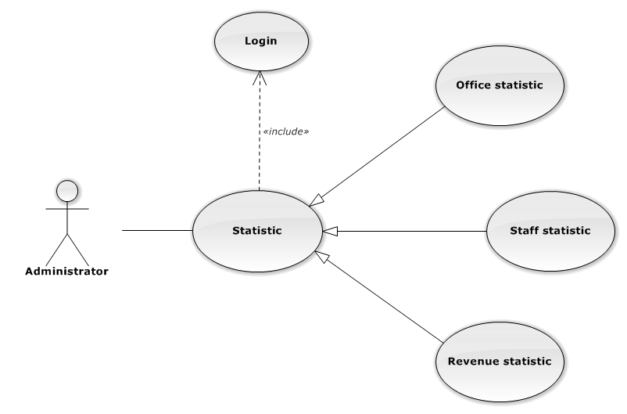

Figure 101: Statistic Use-Case Diagram

##### UC0083 - Office Statistic

###### Use-Case Diagram

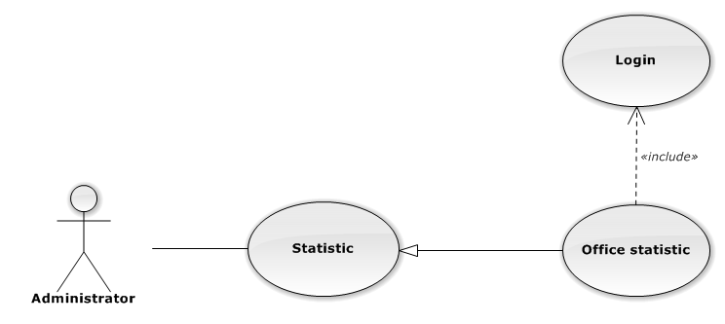

Figure 102: Office Statistic Use-Case Diagram

###### Use-Case Specification

|  |  |  |  |
| --- | --- | --- | --- |
| USE CASE SPECIFICATION | | | |
| Use-case No. | UC0083 | Use-case Version | 1.0 |
| Use-case Name | Office Statistic | | |
| Author | Đặng Nguyễn Khiêm | | |
| Date | 09/10/2014 | Priority | Normal |
| Actor:  Administrator.  Summary:  The statistic about office.  Goal:  The purpose of Office Statistic use case is allowing User to view Office index in graphs.  Triggers:  User choose “Thống kê” link in menu.  Preconditions:  User is authenticated.  Post Conditions:  Success: The graphs are showed.  Failure: N/A  Main Success Scenario:   |  |  |  | | --- | --- | --- | | *Step* | *User* | *System* | | 1 | Click “Văn phòng” tab in statistic page. | The graphs are loaded. |   Alternative Scenario:  N/A  Exceptions:  N/A  Relationships:  Statistic  Business Rules:  N/A | | | |

##### UC0084 - Staff Statistic

###### Use-Case Diagram

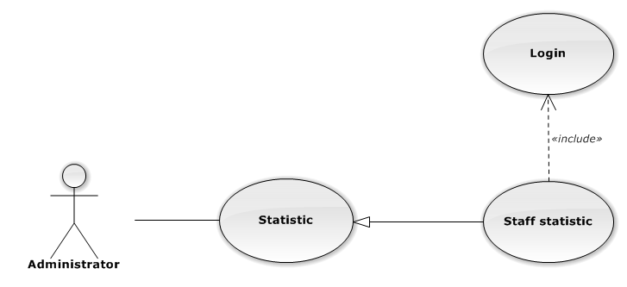

Figure 103: Staff Statistic Use-Case Diagram

###### Use-Case Specification

|  |  |  |  |
| --- | --- | --- | --- |
| USE CASE SPECIFICATION | | | |
| Use-case No. | UC0084 | Use-case Version | 1.0 |
| Use-case Name | Staff Statistic | | |
| Author | Đặng Nguyễn Khiêm | | |
| Date | 09/10/2014 | Priority | Normal |
| Actor:  Administrator.  Summary:  The statistic about staffs.  Goal:  The purpose of Staff Statistic use case is allowing User to view Staff index in graphs.  Triggers:  User choose “Thống kê” link in menu.  Preconditions:  User is authenticated.  Post Conditions:  Success: The graphs are showed.  Failure: N/A  Main Success Scenario:   |  |  |  | | --- | --- | --- | | *Step* | *User* | *System* | | 1 | Click “Nhân viên” tab in statistic page. | The graphs are loaded. |   Alternative Scenario:  N/A  Exceptions:  N/A  Relationships:  Statistic  Business Rules:  N/A | | | |

##### UC0085 - Revenue Statistic

###### Use-Case Diagram

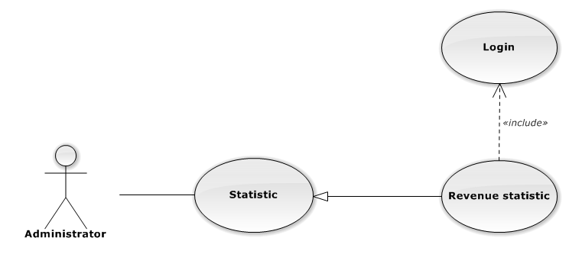

Figure 104: Revenue Statistic Use-Case Diagram

###### Use-Case Specification

|  |  |  |  |
| --- | --- | --- | --- |
| USE CASE SPECIFICATION | | | |
| Use-case No. | UC0085 | Use-case Version | 1.0 |
| Use-case Name | Revenue Statistic | | |
| Author | Đặng Nguyễn Khiêm | | |
| Date | 09/10/2014 | Priority | Normal |
| Actor:  Administrator.  Summary:  The statistic about revenue.  Goal:  The purpose of Revenue Statistic use case is allowing User to view Revenue index in graphs.  Triggers:  User choose “Thống kê” link in menu.  Preconditions:  User is authenticated.  Post Conditions:  Success: The graphs are showed.  Failure: N/A  Main Success Scenario:   |  |  |  | | --- | --- | --- | | *Step* | *User* | *System* | | 1 | Click “Doanh thu” tab in statistic page. | The graphs are loaded. |   Alternative Scenario:  N/A  Exceptions:  N/A  Relationships:  Statistic  Business Rules:  N/A | | | |

### Non-Functional Requirements

#### Reliability

The systems with high reliability, can be used like “always on” system. However, if exist accident, it's not need require immediate repair. All information and Cases can be updated later.

#### Availability

The system always responds to every user who got permission. The expected downtime for maintenance is about 5 minutes each time.

#### Security

Users must login for using the system. The user passwords are MD5 encrypted before being put into Database. Staff are restricted to view other user’s information and any function. Super Administrator has full permission to use the system.

#### Maintainability

Each component only perform specific functions so the modification of a component will not affect other components.

#### Portability

The system can be accessed anywhere with a web browser and Internet connection. It can be run on any browser, but recommend for user is Mozilla Firefox with highest version.

#### Performance

N/A

## Entity Relationship Diagram

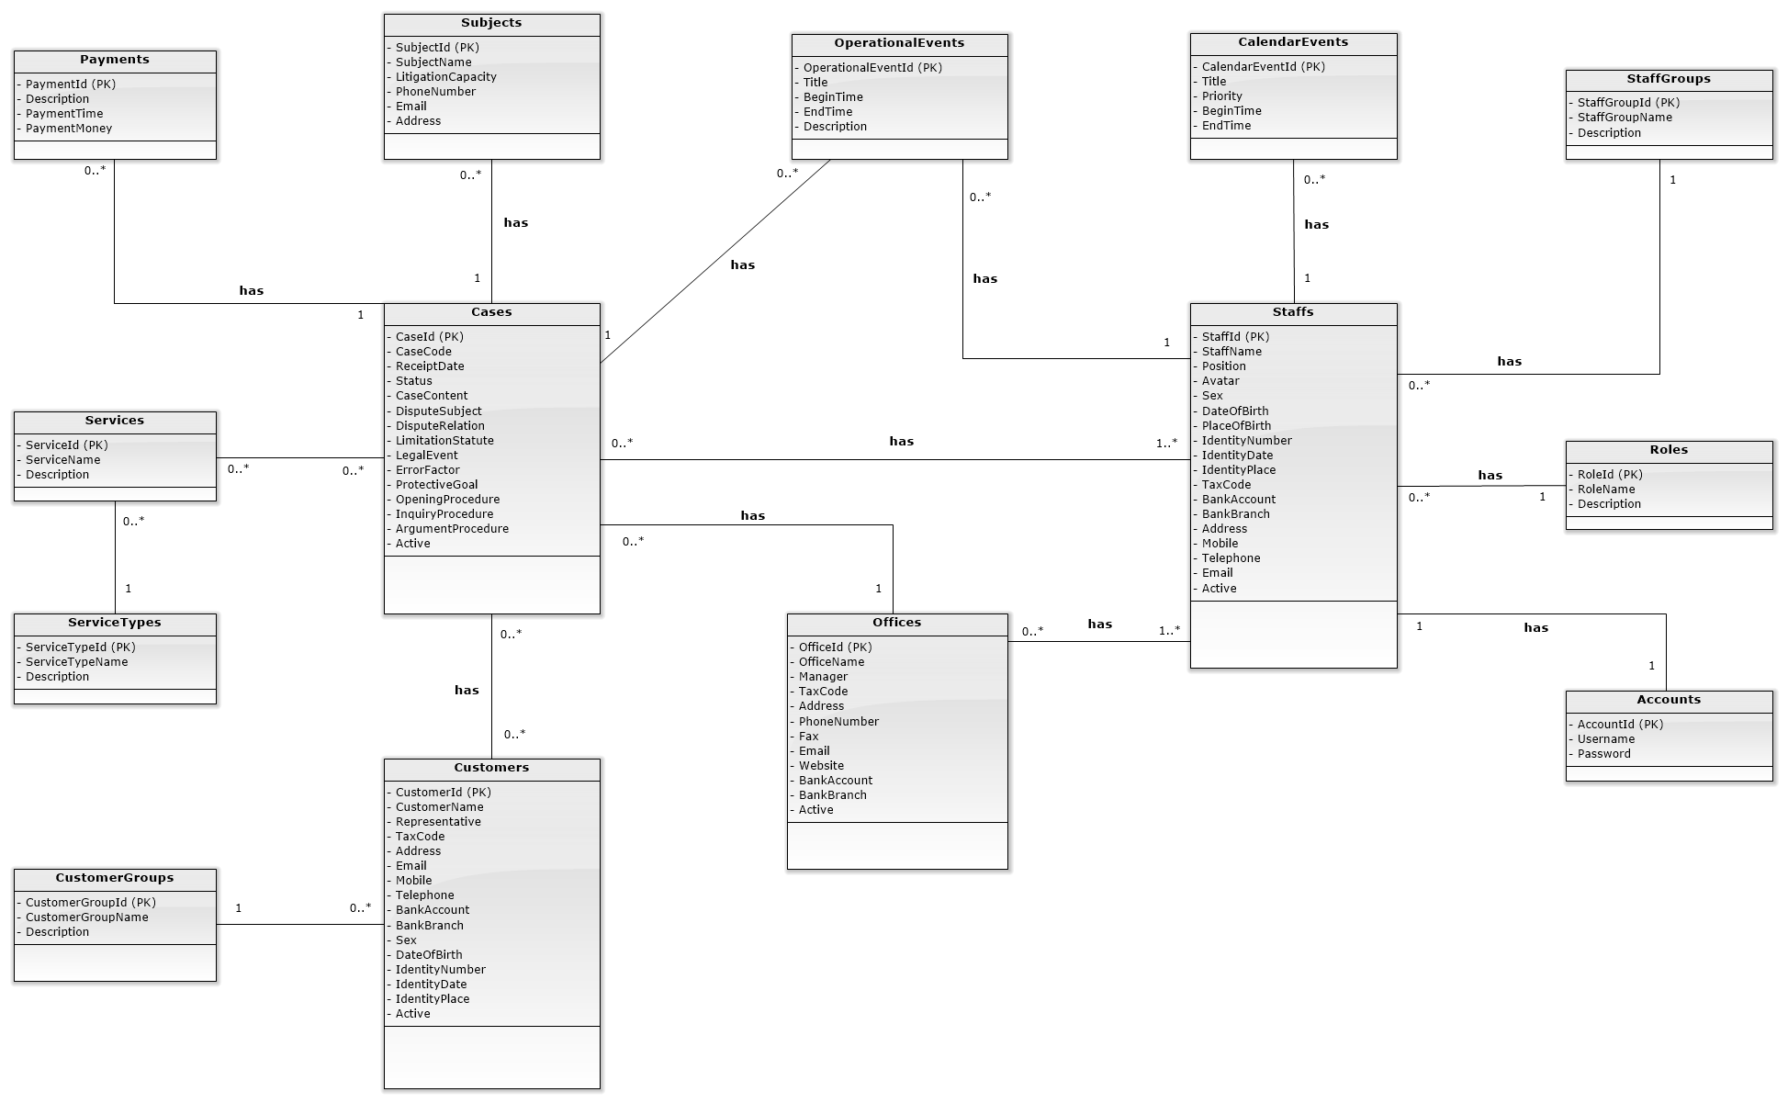

Figure 105: Entity Relationship Diagram